6. Death and Life
Life comes from God. Nothing can live unless God gives it life and maintains it.
God made the first man, Adam, and then gave him life. This was a two-step process, (Genesis 2:7): "Then the Lord God formed a man from the dust of the ground and breathed into his nostrils the breath of life, and the man became a living being."
Man lay in the dust but did not live until God breathed into him. The 'breath of God' is also called the 'spirit of God' (Job 33:4). The process of living is this:

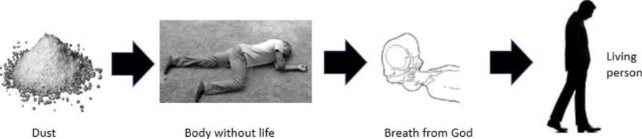

Man is dust (Genesis 3:19). That is all. The process of dying is the reverse of the process of living.
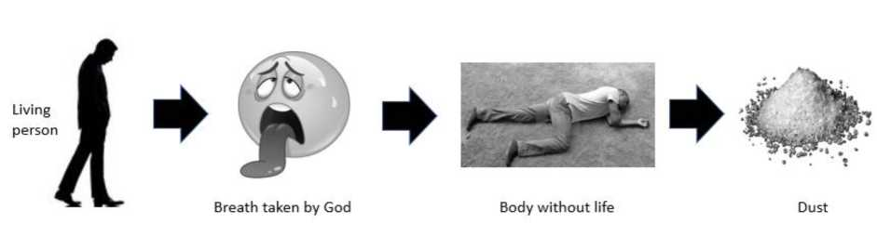
Ecclesiastes 12:7 speaks about death: "the dust returns to the ground it came from, and the spirit returns to God who gave it." The spirit was God's spirit. At the end of man's life, God takes His spirit back and man returns to dust. See also Psalm 104:29, 146:4 and Job 34:14-15. It is the breath or the spirit that keeps man alive. If God takes this away, then man dies.
In this respect, man is like the animals. Land animals were made from the ground (Genesis 1:12,24,25) and had the breath from God giving them life (v30). They die in the same way (Ecclesiastes 3:19,20). Man lives and dies like the animals (Psalm 104:29).
No part of man survives death. Death is the end of man's existence. The 'soul' dies, which means the being or person dies (Ezekiel 18:4,20; Proverbs 23:14; Matthew 10:28; Mark 8:36,37).
The life of man only lasts a short time. He is like a mist that comes and goes (James 4:14). Like the grass which grows up and then withers (Psalm 37:2; Isaiah 40:6). Like a shadow that goes down and disappears (Ecclesiastes 6:12), a cloud that is there one moment and gone the next (Job 7:9), a breeze that comes and goes (Psalm 78:39).
Man does not have a continuing existence.
When man is dead that is the end of his life (Ecclesiastes 9:4-6). The dead "know nothing"! They are not loving or enjoying. Ecclesiastes 9:10 has advice for the living - make the most of your life now.
The dead cannot even praise God (Isaiah 38:18). They are silent (Psalm 31:17; 115:17; 88:10-12). They do not give thanks (Psalm 6:5; Isaiah 38:18-19). They have no thoughts (Psalm 146:2-4).
The destiny of all the living is death. It does not matter if one is good or bad! We all go to the same place. Ecclesiastes 9:2,3: "All share a common destiny - the righteous and the wicked, the good and the bad, the clean and the unclean, those who offer sacrifices and those who do not. As it is with the good, so with the sinful; as it is with those who take oaths, so with those who are afraid to take them. This is an evil in everything that happens under the sun. The same destiny overtakes all. The hearts of people, moreover, are full of evil and there is madness in their hearts while they live, and afterward they join the dead."
David knew this (1 Kings 2:2). So did Joshua (Joshua 23:14) and Job (Job 30:23).
But death need not be the end. There is a way we can find eternal life. Romans 6:23 says, "For the wages of sin is death, but the gift of God is eternal life in Christ Jesus our Lord." God has given Jesus the authority to give eternal life to others (John 17:2; 2 Timothy 1:10). Further verses which teach the gift of eternal life are John 3:16, 10:28, Romans 2:7-8; 1 Timothy 6:12; Titus 1:2 and 1 John 2:25. This occurs through the resurrection and judgment.

The grave
The grave is literally the 'unseen place' or 'covered place,' which is a good description of the grave. It comes from the Hebrew word 'sheol' in the Old Testament and the Greek word 'hades' in the New Testament. When man dies, he is buried in this unseen place. Jesus went to the grave (Acts 2:27; 31, Isaiah 53:9).

Questions you may be asked
Where does the teaching of the immortal soul come from? It came from Jews who took these ideas from Greek philosophers such as Plato (428-348 BC).
What does the Bible mean by 'soul'? The Hebrew word is 'nephesh' and the Greek word is 'psuche'. Both mean the 'life' or 'person'. There is nothing in the word that means it is immortal. It has emotions like a person. It grieves (Job 30:25). It suffers (Isaiah 53:11). It rejoices (Psalm 35:9). It sins (Micah 6:7). It dies (Ezekiel 18:4,20). These are all features of a person or a life.
Does the parable of the rich man and Lazarus teach the immortality of the soul? This is a parable, which is a non-literal story designed to teach a lesson (Luke 16:19-31). Several features show that this is not literal. The parable speaks of bodies not souls. Lazarus goes to Abraham's bosom, while the rich man goes to the grave. They can see each other from where they were. These are not literal things. The lesson of the parable is to live life carefully today because there will be consequences later when we are judged. The parable uses elements of false Jewish teaching to teach them this lesson. The Jewish historian Josephus tells us about these beliefs, which are not found in the Bible.
Where does the teaching of hell fire come from? These come from the Greek word 'gehenna'. It developed as a false teaching from Greek Philosophy where they thought that the wicked would be burnt forever. It was described by the historian Josephus.
The word literally means the 'valley of Hinnom'. It was a literal place outside Jerusalem first mentioned at the time of Joshua (Joshua 15:8; 18:16). It was linked to idol worship and child sacrifice (Jeremiah 7:31). By the time of Jesus, it was the city rubbish tip. Like all rubbish tips, there was always a flame somewhere and always worms (Mark 9:43-48). It does not mean there was an eternal flame where the wicked are burnt forever. It does mean that worthless criminals would be thrown on the rubbish pile. The fire would not be put out and they would burn until their bodies are gone (Mark 9:43).
The wicked will not suffer pain forever in torment because of a short life of sin. This is not compatible with a God of justice and mercy. God does not remain angry forever (Psalm 103:8-10). The dead are silent (see above) and so are the wicked (Psalm 31:17). They remain where they were buried (Psalm 49:11; Deuteronomy 11:4).
The false teaching of the eternal fire of hell has led to misunderstanding other passages:
Jude 7 says Sodom is burnt with everlasting fire. But it is not burning today! What it meant was that the fire will continue burning until Sodom was fully destroyed.
Isaiah 14:9-23 is a parable of Babylon. The king exalted himself to heaven as a god (verse 13,14). So, he would be punished by being brought down to below the ground (verse 15). This is the punishment for all who exalt themselves (Matthew 23:12). As a parable, it was not literal. He did not live forever (verses 19,20).
2 Peter 2:4 tells us that messengers (not divine angels) are cast into hell. The word for hell is different. It is the Greek word 'tartarus' which means the lowest pit. It refers to Korah, Dathan and Abiram who exalted themselves and an earthquake opened the ground up and swallowed them (Numbers 16:30-32).

