194. DANIEL'S OUTLINE OF WORLD HISTORY

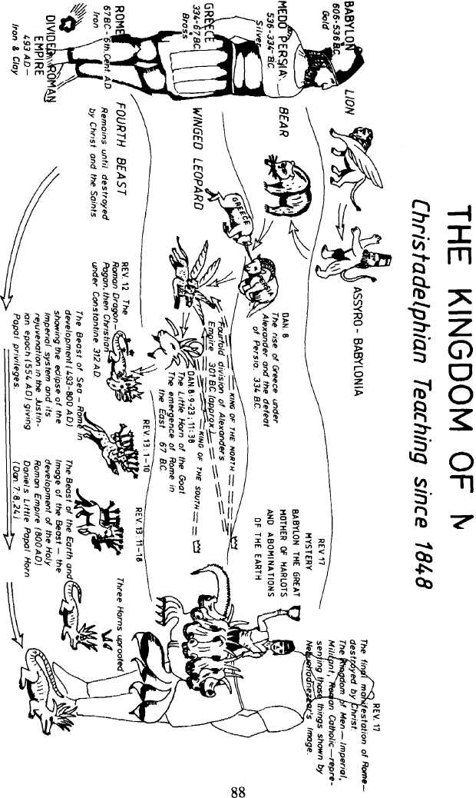

"God maketh known to the King Nebuchadnezzar what shall be in the LATTER DAYS"

The fact that God guides the destiny of nations is illustrated in this chapter. Heathen might is judged and found to be subject to God's will. Human glory is shown to be as a passing shadow. Though Nebuchadnezzar imagined himself to be able to decide his own destiny, he is made to realise that he is but an instrument in the hand of Yahweh.

It is the first of three incidents proving Yahweh to be all wise (Daniel 2:47), all powerful (Daniel 3:28-29) and supreme (Daniel 4:37).
THE KING'S TEST. Daniel 2:1-9.
God, through a dream, revealed to Nebuchadnezzar "what should be in the latter days" (v.28). The dream left the king in a state of shock. He was agitated and disturbed and called upon his magicians, astrologers and sorcerers to help. He not only wanted them to tell him the meaning of the dream, but the dream itself. The so-called wise men were thrown into a state of confusion, and pleaded for information about the dream. But the king was determined ... "I know with certainty that you are trying to gain time, because you see that the word from me is sure ..." (v.8 R.S.V.). The king threatened them with death if they failed to reveal the dream and its meaning.

Desperately the wise men pleaded with the king saying, "There is not a man upon the earth that can meet the king's demand; for no great and powerful king has asked such a thing of any magician . . ." (v.10 R.S.V.).

THE DESTRUCTION OF THE WISE MEN DECREED. Daniel 2:10-16.
The wise men's reaction to the King's request only enraged him more and he ordered the immediate execution of all the wise men. This involved Daniel too, for although he and his three companions had yet to finish their three years training, they were counted in the number (c.f. 1:5 with 2:1). Being absent at the time the decree was issued, they were surprised at the visit of Arioch, the chief of police or "chief of the butchers" (v.14 margin). Daniel's assurances that he would declare the dream persuaded the King to allow an extension of time, although an earlier request from the Chaldeans, the clergy of Babylon, had been refused (v.8).

THE POWER OF PRAYER. Daniel 2:17-23.
Daniel and his companions made their need a matter of prayer together (v.17). As Yahweh had blessed them in their stand against defilement (1:8-17), so too they believed that He would reveal "His secret unto His servants the prophets" (Amos 3:7). We can have the same confidence in the promise of God to hear such pleas (Matthew 7:7), and to grant wisdom (Psalm 25:14; James 1:5). They prayed that they might "not perish with the rest of the wise men" (v.18), and in so doing reacted in a similar fashion to Abraham, who pleaded the cause of Lot "be it far from thee to slay the righteous with the wicked: shall not the Judge of all the earth do right?" (Genesis 18:25).

Again through a dream (v.19) God revealed to Daniel the King's dream and it's interpretation. Immediately Daniel responded in praise, not because his life would no longer be in jeopardy, but to extol the wonderful name of Yahweh, His wisdom and power in controlling the destiny of the Kingdom of Men.

Daniel felt a deep sense of gratitude at the revealed purpose of God. He had revealed Himself as He did to the patriarchs in former days. Daniel called Him the "God of my Fathers" and thanked Him. Let us be similarly appreciative of the scriptures and the power of prayer in our lives.

DANIEL BEFORE THE KING. Daniel 2:24-31.
Hastily Daniel was brought before the king, but before describing the dream and its meaning, Daniel was careful to call Nebuchadnezzar's attention to the fact that "there is a God in heaven that revealeth secrets" and that it was this God Who had revealed unto him the dream and its meaning (v.28).

Daniel therefore confidently explained the dream — what a contrast to the ignorance of the king's advisers.

THE DREAM. Daniel 2:21-35.
Daniel described the object of the dream as a colossal statue of awesome majestic appearance. It was composed of different metals — the head was of gold, the chest and arms of silver, the belly and thighs of brass, the legs of iron and its feet partly iron and partly clay. An unhewn stone, cut out of rock "without hands", i.e. without human hands, struck the image at its feet, causing it to collapse. The metals were broken together and reduced to dust by the stone which then grew into a great mountain and filled the whole earth.

THE INTERPRETATION. Daniel 2:36-45.
1. THE HEAD OF GOLD — THE BABYLONIAN EMPIRE
Although Nebuchadnezzar vainly imagined that he personally was responsible for his power, Daniel revealed to him that "the God of heaven hath given thee a kingdom, power, strength and glory" (v.37,21). God had made him a ruler over all nations (v.38; Jeremiah 27:4-5), and as he represented that golden city (Isaiah 13:19, 14:4), he was appropriately described as the "head of gold".

2. THE BREAST AND ARMS OF SILVER - THE PERSIAN EMPIRE
Babylon was taken by Darius, the Mede, together with Cyrus, the Persian, in the year 539 B.C. The river Euphrates was diverted and the forces of Darius entered up the river bed through the city and Babylon fell (chapter 5; Isaiah 45:1-3). Thus the Babylonian dynasty was succeeded by "the breast and arms of silver", the inferior Kingdom of the Medes and Persians. It's glory was inferior to the Babylonian empire, but it lasted some 200 years. This was largely due to the blessing of Israel by its founder, Cyrus (Ezra 1:1-4; 2 Chronicles 36:22-23).

3. THE BELLY AND THIGHS OF BRASS - THE GRECIAN EMPIRE
The Medo-Persian dynasty was in turn succeeded by "another third Kingdom of brass, which bore rule over all the earth" (v.39). The "belly and thighs of brass" answer to the Grecian empire. In two decisive battles, of Granicus and Issus in B.C. 334 and 333, Alexander the Great of Greece overthrew the power of Persia and rapidly extended his dominion. After the sudden death of Alexander, four generals of his army divided up his empire.

4. THE LEGS OF IRON - THE ROMAN EMPIRE
Gradually Rome rose to the ascendancy, as "strong as iron; forasmuch as iron breaketh in pieces and subdueth all things; and as iron that breaketh all these shall' it break in pieces and consume" (v.40). The Roman legions brought Europe, Britain, Spain and the Mesopotamian countries under their heel. In A.D. 70 Jerusalem "fell by the edge of the sword" (Luke 21:24; Deuteronomy 28:48-57). But one beneficial effect of imperial Rome was the building of roads into Asia and Europe, enabling the extension of the gospel in the name of the risen Christ. The then-known world was turned "upside down" by the power of this message (Acts 17:6), leaving an imprint upon mankind far greater than the power of Rome.

It is interesting to note that no world empire conquered Rome. The Empire disintegrated: it became divided into 10 small nations. These 10 nations became the foundations of the nations of Europe today which are represented by the ten toes of the image's feet. The feet were part of iron and part of clay, indicating that some nations would be powerful and some weak. As iron and clay do not mix together, or "cleave one to another" (v.43), nor does the divided state of Europe with strong nationalistic feelings amongst the European countries preventing total unity of government.

5. THE LITTLE STONE — THE KINGDOM OF GOD
Nebuchadnezzar had seen in his dream the image standing up in all its power and glory, only to be broken to pieces by the little stone. Daniel said this would take place "in the latter days" (v.28). In the latter days all the nations represented by the different metals would be welded into one "great power under the control of one autocratic power, namely Russia. This power will gain control over all the territories previously known as the Babylonian, Persian, Grecian and Roman Empires. This mighty confederacy of nations under the control of Russia, will cause fear in the hearts of all who might oppose its power. Prophecies such as contained in Ezekiel 38, Daniel 11, Joel 3, Zechariah 14, together with Daniel 2, show us clearly that it is God's purpose to overthrow this kingdom of men by destroying the Russian confederacy.

This fearsome Colossus will seem to dominate the world, unable to be conquered. But despite its lion-like power, its bear-like fierceness, its leopard-like swiftness and its ruthless ambition for world domination, it will totter and fall to ruin at the hand of the stone power. He shall come to his end. He shall be broken "by no human hand" (Daniel 8:25 R.S.V.).

Who is the stone-power? None other than the Lord Jesus Christ (Matt. 21:42-44). Note carefully Daniel 2:44 where the interpretation is given.

In the king's dream it must have seemed impossible to Nebuchadnezzar that a little stone could destroy such a mighty image. Men today do not realise the mighty power of God, and that He will bring about vast changes in the very near future. So it will be that "the God of heaven will set up a kingdom which shall never be destroyed . . . and it shall stand for ever" (v.44). We can certainly look forward to the time when God's Kingdom will be established upon this earth and all nations will come to Jerusalem to worship Christ as the King. "The dream is certain and the interpretation thereof sure" (v.45)!

LESSON FOR US:
As Daniel concluded, "the dream is certain, and the interpretation thereof sure" (v.45). Let us acknowledge with Nebuchadnezzar that, of a truth it is, that our God is a God of gods, and a Lord of Kings, and a revealer of secrets (v.47). Daniel chapter 2 is a typical example of God giving us a key to the understanding of His purpose. We are living in the closing days of the Gentiles, when current events vividly demonstrate the accuracy of the prophetic Word.

History and the twentieth century confirm to us that "the Most High rules in the Kingdom of Men" (Daniel 4:17), assuring us that He will soon bring to an end the times of the Gentiles with the dramatic advent of His Son. Our participation in the extension of the Kingdom is invited. Let us diligently prepare now for the time when "the kingdom and dominion and the greatness of the kingdom under the whole heaven, shall be given to the people of the saints of the Most High, whose Kingdom is an everlasting kingdom, and all dominions shall serve and obey Him" (Daniel 7:27).

REFERENCE LIBRARY:
"The Story of the Bible" (H.P. Mansfield)—Vol. 6, No. 10, pages 148-154.
"Exposition of Daniel" (J. Thomas)—Sections 1-2.
"Elpis Israel" (J. Thomas)—Part third, Ch. 1.
"Daniel" (M. Stewart).

PARAGRAPH QUESTION:
- Describe Nebuchadnezzar's dream?
- Briefly outline the meaning of Nebuchadnezzar's dream?
- Who is the "stone" of the dream and what is his work?
ESSAY QUESTIONS:
- Describe fully Nebuchadnezzar's dream, how it was interpreted and what it means.
- Who is the "stone" of Nebuchadnezzar's dream, what is his work and when will all these things be fulfilled?
