203. BELIEF IN THE MESSIAH AT SAMARIA
"We have heard him ourselves, and know that this is indeed the Christ, the Saviour of the world"

For a short period after his meeting with Nicodemus, Jesus was preaching and baptising in Judea. Jesus knew that the hateful Pharisees had heard of his success. Because of their opposition to him he left Judea and turned northward to Galilee. He could either go through hostile Samaritan territory, a direct route, or cross Jordan and go along the eastern side of the river, normally a safe but less direct route. He chose to travel via Samaria.

Our lesson covers the events occurring because of this decision to go through Samaria — we trace the conversation between Jesus and the woman of Samaria, leading up to the belief in the Messiah by many Samaritans. The lesson teaches us that God accepts anybody who approaches Him in spirit and in truth.

John 4:1-42

THE SAMARITANS.
The Samaritans were descendants of the people sent back into Israel by the Assyrians after they had taken the ten tribes into captivity about 750 years B.C. (refer stage 3 notes, lesson 14). The remaining Jews intermarried with foreigners and the true worship of Yahweh became mixed with the worship of pagan gods and became a corrupt version of the truth. A temple was built on Mount Gerizim in the region of Samaria and thus began a long argument as to whether Jewish or Samaritan worship was right. Great hostility existed between the two groups, although the Samaritans claimed to be kinsmen with the Jews. They claimed descent from Joseph, the son of Jacob, through Ephraim and Manasseh. It was with a Samaritan woman, one whom, according to Jewish traditions, he should have hated and despised, that Jesus spoke.

JACOB'S WELL.
Jacob's well lay in the valley between the mountains of Ebal and Gerizim at Sychar, near Shechem. The well had been dug by Jacob in a parcel of land bought from an inhabitant of the region but which was quite likely the site of Abraham's encampment (see Gen. 33:18-20; Acts 7:16). It was 40 metres deep and the water bubbled, i.e., it was 'living' water. When we look at the history of God's dealings with his people at Shechem we find emphasised the worship of God, the covenants of promise, and the cleansing of works of evil. Salvation through Christ was to be taught here against this remarkable background,

AN UNUSUAL CONVERSATION (Jn. 4:7-20).
Jesus and the disciples were travelling northward through Samaria. Thirsty and tired, Jesus rested at the well while his disciples went to buy food nearby. He did indeed feel the physical weaknesses that all men feel. While he "sat thus on the well" a Samaritan woman approached with her waterpot. Deliberately Jesus asked for a drink. According to Jewish tradition he should have overlooked her presence completely, but he saw here, a grand opportunity to spread the Gospel net.

The woman had recognised Jesus as a Jew and therefore she answered with some surprise, "How is it that thou, being a Jew, askest drink of me, which am a woman of Samaria? for the Jews have no dealings with the Samaritans" (v.9). He did not rebuke her but encouragingly told her that had she known him, and asked of him, HE would have given HER "living water". Now "living" water was the usual description for "running" or "bubbling" water, and a spring was sometimes called a "a gift of God". Naturally the woman took Jesus literally. This unexpected reply puzzled her for she did not understand that Jesus was talking of eternal life.

Responding to Jesus' reply the woman respectfully said, "Sir, you have nothing to draw with, and the well is deep, where do you get that living water? Are you greater than our father Jacob . . .?" He continued by comparing the natural water with the true water of life which he could give, "Whosoever drinketh of the water that I shall give him shall never thirst; but the water that I shall give him shall be in him a well of water springing up into everlasting life". But because her mind was still thinking about natural water and not the spring of eternal life, she saw the obvious gain of the gift that the stranger said he could give. She now became the one asking for a drink. Eagerly she asked.

At this point Jesus had turned the conversation. She was humble and interested. However, the woman did not yet know who he was and what were his powers. Jesus then made a perfectly reasonable request "Go, call thy husband, and come hither", as if he wanted him to share in the gift too. She answered that she had no husband and Jesus by revealing the secrets of her private life, brought her to realise that he was a prophet, not just a mere stranger who talked in riddles. She was not yet at the stage of understanding that Jesus was the prophet greater than Moses (Deut. 18:15-18). She hastily left the subject of her immoral life and seized this opportunity to find a solution to the great question of whether Mt. Gerizim or Jerusalem was the correct place to worship.

TRUE WORSHIP OF GOD (Jn. 4:21-25).
In his answer, Jesus made several things quite plain. These things are important to us, too. He said:

- destruction will come on Gerizim and Jerusalem and so prevent worship in either of these two places (this happened about 40 years later);
- salvation comes from the Jews, through the Hope of Israel, but ...
  - "TRUE worshippers shall worship the Father IN SPIRIT and IN TRUTH", i.e., intelligently and sincerely, with the correct beliefs and not with great external display (cp. Josh 24:14 — these words were spoken in almost the same place as Jesus was then standing), neither in confusion as had the Samaritans.
  - The Father seeks true worshippers to worship Him, (cp. Isa. 66:1-2). God wants Jews and Samaritans to reverently serve Him in mind and deed.
  - God is spirit, i.e., He is an intelligent being and not a lifeless idol. To a certain extent, Jesus' reply made the woman realise her responsibility to God. No doubt she felt in the power of his answer that the Samaritans were wrong. She in effect admitted this when she hastened to add that the Messiah would teach the Samaritans the truth when he
came.

THE BELIEF IN THE MESSIAH AT SAMARIA (Jn. 4:26-35).
Then came the great revelation from Jesus, "I that speak unto thee am he (the Messiah)". To a Samaritan woman he had made the first public announcement of his Messiahship.

Leaving her waterpot, the woman hurried back to the city to call her neighbours. Meanwhile Jesus explained to the disciples, who had just returned, that he had a great and joyful work of conversion of men's hearts in the city of Sychar. With his eye of faith he could see many Samaritans repenting, for the woman was spreading the message that the Messiah was outside the city, and they were coming to see him. What an amazing response the people showed. What a contrast to the Jews who had opposed Jesus prior to his leaving Judea. Many Samaritans believed because of the words Jesus spake to them. Seeking the water of life they asked him to remain. For another two days Jesus showed them the "gift of God". Indeed the harvest in this place was great.

LESSON FOR US.
Jesus spoke of "living water". To those who spiritually thirst Jesus can give this water. It is the word of God and this can lead people to eternal life (Jn. 5:39; 17:3). The prophet Isaiah used similar language when he said "Ho, everyone that thirsteth, come ye to the waters, . . . incline your ear and come to me; hear and your soul shall live; ..." (Isa. 55:1-3).

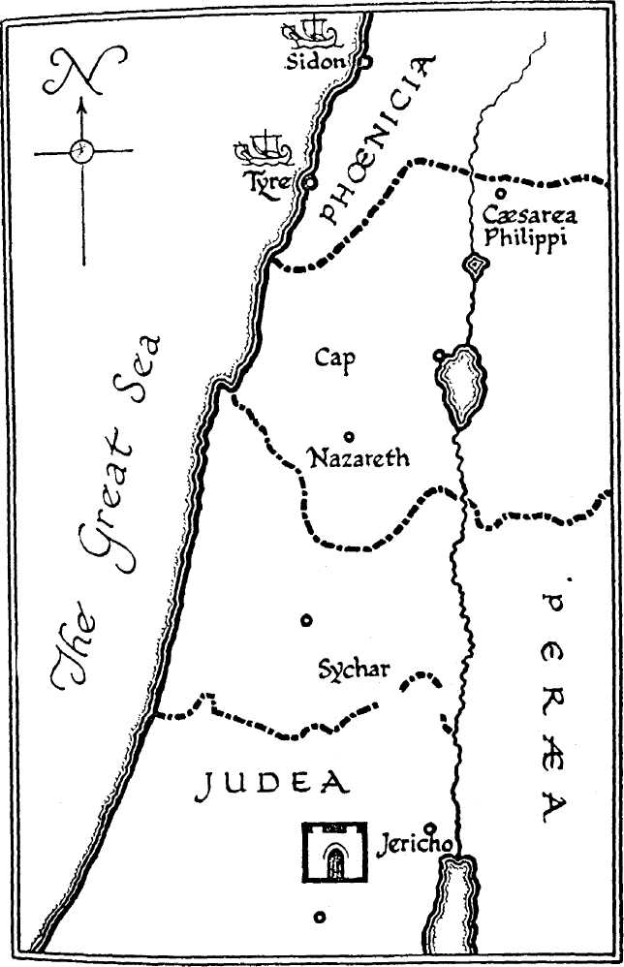

But certain requirements are made of those who come to God. They must worship Him in the correct manner. This applies to us too. God seeks our repentance and then a worshipping of Him in sincerity, holiness, truth and spirit. This means that we should learn early to give our lives to God, believing the Truth and not trying to put on a show of serving God. If we believe that Jesus truly is "the Saviour of the World", then God has promised us eternal life, the highest honour possible for any man or woman.
D8CAPOL1S

REFERENCE LIBRARY:
"The Gospel of John" (J. Carter)—Chapter 4.
"Story of the Bible" (H. P. Mansfield)—Vol. 8, pages 118-127.
"A Life of Jesus" (M. Purkis)—pages 76-80.
"Nazareth Revisited" (R. Roberts)—Chapter 14.

PARAGRAPH QUESTIONS:
- Who were the Samaritans and what did they believe?
- What did Jesus tell the Samaritan woman about true worship?
- How did Jesus show to the woman of Samaria that he was a prophet?

ESSAY QUESTIONS:
- Describe the conversation that Jesus had with the woman, of Samaria at Jacob's well.
- What did Jesus say about the dispute that existed between the Jews and the Samaritans on the question of true worship?

