308. DIVISION IN THE KINGDOM
"So Israel rebelled against the house of David unto this day"

Solomon's sin was to bring great suffering to the nation. His folly led to division and enmity which will only be healed when Jesus Christ returns (Ezek 37:22). This was brought about by a man who left an indelible mark of evil in Israel's history and became known as the man "who made Israel to sin" (1 Kgs. 14:16). His name was Jeroboam.
The aim of this lesson is to see the great tragedies which occur when God is forsaken in the hearts and minds of men.

1 Kings 11:26-43; 12

THE MAN JEROBOAM (1 Kings 11:26-28).
Jeroboam was a man of considerable ability and intiative. While he was still young, Solomon recognised his value and put him in charge of workers from Ephraim repairing the fortifications around Jerusalem. The words of Proverbs 22:29 applied to him: "Seest thou a man diligent in his business? He shall stand before kings; he shall not stand before mean men". In fact, Jeroboam was destined to become a king himself.

THE PROPHECY OF AHIJAH (1 Kings 11:29-40).
The prophet Ahijah was instructed by God to meet Jeroboam on his way from Jerusalem. Ahijah was wearing a new garment and as he met him, Alijah tore the cloak in twelve pieces, indicating God's intention to divide the nation. Ten of these he gave to Jeroboam while he retained two. He told Jeroboam that this act was symbolic of what God was about to do to Israel. The twelve pieces were the twelve tribes, ten of which God was going to rend out of the hand of Solomon while one tribe (in addition to Solomon's own tribe of Judah) would be retained on account of the promise to David and the sanctity of Jerusalem which was situated on the border with Benjamin (vv. 31-32, 36). The reason for such a judgment was carefully spelled out for Jeroboam's instruction: "Because that they have forsaken me and have worshipped Ashtaroth... and have not walked in my ways" (v.33). More directly still, he was told that if he hearkened to God's commandments, then a "sure house" would be built for him.
Jeroboam was greatly pleased with these words, for he was ambitious and sought power. But the message was potentially dangerous. If Solomon should find out, then his life would be in jeopardy. But instead of keeping the words to himself, Jeroboam foolishly told others Solomon already had good cause for suspicion and vigilance, for Yahweh told him that he would raise up one who would divide the kingdom following his death (1 Kgs. 11:11-13). When the message of Ahijah's prophecy reached him, he therefore wasted not a moment in ascertaining the identity of the rival. "Solomon sought therefore to kill Jeroboam. And Jeroboam arose, and fled into Egypt unto Shishak king of Egypt, and was in Egypt until the death of Solomon".

THE CONFERENCE AT SHECHEM (1 Kings 12:1-5).
Solomon died after he had reigned forty years. His son Rehoboam, whose mother was an Ammonitess, succeeded him upon the throne (1 Kgs. 11:42; 14:21; cp. Deut. 23:3). The public coronation of the young monarch was to take place at Shechem and all the people had assembled for the occasion.
But the elders of Israel meanwhile had called Jeroboam from Egypt upon Solomon's death. Jeroboam was no doubt anxious to bring about the fulfilment of the promise of Ahijah to him. But how would it come about?

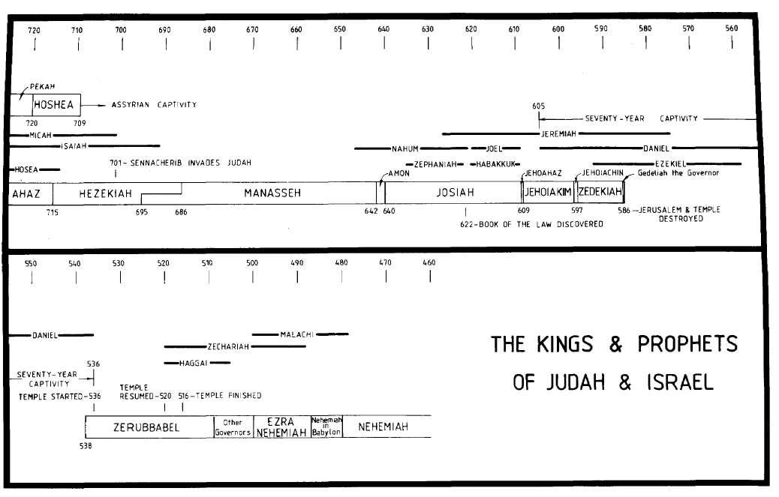
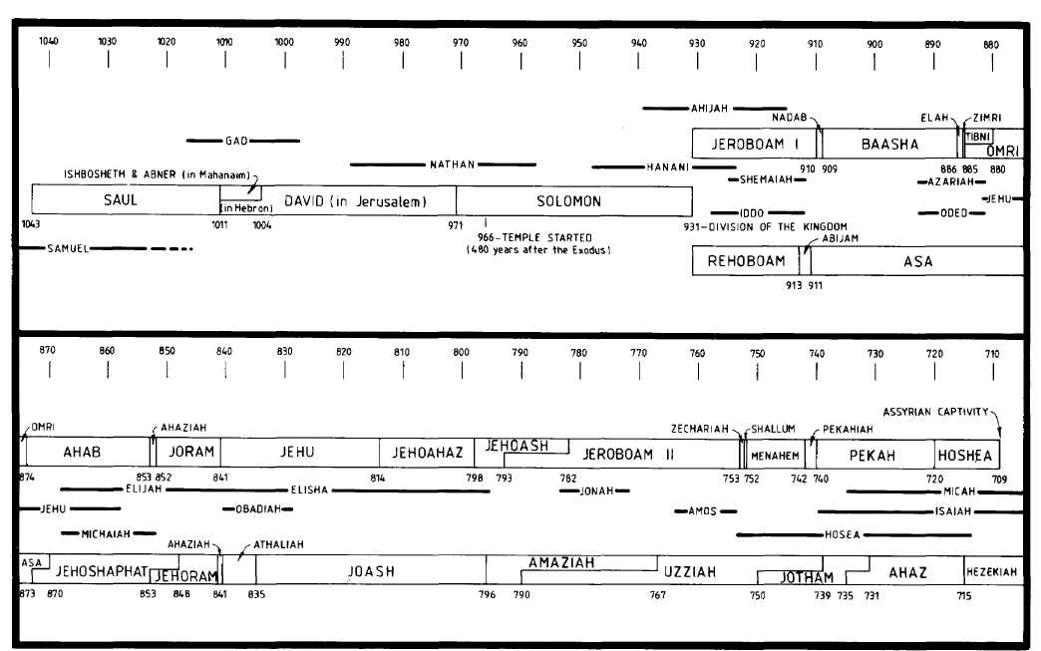
There were two issues which Jeroboam seized upon and was able to cunningly exploit to his own end.

- There had always been jealousy and rivalry between the northern ten tribes and the south (v.16; cp. 2 Sam. 19:41-43).
- The people were grieved because of the heavy burden of taxes they had to pay in order to maintain Solomon's public works.

Jeroboam combined both factors and agreed to represent the people's case. Time and opportunity played into his skilful hands. By the time Rehoboam arrived a tense explosive atmosphere prevailed. Jeroboam headed the deputation and the request was made, "Thy father made our yoke grievous: now therefore make thou the grievous service of thy father, and his heavy yoke which he put upon us, lighter, and we will serve thee."
This was a reasonable demand which shows how clever Jeroboam was. If Rehoboam rejected it, then he appeared a tyrant; if he accepted it, then Jeroboam's prestige would be enhanced. Whatever happened must be to Jeroboam's advantage. Moreover, Rehoboam could not argue against the reasonableness of such a request. He could not brand Jeroboam as a disturber of the peace, or charge him with treason. In fact, Jeroboam had posed as a patriot, anxious to serve the king and the country rather than cause any trouble.

THE FOLLY OF REHOBOAM (1 Kings 12:6-15).
Rehoboam told the people to depart for three days and then to return and he would give them his answer. In that time he sought advice from the experienced counsellors of Solomon, who had witnessed his wisdom and judgment, as well as from the young men, his contemporaries, who had grown up with him. The voice of age and experience counselled moderation: "Speak good words to them, then they will be thy servants forever" (v.7). They knew how important it was for the young new king to gain the favour of his subjects, and they were more aware of the mood of the people, the ambitions of Jeroboam, and the dangers of the situation. They urged Rehoboam to accept the conditions set before him.
But Rehoboam forsook their counsel. Perhaps he had made up his mind beforehand. Perhaps the very presence of his known rival, Jeroboam, hardened him against compromise. So he went to the young men. They were impetuous, short-sighted and aggressive. In their view taxation should be sharply increased. To give way to the demands of the people, they argued, would be an evidence of weakness.
For three days the people were kept in suspense. The king in his inexperience placed before them the suggestions of the young men: "My little finger shall be thicker than my father's loins... I will add to your burdens... I will chastise you with scorpions". He made them feel the power of his position, and roughly announced that their suffering would be increased. This confirmed the fears of the people: it was the last act of tyranny as far as they were concerned. The result was rebellion.
In retrospect the folly of Rehoboam is transparent to all. Yet, without at all seeking to excuse Rehoboam, the record does add that the turn of affairs had been brought about by Yahweh so that the words of Ahijah would be fulfilled (v.15 R.S.V.).

THE KINGDOM DIVIDED (1 Kings 12:16-24).
When all the people saw that their request had been repulsed, they were enraged. "What portion have we in David?... to your tents, O Israel: now see to thine own house, David". This was the language of division. Jeroboam sensed that his plans were bearing fruit. The foolish answer of Rehoboam had incited rebellion. Rehoboam sought desperately to quell the revolt. He sent Adoram to speak with the people. He could hardly have made a worse move — Adoram was in charge of taxation, and his presence incensed the people more! They took up stones and stoned him to death. Rehoboam fled to Jerusalem for his life and meditated revenge. He gathered together a large army to crush the revolt, but was forbidden by Shemaiah, the prophet, to proceed with his plans, for what had happened was of God.
Jeroboam was elected king by the will of all Israel. Now division was cemented and Israel was divided into two nations. Because of iniquity, Saul, the first king, had the kingdom taken away from his family and given to David. David proved himself worthy and was promised a sure "house" (2 Sam. 7:11-16, 26). Now David's son was unworthy and the kingdom might have been taken away, as it was from Saul, if it were not for the unqualified promise of God's mercy: "But my mercy shall not depart from him as I took it from Saul whom I put away before thee" (2 Sam. 7:15). Thus two tribes were left with the seed of David. Not until the return of Christ will the twelve tribes be united again (Matt. 19:28; Lk. 1:32-33; Ezek. 37:22).

JEROBOAM'S FEAR AND APOSTASY (1 Kings 12:25-33).
Jeroboam could have profited by the mistakes of Solomon and Rehoboam. He could have consolidated his position and maintained favour with God. But the maintenance of his own authority was more important to him than maintaining the authority of the Word of God. He realised that though Israel was now divided politically into two kingdoms, the worship of Yahweh, centred in Jerusalem, would provide a unifying influence which would prove stronger than the forces driving them apart. The Law required that all males should appear before Yahweh three times a year (Ex. 23:17). Surely this would result in his influence waning while Rehoboam's position would be enhanced, he reasoned.
"If this people go up to do sacrifice in the house of Yahweh in Jerusalem, then will the heart of this people turn again unto their lord, even unto Rehoboam king of Judah, and they shall go again to Rehoboam king of Judah" (v.27).
How was he going to handle this situation? His solution reveals his cunning and unscrupulous ways. Under religious pretence, he perverted the truth in such a way that many failed to perceive the gross evil of his deceptive mixture of good and evil. He did three things:

- Vv.28-30: He denied a fundamental doctrine and made two golden calves which he placed in the north and south, at Dan and Bethel (cp. Ex. 20:3-4; 32:7-8). He argued that it was too far to go up to Jerusalem and in any case God was everywhere present (Josephus).
- V.31: He did not deny the need for a priesthood, but he changed their qualifications: instead of being drawn exclusively from the sons of Aaron, he made priests of the humble, common class (Num. 3:10).
- Vv.32-33: He did not deny the need for feasts, but he changed the day; whereas the feast of Tabernacles was appointed to commence on the fifteenth day of the seventh month, Jeroboam's feast began on the fifteenth day of the eighth month.

Thus his religion became a worship of the will of man. But God requires man to worship Him in the way He lays down; they that "worship him must worship him in spirit and in truth" (Jn. 4:24). All else is superstition.
For his sins Jeroboam became a marked man in Israel. All of the twenty-three kings that came after followed his ways. Of them all, except the last, the words recur: "He walked in all the way of Jeroboam the son of Nebat, and in his sin wherewith he made Israel to sin..." The calves of Bethel and Dan became a snare to the ten tribes and were the root of the sins that finally brought captivity (cp. 2 Kgs. 17:21-23; Hos. 10:5-6). As far as Jeroboam himself was concerned, God declared His intention to utterly destroy his house (1 Kgs. 14:7-16). So the age of gold and glory under David and Solomon descended to an age of division and apostasy.
Apostasy from the Truth inevitably bring disaster to mens lives The greatness and glory of Solomon's reign melted away through his departure from God's commandments.

- As God is just and equal in all His ways, so we ought to be just in our dealings with men. Rehoboam answered his people in a way which caught the words of his grandfather David: "He that ruleth over men must be just, ruling in the fear of God (2 Sam. 23.3).
- We ought to value the voice of experience among us. Rehoboam listened instead to the young and inexperienced and thereby lost most of his kingdom.
- A bad example lives long in the minds of mankind. Jeroboam introduced false worship, causing Israel to sin, and twenty-three subsequent kings walked in the same way.
- Jeroboam's religion had elements of true worship in having central places of worship, priests and feasts, but each was a deviation from what God required and He rejected it. God will not be mocked. In our worship we must uphold God's commands and His standards.

REFERENCE LIBRARY:
"The Story of the Bible" (H.P. Mansfield)—Vol. 4, No. 11
"The Ways of Providence" (R. Roberts)—Chapter 19
"The Visible Hand of God" (R. Roberts)—Chapter 25

PARAGRAPH QUESTIONS:
- Why was the kingdom divided and why were two tribes given to Rehoboam?
- How was Jeroboam told that the kingdom would be divided and he would be king?
- Briefly state the request which the people made to Rehoboam at Shechem. What advice did he receive and how did he answer the people? What lesson do we learn from this incident?

ESSAY QUESTIONS:
- Explain the causes and results of the failings of both Rehoboam and Jeroboam.
- Describe how the division of the kingdom occurred after Solomon's death.

How and why did Jeroboam introduce a false worship into Israel and what was the effect on the kings who followed him? What are the main lessons for us from this?

