318. THE KINGDOM OVERTHROWN
"I will overturn, overturn, overturn it; and it shall be no more, until he come whose right it is; and I will give it him"

The untimely death of Judah's dedicated reformer, Josiah, paved the way for the outpouring of Yahweh's disciplinary judgments upon Judah. Their king had, by his enthusiastic stand for the Truth, restrained the impending judgments. But 120 years after the fall of Israel, Judah had also succumbed to the corruption of apostasy. They had been privileged because of the importance in Yahweh's mind of David and His covenant, of Jerusalem being the "city chosen to put His Name there", and because of the priests and Levites who attempted to strengthen the things which remained. Despite this, the four kings after Josiah were evil. They hastened the rate of spiritual decay and so the day of captivity drew near.
Our aim in this lesson is to see how the judgments decreed by God against Judah came to pass in exact accordance with the words of His prophets. The same Word has appointed destruction upon the Gentile world in the last days.

2 Kings 24 & 25

ASSYRIA FALLS, BABYLON RISES.
The Assyrian stronghold of Nineveh was caught in a pincer movement, when Cyaxeres of Media and Nabopolassar of Babylon (father of Nebuchadnezzar) attacked the city. Nineveh fell in the year B.C. 612. The Empire was divided and Media annexed the north and north east, and Babylon the south and south west. This included Syria, Palestine and Egypt. The weakened Assyrian removed the remnant of his power to north Syria at Harran.
Egypt wanted to preserve Assyria as a buffer state, and therefore went to the aid of Assyria (2 Kgs. 23:29-30 R.S.V.). As Pharaoh-Necho marched north, Josiah decided to intervene and, despite the Egyptians' warnings, attacked Egypt at Megiddo. Josiah was fatally wounded in the battle.
Thus at a time of international crisis, Judah was destitute of its dedicated reformer. This tragic loss spelt the death-knell of Judah. The prophetess Huldah had said of Josiah, "thine eyes shall not see all the evil which I will bring upon this place" (2 Kgs. 22:20); his wicked sons were to bring on themselves the impending calamities (Zeph. 1:8).

AN APOSTATE JUDEAN KING AND A REVERENTIAL BABYLONIAN MONARCH.
In the fourth and fifth years of Jehoiakim's reign Jeremiah recorded all the messages from Yahweh on a scroll, in the hope that Judah might heed the warnings of impending judgments and repent. However, their arrogant and profane king, upon hearing the reading of the scroll, slashed it in pieces and destroyed it in the fire (Jer. 36:20-26). He proudly imagined that he could oppose and belittle the judgments of Yahweh.
And yet in the same year (the fifth year of Jehoiakim corresponding to the second year of Nebuchadnezzar's reign), the Babylonian monarch, ruler of a world empire, acknowledged Yahweh as "a God of gods, and a Lord of Kings, and a revealer of secrets" (Dan. 2:47). Note the contrast — an impious, apostate king, Jehoiakim, and a humbled Emperor Nebuchadnezzar: one despising God's word and the other honouring it.
Jehoiakim's rejection of Yahweh's counsel only consolidated His determination to execute punishment upon him. Our Bibles reveal the folly of the king and nation in detail for our learning and admonition. Let us realise that "there is no wisdom, nor understanding, nor counsel against Yahweh" (Prov. 21:30; see also 1:27-30; 5:11-12; 13:13; 19:21; 29:1).
Jehoiakim paid tribute for three years, until Nebuchadnezzar suffered a setback in his attack on the Egyptians. Ever ready to turn to Egypt, Jehoiakim rashly supposed that the Babylonian power was vanquished. But Nebuchadnezzar recovered his forces and for a while was content to punish Jehoiakim with local armies (2 Kgs. 24:1, 2). Finally Nebuchadnezzar decided to put down Jehoiakim's rebelliousness himself. He bound him in chains to take him to Babylon, but then seems to have changed his mind and cast him over the walls of Jerusalem, where he perished as Jeremiah had prophesied (Jer. 22:18, 19; 36:30; 2 Chron. 36:6).

THE FOUR KINGS WHO CLIMAXED JUDAH'S WICKEDNESS.
Josiah was survived by three sons, Eliakim, aged 25 (2 Kgs. 23:36), Shallum, aged 23 (2 Kgs. 23:31; Jer. 22:11) and a younger son, Mattaniah aged 10 (2 Kgs. 24:17-18).

SHALLUM: Following the inopportune loss of Josiah, the people of Judah appointed the second son of Josiah, Shallum, as their king. They changed his name from Shallum to Jehoahaz ("Yahweh upholds"). He was looked upon as a "young lion" (Ezek. 19:3, 5), but he failed to live up to his name or to the people's expectations. Yahweh did not uphold him, for after Pharaoh-Necho's unsuccessful support for Assyria (Nabopolassar having completed the overthrow of Assyria) the Egyptians returned and placed Judah under tribute. They deposed Jehoahaz, who had reigned only three months, imprisoned him at Riblah and eventually exiled him in Egypt where he died (2 Kgs. 23:33; 2 Chron. 36:1-3; Jer. 22:12).

ELIAKIM: Josiah's eldest son, Eliakim ("El establishes") was set up by Pharaoh-Necho as a vassal-king (2 Chron. 36:4-8). The Egyptians changed his name to Jehoiakim ("Yah establishes"), but, like his predecessor, he also proved to be undeserving of his name. He was required to pay a large tribute to Egypt. To achieve this, he imposed upon the nation heavy taxation and this at a time of severe drought (Jer. 14:1). The prophet Jeremiah denounced the covetousness of Jehoiakim. He built luxurious royal apartments in difficult times and used forced labour (Jer. 22:13-19).
Far from returning to the ways of Josiah, as exhorted by the prophets, he reverted to the heathen practices of Manasseh. He was "unjust and malignant, neither holy towards God, nor forbearing towards man" writes Josephus (Ant. X, 5, 2). The rapid rate of spiritual decay only emphasised the need for the purging effects of God's wrath.
It was in the third year of Jehoiakim's eleven-year reign that Nebuchadnezzar set out to consolidate his power, especially against Egypt (Dan. 1:1; 2 Kgs. 24:1). The two mighty armies clashed at the great battle of Carchemish on the Euphrates. Nebuchadnezzar was victorious, so fulfilling the predictions of the prophet Jeremiah (46:5-11). Intent on adding to his conquests, the Babylonian marched south and seized Jerusalem. However he was suddenly interrupted in his southern campaign by the death of his father in Babylon. He hastily placed Jehoiakim under tribute, demanding that the taxation which was previously exacted for Egypt, be sent to Babylon instead. He seized some of the Temple vessels as spoils of war (2 Chron. 36:7), and took a few hostages from the royal family back to Babylon. Daniel was amongst those in the first deportation into Babylonian exile (Dan. 1:1-3).

JEHOIACHIN: The Babylonian overlords placed Jehoiachin, otherwise known as Jeconiah or Coniah (1 Chron. 3:16; Jer. 22:24-28), the 18 year old son of Jehoiakim, as the successor on the throne. His name means "Yah will establish", but his reign of three months and ten days indicated otherwise (2 Chron. 36:9; 2 Kgs. 24:8). Nebuchadnezzar changed his mind about Jehoiachin's appointment, returned and carried him, his mother and 10,000 others away as captives to Babylon. The city fell in the year 597 B.C. and, of those taken captive, many were of the wealthy, influential class. Among the captives were Ezekial and Mordecai.
Jehoiachin continued to live for many years in Babylon and received favourable treatment from the son of Nebuchadnezzar. It is interesting to note that his grandson, Zerubbabel, was one of the leaders of the return from exile (Ezra 3:2; Hag. 1:1).

ZEDEKIAH: The last king of Judah and youngest son of Josiah, Mattaniah, was set up by the Babylonians over a depleted nation. Ezekiel calls him, not a king, but a "profane wicked prince" (21:25). His name was changed to Zedekiah ("Righteousness of Yah"), as a sign of his vassalage to the Babylonians.
These last days were marked by religious apostasy and moral degeneracy (Ezek. 8-11; 22). Zedekiah, with the backing of a pro-Egyptian court, was constantly agitating against the Babylonian yoke and turning to Egypt for aid (Jer. 27). Not only was this political suicide, but it was also a flagrant violation of his oath of allegiance to Nebuchadnezzar (Ezek. 17). The full weight of Yahweh's wrath was now about to be unleashed against Judah.
Yahweh did not uphold him, for after Pharaoh-Necho's unsuccessful support for Assyria (Nabopolassar having completed the overthrow of Assyria) the Egyptians returned and placed Judah under tribute. They deposed Jehoahaz, who had reigned only three months, imprisoned him at Riblah and eventually exiled him in Egypt where he died (2 Kgs. 23:33; 2 Chron. 36:1-3; Jer. 22:12).
Zedekiah's eleven year reign came to an end when Nebuchadnezzar beseiged Jerusalem for 18 bitter months. The city, reduced to famine conditions, fell in the year 586 B.C. (2 Kgs. 24:18-25:7; 2 Chron. 36:10-21; Jer. 52:1-11). Zedekiah attempted to flee under cover of darkness but was overtaken. He was dragged before Nebuchadnezzar, and forced to watch the execution of his own sons. Then his own eyes were put out. As a wretched prisoner he was taken to Babylon along with the remnant who survived the dreadful carnage of the overthrow of Jerusalem. Only the poorest sort of people were left in the land.

"I WILL OVERTURN . . . UNTIL HE COME".
Right until the bitter end, Yahweh's mercy was evident in His sending of prophets to warn and exhort the people of Judah. His compassion was on His people and on His dwelling place. But they "mocked the messengers of God, and despised His Words, and misused His prophets, until the wrath of the Lord arose against His people, till there was no remedy" (2 Chron. 36:15, 16). Thus was fulfilled the prophecy, "Remove the diadem, and take off the crown ... I will overturn, overturn, overturn, it" (Ezek. 21:26-27).
The land enjoyed her sabbaths, even a seventy year period of rest (2 Chron. 36:21; Jer. 25:11, 12; 29:12). The throne of David would remain without a king until, as predicted in Ezekiel 21:25-27, one would come forth "whose right it is; and I will give it him". This did not eventuate in the return from captivity, for the one marked out for this honour was of a much later dispensation. He "whose right it is" had to be David's greater son and son of God (2 Sam. 7:12-14), a just ruler (2 Sam. 23:3; Isa. 11:1-15), a slain Messiah (Psa. 22; Isa. 53) and a resurrected King after the order of Melchizedek (2 Sam. 7:16; Psa. 110:1-4). In Jeremiah 23:5, 6 and 33:14-16 this great Davidic King is described as the "righteous branch" to be raised up unto David, to reign and prosper and reunite Israel and Judah under his royal name of "Yahweh our righteousness". He will be faithful to this title. Zedekiah's name also means "Righteousness of Yah", but he did not live in accordance with its meaning.
That King of course, is the Lord Jesus Christ and as promised to Mary, "He shall be great, and shall be called the Son of the Highest: and the Lord God shall give unto him the throne of his father David" (Lk. 1:31-33). He who was slain will soon return and "reign in righteousness" (Isa. 32:1). Then shall the "righteous flourish" and delight themselves in the "abundance of peace" (Psa. 72:7; 37:11).

LESSONS FOR US:
- The Gentile world in which we live is rapidly approaching the appointed day when God shall judge the world in righteousness.
- Shall we earnestly contend for the faith, as did the dauntless Jeremiah, or shall we be corrupted by the faith-destroying influences of our times?
- Shall we trust in Yahweh or shall we trust in Egypt, as did those Kings of Judah?
- We must resolve to "strengthen the things which remain" and assist those of like precious faith.
- Only then can we look beyond the storm clouds of judgment now appearing, to a participation in the kingdom when David's power is reestablished.

REFERENCE LIBRARY:
"The Story of the Bible" (H.P. Mansfield) — Vol. 6, Nos. 5-9
"Josephus" (Antiquities) — Book 10, Chapters 5-8
"The Ministry of the Prophets — Jeremiah" (C.C. Walker)
"The Book of the Prophet Ezekiel" (W.H. Boulton)

PARAGRAPH QUESTIONS:
- What is the meaning of King Zedekiah’s name? How was this made the subject of prophecy?
- Write brief notes on King Jehoiakim and his reign.
- Describe the power struggle between Egypt, Assyria and Babylon in relation to Judah at the time of her captivity.

ESSAY QUESTIONS:
- What was the consistent fault in the attitudes of the last kings of Judah?
- Briefly show how the three sons of Josiah failed to live up to their changed names.
- "I will overturn, overturn, overturn it: and it shall be no more, until he come whose right it is; and I will give it him " (Ezek. 21:25-27).
- When were these words said and to whom?
- Who is spoken of in the phrase "until he come"?
- What will he be given and what will be his role?
- Describe the attacks conducted by Babylon against Judah which culminated in the captivity in Babylon.

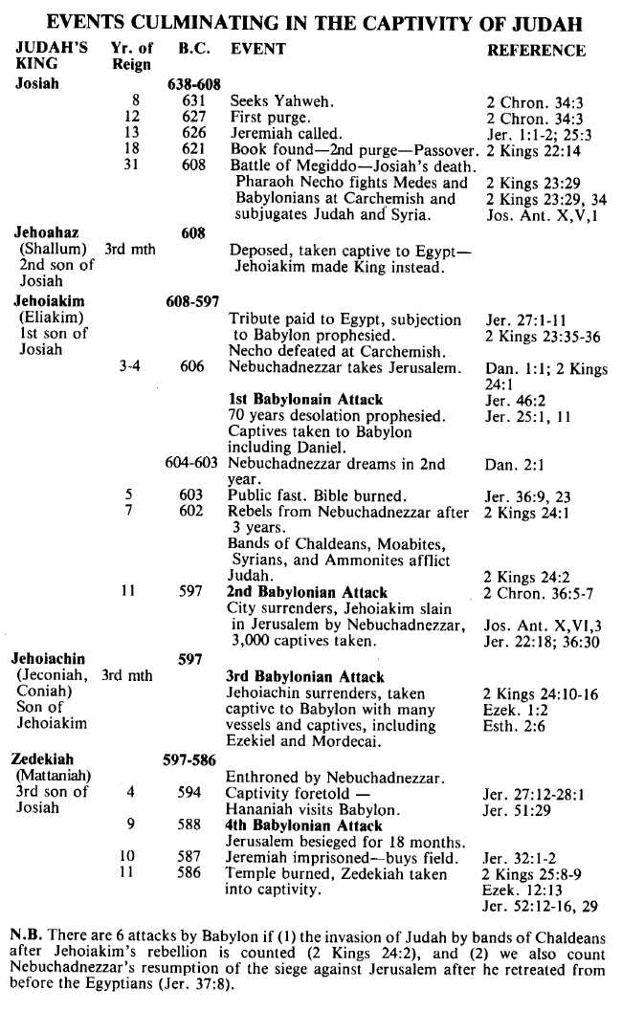
Section 3 THE EXILE AND RETURN
Punishment rested sore on the nation of Israel. Wave after wave of spoilers had swept down from the north, taking the people away from their houses, their land, their city and their Temple. Their heads were hung down and they wept as they sat by the rivers of Babylon and remembered Zion.
Yet in the midst of the deprivation of captivity, a change came over the people. Ezekiel the prophet spoke of the reasons for the captivity, the need of repentance and the glorious future ahead for the nation. Daniel's friends stood apart from the idolatry of Babylon and inspired obedience of God's commandments. Daniel himself, by his God-given wisdom and understanding, made even the great ruler of Babylon's empire confess that there is a King of Heaven Who controls the inhabitants of the earth.
Gradually the people of the captivity were turned to their God, so that, when the 70 years were completed and Cyrus the Persian gave his decree, there were thousands who rejoiced to follow Zerubabbel back to the land of their fathers to build up again the Temple of their God.
Ezra arrived on the scene, then Nehemiah, and as a backdrop there were the voices of the prophets Haggai, Zechariah and Malachi. The heroic endeavours of faithful men and women striving under difficulties to do the work of God provides a thrilling record of adventure, and a powerful example for all who, in any age, would build for the Truth.

