322. NEHEMIAH — MAN OF FAITH AND ACTION
"Let us rise up and build”

After the first return of the Jews to the Land under Joshua and Zerubbabel, there was a further restoration under Ezra the scribe. Thirteen years later Nehemiah returned to Jerusalem as Governor of the Province. The inhabitants were disorganised and despondent. It required a man of prayer, faith and action to stabilise the little state and inspire his fellow countrymen with the fear of Yahweh. Nehemiah was just such a man.

Our aim in this lesson is to see how Nehemiah's great faith and sense of purpose inspired his brethren and enabled him to overcome the many and varied problems which confronted him.

Nehemiah 1 & 2

BAD NEWS FROM JUDEA (Nehemiah 1).
Nehemiah held the honoured position of cupbearer to Artaxerxes, the King of Persia. His brother, Hanani, and others, had just come back from Judea and he asked how the new state was faring. It was his first question. Though he worked in Shushan the palace his heart was in Jerusalem. He was deeply grieved by the report, "The remnant that are left of the captivity there in the province are in great affliction and reproach: the wall of Jerusalem also is broken down, and the gates thereof are burned with fire" (1:3).

PROBLEM 1: HOW COULD NEHEMIAH OBTAIN LEAVE AND JOURNEY TO JERUSALEM TO HELP HIS PEOPLE?
Answer: That he should have contemplated so great a task is a mark of the greatness of Nehemiah's character, for he was comfortable and well off in the palace of Persia. There was little he could do physically and so he turned to the Father. He "wept and mourned certain days, and fasted, and prayed before the God of Heaven". Here was sincerity. The prayer he uttered reveals a mind disciplined by the fear of God and vibrant with the hope of Israel. Captivity had only served to ignite and strengthen his zeal. He addresses God in terms of His covenant mercy (v.5), pleads for His attention, and acknowledges His righteousness and the nation's guilt (vv.6-7). He then appeals to the promises of the past which guaranteed restoration upon reform (vv.8-9).

The prayer is tinctured with citations from the Pentateuch, showing how closely Nehemiah had kept the Word in his mind. Note the cross references in the margin and see how many direct allusions you can find. Next, he appeals to the Fatherhood of God in the birth of the nation (v.10). He concludes with a moving plea for an answer to his desires. Implicit in his prayer was his willingness to go back and serve. But the great obstacle was his employment and so he prayed, "grant me mercy in the sight of this man", i.e. the king.
Four long months went by (cf. 1:1, 2:1) and there had been no response. The king noticed his sad countenance, for normally he was cheerful. Nehemiah was "very sore afraid" that the king should thus rebuke him. Opportunity was nevertheless provided to explain, "... why should not my countenance be sad, when the city, the place of my fathers' sepulchres, lieth waste?" Then the king said, "For what dost thou make request?" Nehemiah could scarcely believe his ears. Was not Yahweh answering his prayer? Ever mindful of God watching over his words and actions, he offered up a silent prayer before making his petition known to the king. He had obviously impressed the king and also, it would appear, "the queen sitting by him" (v.6). If she indeed was Esther, as the chronology of those times allows, no doubt she would have added her support for his request. So the king granted leave and sent him away with letters securing his protection and authorising him to obtain building materials of the king's forest. What an incredible response this was.

It is important to note the impact of this favourable reply upon Nehemiah. He perceived that it was of God, "And the king granted me, according to the GOOD HAND OF MY GOD upon me" (2:8). It was this assurance that impelled him upon a work fraught with opposition and difficulty, but which he did not relinquish until completed. There is a lesson in this. Most give up when they are on the point of success. With God on our side, the Truth will prosper despite reverses and opposition, until at length the "earth shall be filled with the glory of the Lord" (Num. 14:21; Isa. 50:7-8).

When Nehemiah arrived in Judea he showed to the "governors beyond the river" his letters of authority. But, alas, the Samaritans, headed by Sanballat and Tobiah, "were grieved exceedingly that there was come a man to seek the welfare of the children of Israel (2:10). Theirs was a typical display of anti-semitism which was to grow stronger as Nehemiah forged ahead with his plans. Nehemiah inspected the broken-down walls and gates by night. He had not at this stage informed the Jews what "God had put in my heart to do at Jerusalem" (2:11-16).

PROBLEM 2: HOW COULD HE AROUSE AND ENTHUSE THE DEJECTED, DISINTERESTED REMNANT FOR THE WORK OF REBUILDING?
Answer: He identified himself completely with their problems, "Ye see the distress that WE are in". He pointed out that they were the subjects of shame and that they were responsible and had a duty to remove the cause of it. Actions must replace indifference and apathy: "Come and let us build up the wall of Jerusalem that we be no more a reproach", he said (2:17). When he related the divinely controlled circumstances that enabled him to be there, and how the king had authorised him, they responded, "Let us rise up and build".

Thus the example of Nehemiah's enthusiasm inspired the people. Enthusiasm is contagious. If we show it in our discipleship, we, like
Nehemiah, will be blessed and others will be encouraged as well (cp. Phil. 1:14; Rom. 12:11).

But the zeal of the remnant of Israel aroused an unfavourable reaction in their enemies. Sanballat, Tobiah and Geshem "heard it" and laughed them to scorn and insinuated that the Jews were about to rebel against Artaxerxes (2:19).

PROBLEM 3: HOW TO COPE WITH RIDICULE? (Nehemiah 2:19, 20; 4:1-9).
Answer: Ridicule can either discourage or stiffen determination. Nehemiah was a great leader. His mind was active and constantly he meditated upon the issues, and therefore had a ready answer. Because his conviction was strong, he was able to meet this challenge with an answer which showed his determination. Thereby he silenced his enemies, but encouraged his brethren. "The God of heaven, he will prosper us; therefore we his servants will arise and build: but ye have no portion, nor right, nor memorial, in Jerusalem" (2:20).
Nehemiah 3 records the names of those who rose to the challenge and gives the portions of the wall they were responsible for building.

As the work got underway, and words became actions, the ire of their adversaries intensified. Besides mocking, Sanballat took reports of the activity back to Samaria and told his brethren and the "army of Samaria". Their disdain for the project was summarised in the words of bitter Tobiah, "Even that which they build, if a fox go up, he shall even break down their stone wall" (4:3). News of this resistance and the threat which it contained found its way back. But Nehemiah was undeterred and he countered with prayer and action. He united the people in prayer and sought that the adversary might instead be the victim of his own intentions: "Hear, O our God, for we are despised: and turn their reproach upon their own head" (4:4). The Jews were encouraged and set their minds on the work which thereby proceeded apace (4:6).

The sight of the strengthened walls again generated a conspiracy of hatred among the mixed peoples of Samaria, and this time they resolved to fight. But united prayer, coupled with the practical measures of setting a watch, ensured that the work progressed (4:5-9).

PROBLEM 4: HOW TO OVERCOME PESSIMISM BROUGHT ABOUT BY OPPRESSION AND HARD WORK? (Nehemiah 4:10-23).
Answer: The opposition and hard work began to take its toll. Those of weaker faith began to complain and they dampened the spirits of others. Complaining, like enthusiasm, is infectious. Some lost heart because all their work had made little impression on the rubbish and rubble and they were getting weary (4:10). Others had heard rumours about the enemy's plans for attack and "ten times" repeated them: "From all places where they live they will come up against us" (4:12 R.S.V.). How could Nehemiah answer this challenge — a challenge this time from within?

The first measures he took were practical. He placed families with their weapons at strategic points (4:13). Men will fight when their families are involved and so the borders are secured! Jews today follow the same idea with the Kibbutzim. Then he reminded them that the LORD, "which is great and terrible", was on their side and would fight with them. They must be more conscious of God than of men. When the enemies saw that their plans were known and thwarted they were discouraged. The people, on the other hand, returned to the task of rebuilding.

From that time onward the builders worked with their swords at their sides. Because they were spread out over a considerable distance it was not possible for the whole work to be effectively guarded. A trumpeter was with Nehemiah and when he sounded an alarm they were to come and give assistance. Thus the ecclesia was united in the work and their courageous leader was both in the midst of the work and at the forefront of attack, encouraging them. The watchword was, "our God shall fight for us" (4:20). Those who lived outside Jerusalem were asked to remain inside the city at night. Thus they provided labour by day and protection by night. So busy were they that there was no time for changing into bed clothes! All the while they were inspired by the lofty example of Nehemiah, who put into practice himself the things which he spoke to the people.

PROBLEM 5: HOW TO COPE WITH SUBTLETY AND FALSEHOOD? (Nehemiah 6:1-14).
Answer: The enemies outside had tried to bring the work to a standstill by ridicule, intimidation and violence. Failing in this they became frustrated and tried more cunning means. They sought a conference with Nehemiah, but their real intention was to harm him. They knew that he was the mainstay behind the work, and that if they could destroy him it would cease. But he quickly perceived their objectives and gave a classic answer to any who would interfere with the work of building up, "I am doing a great work, so that I cannot come down: why should the work cease, while I leave it, and come down to you?" (4:3). On four occasions they sent to Nehemiah, but each time they received the same answer.

Sanballat thought hard and then concocted a letter which he thought might finally entice Nehemiah to the conference table. He sent his servant to him with a letter saying that it was commonly reported that the wall was being built for the purposes of rebellion, and that Nehemiah was intending to appoint himself king! This could have serious consequences, so he had best come and confer with them! But Nehemiah understood their intentions and lies and told them so, "There are no such things done as thou sayest, but thou feignest them out of thine own heart".

JERUSALEM IN THE TIME OF NEHEMIAH
The family groups involved in rebuilding the walls of Jerusalem.

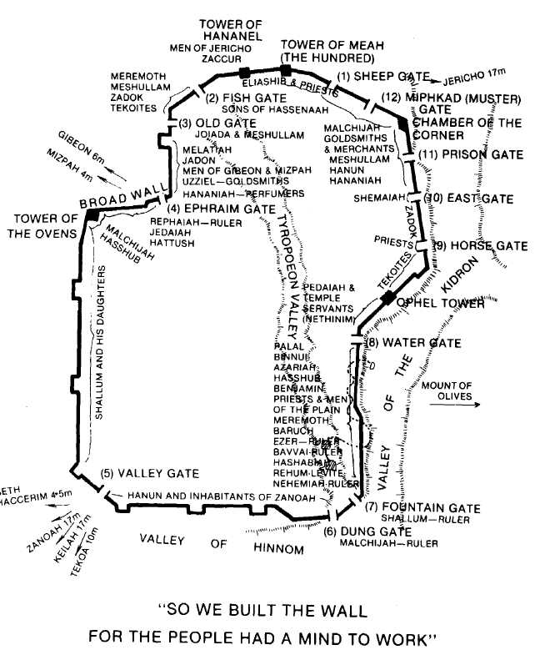
Tobiah and Sanballat then sought by cunning means to destroy Nehemiah's reputation by showing that he was fearful and afraid. They commissioned Shemaiah to meet Nehemiah in the Temple with the doors locked. He was to tell Nehemiah that they must be barred because his enemies were going to slay him in the night. Now Nehemiah had always displayed fearlessness and thereby encouraged the people. Had he yielded to this request his honour would have been soiled. Thus he replied, "Should such a man as I flee?" Thus he stood by his principles in the face of a very subtle challenge. Moreover, Shemaiah had posed as a friend and claimed to have been sent by God (6:10-14)! How important it was for Nehemiah to be perceptive — cunning as a serpent but harmless as a dove, as the Lord was later to say.

THE WALL COMPLETED (Nehemiah 6:15, 16).
Despite all attempts to the contrary, the work was completed. There is a note of triumph in the words, "So the work was finished in the twenty and fifth day of the month Elul, in fifty and two days!" (v.15). This was a remarkable feat. It was clear that God's blessing had been upon them throughout. Nehemiah made no secret of this fact and even their enemies perceived it and were disheartened. Of Nehemiah it might truly be said, "Many are the afflictions of the righteous: but the Lord delivereth him out of them all" (Psa. 34:19).

LESSONS FOR US:
- Nehemiah was sincere when he desired to return to Judah and so Yahweh answered his prayer.
- He was a great leader because he did not give up in the face of problems, but sought God and personally involved himself in the work with the people.
- He was a man of prayer AND ACTION. Actions are more sincere than words. So too today, faith must be practised as well as professed — for by our works shall we be judged.
- Enthusiasm and pessimism are contagious. We can inspire others in the Master's service only if we are keen and dedicated ourselves.
- Nehemiah was a man of quick perception. There is a need for us to be instructed in the principles of the Truth so that we can discern and reject the subtle philosophies of our day e.g. evolution, liberalism and permissiveness.

REFERENCE LIBRARY:
"The Story of the Bible" (H.P. Mansfield)—Vol. 7, Nos. 6, 7
"Nehemiah" (R. Abel) — C.S.S.S. Notes

PARAGRAPH QUESTIONS:
- Make a list of the problems Nehemiah had to overcome.
- Nehemiah prayed to God when he heard that the walls of Jerusalem were broken down and that the remnant there were in affliction. What did he say?
- Recount the incident in the palace of Artaxerxes in which Nehemiah obtained permission to return to Judea.
- List the characteristics of Nehemiah which made him a great leader.

ESSAY QUESTIONS:
- Write a character study of Nehemiah.
- Explain how Nehemiah coped with the problems which confronted him when he undertook the rebuilding of the walls of Jerusalem.
- In what ways was Nehemiah a great leader? Give examples of his leadership.
- What lessons do you learn from the example of Nehemiah?

