337. FEEDING THE MULTITUDE
"I am the Bread of Life"

Five thousand people were fed by the Lord Jesus Christ on the eastern shores of Galilee. He did not provide this food merely satisfy their hunger; there was a deeper spiritual meaning which he impressed upon his disciples and his audience: he was the bread of Life. Those who could perceive the intent of his words and accept him their saviour would at length partake of eternal life.
Our aim in this lesson is to see that only by coming to Jesus Christ and accepting his teaching can we have a hope of life when he returns.

John 6:1-14; Mark 6:31-44

COME YE YOURSELVES APART (Mk. 6:31-34). ,
Two years had passed in the ministry of the Lord Jesus and his popularity was approaching its peak. The ever-present multitude with mixed desires and needs was a constant drain upon the resources of the Master. The disciples had returned from their preaching effort and were anxious to report the wonderful things that had been accomplished (Mk. 6:12, 13, 30). At this time also news of the death of John Baptist, the Lord's great forerunner and cousin, reached him. It became evident that a respite from the crowds and excitement of events was necessary, so that Jesus could commune with his disciples and build up their spiritual perception for events still to come. "Come ye
yourselves apart into a desert place, and rest a while", he said to them. So they took ship and departed for the opposite shores of the Sea of Galilee. The multitude noted their departure however, and followed around the northern shore, until they came upon Jesus and his disciples. Others from neighbouring towns joined the multitude until
numbers had swollen to five thousand (v.33). Thus the Lord's privacy was invaded.
They had come because they were impressed by his miracles of healing (Jn. 6:2), but they were oblivious of THEIR greatest needs. The Lord was touched by their determination. He saw them "as sheep having no shepherd" (v.34), and Mark poignantly expresses his reaction: "Jesus was moved with compassion toward them". Great and pressing though his personal needs were, he showed the qualities of a true shepherd when he put his needs aside for the sake of others. There was no-one else the people could turn to, for the synagogues and Temple were presided over by men filled with self-interest and who oppressed the poor and needy.
So he began to teach them many things, providing them with that spiritual food and drink which could restore them eternally (cp. Psa. 23:2-3; Ezek. 34:23-24; Jn. 10:11; Lk. 9:11).

FEEDING THE FIVE THOUSAND (Jn. 6:5-14).
He taught and healed them hour after hour until evening was almost upon them (Lk. 9:12). They had not eaten and the disciples thought they had to do the practical thinking for their master. How wrong they were in thinking they knew better than he. They called upon the Lord to quickly dismiss the people so they could buy bread in the neighbourhood (Mk. 6:36). But the Lord was cognisant of the crisis which had developed, and he was loathe to send away people intent upon his words. He answered the disciples: "Give ye them to eat". They failed to comprehend the greatness of the Son of God in their midst, and began to calculate how much money would be necessary for them to feed so vast a throng. How far short these practical men fell in practice, even though they had so recently recounted what they had been able to do (Mk. 6:30). They reasoned that there was no way of providing bread apart from a vast expenditure, and they had so very little in their purse (Mk. 10:28).
The Lord asked how many loaves they had, and told them to go and find out (Mk. 6:38). It was Andrew who came back with the answer. "There is a lad here, which hath five barley loaves, and two small fishes; but what are they among so many?" (Jn. 6:9). The scene was now set for one of the most notable of the Lord's miracles. He directed the disciples to seat the crowd in companies of hundreds and fifties upon the green grass. As evening came on, five thousand men and women witnessed the Son of God take the loaves and fishes, look up to heaven and bless and break the loaves and give them to his waiting disciples to set before them. He also divided the two fishes and multiplied them for all to partake of. The result is summarised: "And they did all eat and were filled" (Mk. 6:42). Imagine the amazement of the assembly. When they had eaten "as much as they would", the Lord told the disciples to gather up the fragments that remain, "that nothing be lost". Twelve baskets of fragments were gathered. Such conviction was wrought in those present that they said, "This is of a truth that prophet that should come into the world" (Jn. 6:14). They were convinced that he was the great prophet whom Moses had declared would be raised up from among their brethren (Deut. 18:15-18).

THE SIGNIFICANCE OF THE SIGN (Jn. 6:30-40, 47-58).
One year later, at the time of the next Passover, Jesus again took bread and blessed, and brake it, and gave to his disciples, and said, "Take, eat: this is my body" (Mk. 14:22). He used the identical language and this provides us with the key to unlock the true significance of the feeding of the five thousand: he was teaching that by the breaking of his own body in death he would provide true bread which would sustain many unto life eternal. The same teaching underlies the Lord's supper where his death is remembered in the partaking of the bread.
As the five loaves were distributed among five thousand, so the grace of God has abounded through Christ unto a vast multitude (Rev. 7:9; Rom. 5:15). They shall be redeemed from among men and shall not hunger or thirst anymore, for the Son of God shall gather them as his sheep and shall feed them and lead them to living fountains of water (Rev. 7:16-17; 1 Pet. 2:25; 5:4).
These principles were taught to the people on the following day when they found him at the synagogue in Capernaum on the other side of the lake. Tragically they had not learned the true significance of their miracle, for they were just seeking further satisfaction of their hunger. Jesus rebuked them: "Labour not for the meat which perisheth, but for that meat which endureth unto everlasting life, which the Son of Man shall give unto you" (Jn. 6:27; cp. Isa. 55:1-3).
He identified himself as the true bread: "I am the bread of life: he that cometh to me shall never hunger; and he that believeth on me shall never thirst" (v.35). The distribution of the loaves was an enacted parable foreshadowing the giving of his flesh for the life of the world (v.51). Failure to discern him as the true bread from heaven would be fraught with dire consequences: "Except ye eat the flesh of the Son of man, and drink his blood, ye have no life in you" (v.53).

THE FRAGMENTS.
After feeding the multitude the Lord had told the disciples to gather up the fragments, "that nothing be lost". In his explanatory discourse the next day the Lord uttered words which charged this request with meaning. "And this is the Father's will which hath sent me, that of all which he hath given me I should lose nothing, but should raise it up at the last day" (v.39; cp. 17:12). The immensity of the mind of the Lord, as he performed that miracle on the shores of Galilee can now be perceived: he saw the event as pre-figuring his own death one year hence. He saw that through the provision of this bread, life would be given not only to the lost sheep of the house of Israel, but also to the Gentiles — none of the fragments must be lost — for those crumbs would provide sustenance for the Gentiles (Mk. 7:28; refer Lesson 13). In his speech he repeatedly emphasised that the True Bread would be available to "all", or "the world" (vv.33, 39, 40, 51). John's gospel lays great stress on this inclusion of the Gentiles in the hope of Israel through faith in Jesus Christ (cp. 3:15, 16; 4:23; 12:32; 20:31).
It is significant that a short while later in the same semi-Gentile territory of Decapolis he repeated the miracle, when four thousand men, besides woman and children, were present (Mk. 8:1-9; Matt. 15:38). His words and actions were almost the same — the Lord was teaching that "other sheep", the Gentiles, would yet come into the hope of Israel.
The fact that there were twelve baskets of fragments gathered up emphasises the Israelitish character of the hope. Gentiles may be saved but only by becoming the “Israel of God” through faith (Cp. Eph. 2:12; Jn. 4:22; Gal.6:16).

A GREATER THAN MOSES.
In all of Israel’s history only one event could be compared to Jesus’ miracle. By the hand of Moses God fed, not 5,000 for one day, but a whole nation in the deserts of Sinai for 40 years. The people were quick to make a comparison. Initially they declared him to be the prophet promised by Moses, and had even sought to take him by force to make him king (Jn. 6:14-15). Now when he rebuked their motive for seeking him, they required a sign from him to prove his authority, saying that Moses was vindicated by giving their fathers bread from heaven! Their slighting comparison only emphasised their own shortcomings. God had in fact given their fathers bread in the desert, not Moses; and the true analogy was not so much between Moses and Jesus, but between the manna, which was God-given, and Jesus the Son whom God sent into the world (v.39). He was the true bread because he would give life eternal (whereas the wilderness generation which ate manna were dead, v.49); and the world and not just one generation of one nation would benefit: "For the bread of God is he which cometh down from heaven, and giveth life unto the world (v.33). Truly a greater than Moses had come!

POPULARlTY WANES (Jn. 6:59-69).
The discourse was not well received by the majority of the crowd. They had come to Jesus for more food and excitement, but Jesus had instructed them and appealed to their understanding and motives when he made the statement, "Except ye eat the flesh of the Son of man and drink his blood, ye have no life in you" (Jn. 6:52, 60-61). This statement was repugnant to the Jews for the Law forbad the eating of blood (Lev. 17:10). They took him literally, and their Jewish sensitivaties were aroused. Jesus clarified his meaning: he was not referring to his literal flesh and blood, for the "flesh profits nothing” (v.63); they must take in and digest his words, purpose and teachings: “the words that I speak unto you, they are spirit and they are life. "Hear”, said Isaiah, “and your soul shall live” (55:3).
From that time forward many of his disciples left him (v.66). The pinnacle of his popularity had passed. Even among the twelve there were some misgivings. The previous night Jesus had walked on the water as they rowed across the lake towards Capernaum. He had calmed their troubled hearts with the words: "It is I; be not afraid” (Jn.6:20), but even they found it hard to believe it was Jesus, for they “considered not the miracle of the loaves, for their heart was hardened” (Mk.6:52). Twice within 24 hours they had seen the power of the Creator Now the question came from Jesus, "Will ye also go away?

Peter was quick to reply, “Lord to whom shall we go? Thou hast the words of eternal life, and we believe and are sure that thou art that Christ, the Son of the living God” (vv.68-69).

LESSONS FOR US:
- Like our Lord we must not dismiss men but draw them to the Gospel, showing kindness and compassion as good shepherds.
- Christ is the true bread from heaven; outside him death reigns, for to no-one else can we turn for "the words of eternal life".
- Only by careful study of the words of Jesus shall we see and appreciate his meaning.
- Christ's death is memorialised in the partaking of the Lord's Supper, even as the feeding of the multitude foreshadowed it.

REFERENCE LIBRARY:
"Gospel of John" (J. Carter)—Chapter 6
"The Story of the Bible" (H. P. Mansfield) -Vol. 9, Pages 113-131

PARAGRAPH QUESTIONS:
1. Why did Jesus seek to take the disciples apart into a desert place prior to the feeding of the 5,000?
- Tell why the loyalty of Jesus' followers waned when he spoke to them in the synagogue in Capernaum on the day after feeding the 5,000.
- "I am the Bread of Life", said Jesus Christ in the discourse that followed the feeding of the 5,000. Show how this thought developed out of the miracle.

ESSAY QUESTIONS:
- Recount the miracle of the feeding of the 5,000. What is the spiritual significance of this miracle?
- Why did a number of those amongst the 5,000 whom Jesus fed seek for him the next day? How did they compare him with Moses and what was his response?
- "Lord to whom shall we go? Thou hast the words of eternal life". When did Peter say these words to Jesus and what led up to them? What lesson do we learn from this incident?

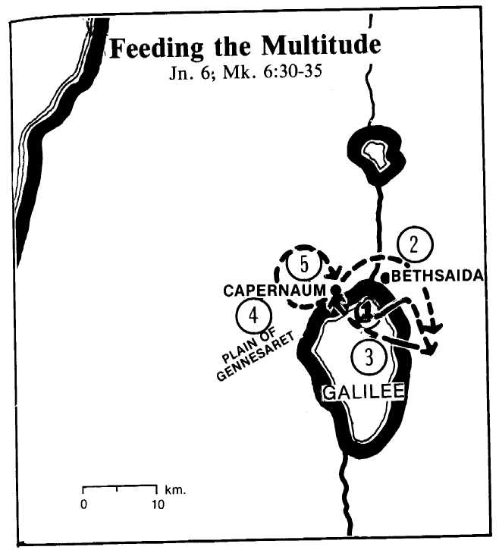
- The twelve return from their preaching effort and news of John's death reaches Jesus. Hence they decide to go across the lake to the desert near Bethsaida (Mk. 6:16, 30-31).
- The multitude follows around the top of the lake (Mk. 6:32-33).
- After the feeding of the 5,000 the twelve set out across the lake. The Lord walks to them on the water (Jn. 6:15-21). They reach Capernaum.
- The Lord heals many in the land of Gennesaret (Mk. 6:53-56).
- He delivers his speech on the bread of life in the synagogue at Capernaum (Jn. 6:59).
The incidents of Lesson 13 follow immediately.

