338. DEFILEMENT AND HYPOCRISY
"That which cometh out of the mouth, this defileth a man"

The height of the Lord's popularity had been reached in the feeding of the 5,000. Then came the turning point with his speech in Capernaum which offended many of his disciples so that they walked no more with him. In the wake of this incident the forces of opposition began to stir.
A deputation of the Scribes and Pharisees came to Jesus on the issue of defilement through failure to wash hands. Jesus rebuffed them at hypocrites, pointing out that defilement arises from a failure to wash, hearts and minds.
The rejection of Jesus by the Jews proved to be the riches of the Gentiles, for Jesus was thereby driven further north to the borders of Tyre and Sidon where he found a faithful Gentile woman. Returning to Galilee he found Gentiles who glorified the God of Israel and who in a crowd of 4,000, received bread from heaven.
The aim of this lesson is to show that human tradition can stifle the claims of God's commandments and that defilement has its source in the human heart.

Matthew 15:1-31

A CONTEST OF RELIGIONS (Matt. 15:1).
The Pharisees had developed a religion centred upon formalities. Though their way of life was founded upon the Law of Moses and the standards of moral conduct which they set were generally high (Matt. 23:3), they had nevertheless neglected the very force behind the Law — "thou shalt love the Lord thy God with all thy heart, and with all thy soul, and with all thy mind, and with all thy strength" (Mk. 12:30). They were so pre-occupied with all kinds of external rules and regulations that these had become religion itself.
To the mind of the Pharisee this approach had "advantages"; it made "religion" easier to observe, and, more importantly, it made it simpler to check up on the failings of others (as the Pharisees saw them) including the Lord Jesus Christ!
The issue was joined as Scribes and Pharisees who had been sent from Jerusalem confronted Jesus: "Why do thy disciples transgress the tradition of the elders?" It was a contest of religions in which there could be no compromise. Either the demands of God consist of obedience to external rules and regulations, with no regard to the thoughts and intents of the heart, or else they consist of obedience springing from hearts and minds centred upon Divine ideals.

THE TRADITIONS OF THE ELDERS (Matt. 15:2).
The Pharisees felt they had a water-tight case against Jesus: "Thy disciples wash not their hands when they eat bread". Jesus had just fed 5,000 in the desert (Matt. 14:20, 21). They could not have followed the Pharisees' manner of washing, namely, carefully holding their hands upwards after washing so that the whole hand might be covered to the wrist and so that the water contaminated by the washing might not run down the fingers again and pollute them.
By concentrating on such trivialities, the Pharisees had obscured the weightier issues of the Law, justice, mercy and faith (Matt. 23:23-24). They were scrupulously clean with their crockery, but were unconcerned that the food which they ate from that crockery had been obtained by craft and fraud (Mk. 7:4).

OBEDIENCE STIFLED BY TRADITION (Matt. 15:3-9).
Jesus stopped neither to justify nor apologise for his disciples. Instead he turned the issue back upon the Scribes and Pharisees: "Why do ye also transgress the commandment of God by your tradition?" There was a great contrast between "traditions of men" and "commandments of God". But not only did the traditions of men set aside the commandments of God, they over-rode them in order to satisfy men's selfish desires.
Jesus gave an illustration of how the tradition of the elders contradicted the Law of God. God commanded that father and mother be honoured in deeds as well as words, so that, in time of need, they should be helped materially. Further, the Law threatened severe punishment against those who despised or spoke with contempt against their parents — principles as applicable today as in the time of Moses (Prov. 20:20; 30:17; Eph. 6:2). Yet the tradition of the elders released a man from these obligations if he gave generously to the Temple treasury (Corban). Thus the commandment of God was nullified by the tradition of men (v.6). Jesus called the Pharisees "hypocrites", for whilst they pretended to be worshippers of God, they really put first the traditions of men.
Isaiah prophesied of such a class of people, "This people draweth nigh unto me with their mouth, and honoureth me with their lips; but their heart is far from me. But in vain do they worship me, teaching for doctrines the commandments of men" (29:13).

DEFILEMENT AND ITS SOURCE (Matt. 15:10-20).
Jesus then turned and called the wondering multitude to him, declaring, "Not that which goeth into the mouth defileth a man; but that which cometh out of the mouth, this defileth a man". The Scribes were fundamentally wrong. They reasoned that outward observances would cleanse the inner man. But Jesus set the record straight — there was little point in abstaining from unclean meats if actions are not in keeping with the principle demonstrated. The Law of God is designed to transform the heart and thereby affect the thoughts, words and deeds which issue from the heart.
But some of Jesus' disciples were not concentrating upon his teaching. They were more worried about the effect of his forthright approach. After all, the Pharisees were powerful and dangerous op-j ponents. So, perhaps with a tone of censure in their voice, they warned Jesus, "Knowest thou that the Pharisees were offended?" They wanted the Truth he spoke to be modified so as to be "respectable" in the eyes of the world. But this can never be achieved. In the final analysis it would be the Pharisee, not Jesus, who would be overthrown: "Let them alone: they be blind leaders of the blind. And if the blind lead the blind, both shall fall into the ditch."
Even the closest disciples were baffled. On returning to the house they sought enlightenment. The explanation was simple but fundamental. Whatever goes into a man from outside goes straight to the stomach, bypassing the heart. All foods then are clean, for how can they affect a man's thinking?
The source of defilement is within man himself. The human heart (which, in the Hebrew idiom, was the seat of the intellect) is prone to sin. Unenlightened by God's word, it will spontaneously produce thoughts which lead to sinful actions. Jeremiah terms it "desperately wicked" (Jer. 17:9). Man does not need an external devil to entice him to sin; his own lust causes that (James 1:14-15).
Jesus then outlined those things hidden in the heart. The heart is the source of "murders" and, furthermore the source of all thoughts which, given opportunity of development, would lead to murder. "Adultery" and "fornication" are both mentioned. Adultery involves a breach of a sacred covenant made with one's marriage partner; fornication equally involves unfaithfulness to a future marriage partner; and both are classed as a sin against God (Gen. 39:9; Psa. 51:4, cp. title). Thus all forms of sexual vice and laxity are covered. "Thefts" include robbing God as well as fellow man. "False witness" is pulling down the reputation of another. "Blasphemies" are an affront against the majesty of God.
And so the evils of the heart go on. Mark, in his parallel account, includes a much fuller list (Mk. 7:21-22). It is notable that in his catalogue of sins Jesus includes thoughts, words and deeds. Sin is then defiance of the Laws of God in thought, word or deed. A man is defiled by these things, not by eating with "unwashen hands".

THE FAITH OF A GENTILE WOMAN (Matt. 15:21-28).
The clash with the Scribes and Pharisees had a remarkable sequel. The danger which now threatened Jesus caused him to withdraw northward to the borders of Tyre and Sidon. This was a Gentile area and considered "defiled". No Pharisee or Scribe would be found there.
But to Jesus, Tyre and Sidon were no worse than Chorazin and Bethsaida (Matt. 11:21). By his actions Jesus abolished the distinction that existed between people as his words had abolished the distinction between foods.
Meanwhile a distressed Syro-Phoenician woman was pestering Jesus. Her daughter was grievously sick. Her only hope lay with Jesus. She flung herself at his feet: "Have mercy on me, O Lord, thou Son of David".
But there was no response. NO word of comfort was uttered.
"Send her away" was the advice of the impatient disciples. They echoed the thoughts of the Pharisees; she was of an unclean nation (Deut. 7:1-2).
To Jesus there was no such separation. Faith, not the accident of birth, makes a person acceptable with God. Yet her faith needed refining — she needed to appreciate her relationship to Israel: "I am not sent but unto the lost sheep of the house of Israel", Jesus said.
She persisted with a desperate plea, "Lord, help me". It was a cry for salvation, but salvation is only "of the Jews" (Jn. 4:22). "It is not meet to take the children's (Israel's) bread, and to cast it to the dogs (the Gentiles)". The woman grasped at the opportunity Jesus' words afforded: "Truth, Lord: yet the dogs eat of the crumbs which fall from their masters' table". Her words were so apt, perhaps even more than she realised. The "children" had recently refused the "bread of life" (Jn. 6). Jesus had been driven to the very border of the "table". And the "crumbs" had fallen to the Gentile woman at his feet.
Jesus was touched by her response: "O woman, great is thy faith: be it unto thee even as thou wilt". By faith and not by the works of the Law this "woman of Canaan" found acceptance in the eyes of God (cp. Eph. 2:8-9; Acts 14:27). And over the border, in a despised Gentile land, a little girl felt strength and vitality flow back into her body.

RETURN TO DECAPOLIS (Matt. 15:29-31).
From the borders of Tyre and Sidon, Jesus led his small band of disciples back to the eastern shores of Galilee, in the area of Decapolis, a part of the land dominated by the Gentiles: "Galilee of the nations", Isaiah had called it (9:1).
There on a mountain was a scene which would have disgusted the Pharisees but thrilled those who knew that discipleship depended upon the thoughts of the heart, not upon race or ritual. For on the mountain a "great multitude" of Gentiles "cast themselves down at Jesus' feet; and he healed them".
The contrast was graphic. Those in Israel who could walk, see and speak turned their backs upon Jesus: but the "lame, blind, dumb and maimed" Gentiles struggled to the top of a mountain to come to Jesus. There they worshipped "the God of Israel".

LESSONS FOR US:
- We must not view the Truth as a series of laws by which we can judge others.
- Rather the Truth must affect the motives of our hearts and find expression in words and actions in accordance with the commandments of God.
- If the heart of man is not controlled by the Law of God, it is the source of every imaginable evil.
- Outward appearance, race or colour are of no consequence in the eyes of God—the bread of life is available to all.

REFERENCE LIBRARY:
"A Life of Jesus" (M. Purkis)—Book 5, Chapters 4 and 5
"The Gospel of the Son of God" (L. G. Sargent)—Part IV, Chs. 2, 3

PARAGRAPH QUESTIONS:
- What did Jesus say about the human heart when he taught about the source of defilement?
- How was the commandment "Honour thy father and thy mother" annulled by the "tradition of the elders"?
- Upon what basis was the Canaanite woman's request to Jesus answered? What did Jesus say?

ESSAY QUESTIONS:
- In what way did the "tradition of the elders" contradict the commandments of God? Give an example.
- Jesus showed the Pharisees that their ideas concerning defilement were wrong. Explain what he taught about defilement and the source of sin.
- Describe what happened when Jesus was approached by "a woman of Canaan" when he was in the coasts of Tyre and Sidon.
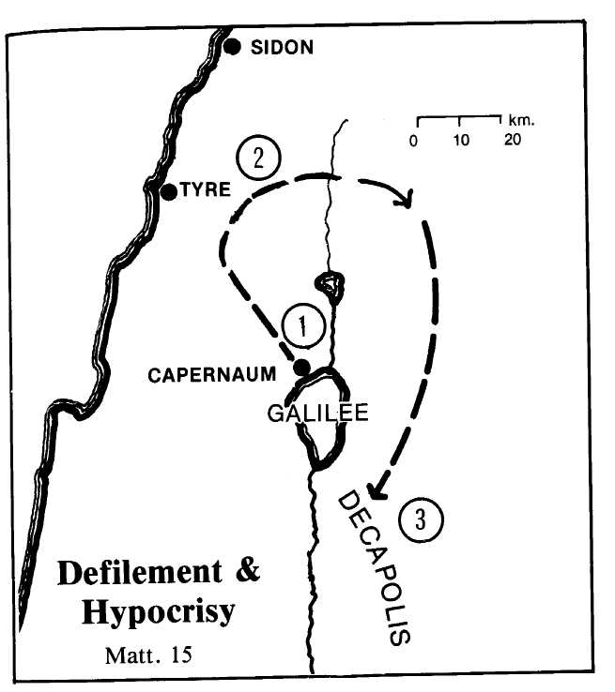

- In Capernaum the Lord was confronted by a deputation of Scribes and Pharisees and was questioned about his breach of the tradition of the elders (Matt. 15:1-21).
- Then he departed into the coasts of Tyre and Sidon where the Syro-Phoenician woman approached him and her daughter was healed.
- He returned to Decapolis where he fed the 4,000.

The incidents of Lesson 339 follow immediately.

