339. OPPOSITION GATHERS IN THE SHADOW OF THE CROSS
"He must go up to Jerusalem and suffer many things . . . and be killed"

The Lord's final year was one of increasing bitterness as he pursued the pathway that was to lead to his death. The pressures of opposition were building up against him as we see him "despised and rejected of men; a man of sorrows and acquainted with grief".
Yet, to the forefront, was his concern for his disciples, his desire to instruct and thus equip them for the sacrifices they also would be required to make. It is an example of selflessness that should inspire our own service.
The aim of this lesson is to show that sufferings must come before reward — for Messiah as well as disciple.

Matthew 16

THE PHARISEES AND SADDUCEES DEMAND A SIGN (Matt. 16:1-4).
It had been some time since Jesus came across the Pharisees. He had left them following the discussion on defilement (Matt. 15), and travelled north, far from their influence, and then to the Gentile area of Decapolis on the eastern shore of Galilee.
Hardly had he crossed the lake to the familiar western shore than he was challenged by a deputation of Pharisees and Sadducees (Matt. 15:39; 16:1). After his exhilarating experiences with the Gentiles, the approach of this group signalled to the Lord that his final period of opposition was about to begin. From now on he would be walking in the shadow of the cross.
The presence of the Sadducees so far from Jerusalem was an indication of the concern with which Jesus was looked upon. Further, the Sadducees were not usually found in company of the Pharisees (cp. Acts 23:7), but like Herod and Pilate, they could become friends when there was work in which their common animosity could be gratified.
They demanded of Jesus a sign from heaven that would serve to authenticate his mission among them. On the surface this seemed a reasonable demand. Had not Moses given such a sign (Ex. 4:1-9)? So also had Joshua (Josh. 10:12-14), Samuel (1 Sam. 12:16-18), and Elijah (1 Kgs. 17:1).
But what sign could be of any significance to those who dismissed such signs as healing the sick, raising the dead, restoring sight to the blind and hearing to the deaf (cp. Matt. 11:4-5)? What sign could be given to the self-centred Pharisee who did not see the cleansing of the heart as a pre-requisite to holiness or to the materialistic Sadducee who rejected the very concept of resurrection? These men were hypocrites, tempting the Lord.
As on previous similar occasions, Jesus refused their request (Jn. 2:18; 6:30; Matt. 12:38). Instead they would receive “the sign of the prophet Jonah".

THE SIGN OF THE PROPHET JONAH
The words of Jesus recalled the message and ministry of Jonah. After a typical resurrection from the dead, he gave the people of Nineveh but 40 days to repent or else destruction would fall on their city. The Ninevites had repented and the threatened punishment was averted. But Jesus, by decrying his generation as "wicked and adulterous", implied that there would be no repentance and therefore punishment would come.
The signs were obvious if only the Pharisees and Sadducees would open their eyes to them. They looked unto the heavens in the morning and the evening and from the colour of the sky they could discern the approaching weather. Could they not lift up their eyes and see the signs of a coming storm?
Their present mission was an omen! Jesus said that no sign would be given them "but the sign of the prophet Jonas". This was the sign of his resurrection after 3 days (Matt. 12:40). But it would come after his sacrifice at their hands! It would therefore seal their fate and come too late for many.
"If they believe not Moses and the prophets, neither will they be persuaded though one rose from the dead" (Luke 16:30-31). They remained obstinately unrepentant and in 40 years Roman armies dyed the land and sea with Jewish blood.
Jesus "left them and departed". The opportunity had been lost. Jesus was not going to press divine mercy upon a people who did not want it.

THE LEAVEN OF THE PHARISEES AND SADDUCEES (Matt. 16:5-12).
The small party left Magdala so abruptly that the disciples forgot to procure bread. When they reached the other side Jesus warned them of the leaven of the Pharisees and Sadducees. He had been contemplating where the hatred of his enemies would lead and he knew that even one of his own disciples would be influenced against him. But, as so often happened, they misunderstood him and it had to be explained that what concerned him was not "the leaven of bread, but the doctrine of the Pharisees and Sadducees".
As leaven insidiously pervades the dough until the whole mass is affected, so opposition to Jesus was being spread by his enemies throughout the nation.
But what exactly did Jesus mean by "the leaven of the Pharisees and of the Sadducees". He spoke not of the leaven of each, but the leaven common to both. They were very different parties.
- The leaven of the Pharisees was hypocrisy (Luke 12:1). They were strict, intensely nationalistic and were preoccupied with the ritual of the Law. This they performed like a theatrical display, to be "seen of men". Their hearts centred on the praise of men and not the praise of God (Matt. 5:5; Jn. 5:44).
- The leaven of the Sadducees was materialism. They were lax in their religion and sympathetic to outside culture, philosophy and worldly practices. They did not believe in the resurrection or future reward and so were engrossed in present gain. Unabashed they accepted the offerings of the Temple treasury.
Though Pharisees and Sadducees differed, they had nevertheless joined in hostility to Jesus and had sought a sign of him. Thus they both belonged to "a wicked and adulterous generation". This is the key to the leaven common to both. Jesus represented the things of God. They were ungodly, alive to self and dead to God. The lesson for us is that this leaven still permeates — neither hypocrisy nor materialism are extinct. They unite in the baser leaven of ungodliness which can fill our lives and take us away from Christ.

THE GREAT CONFESSION (Matt. 16:13-16).
From Galilee the Lord led his disciples northward towards Caesarea Philippi. Now he must prepare his disciples for his suffering and death. In the quietness of the well-watered mountain retreat he asked them, "Whom do men say that I, the Son of man, am?" Their answer revealed a decline in the public's estimation of him. At one time they had no doubt that he was the Messiah (cp. Jn. 6:14-15), but the disciples' answer showed that he had failed to fit the peoples' conception of Messiah—the steady opposition had changed their opinion and they had relegated him to "one of the prophets" (v.14).
But the Lord's enquiry was only important in-as-much as it led to the supreme enquiry, "But whom say ye that I am?" (v. 15).
It was Peter who replied, "Thou art the Christ, the Son of the Living God". This was a moment of exaltation for Jesus. In spite of all that had happened to discredit Jesus, Peter knew that he was the Messiah. Jesus commended him, "Blessed art thou, Simon Bar-jonah: for flesh and blood hath not revealed it unto thee, but my Father, which is in heaven" (v.17).
"Thou art Simon Bar-jona" described Peter's earthly descent—the fact that he described Jesus as "the Christ, the Son of the living God," showed God was at work in Peter's life—he had been born of God(Jn. 1:13).
In verse 18 Jesus continued and said, "And I say unto thee, that thou art Peter ('Petros') and upon this rock ('petra') will I build my ecclesia, and the gates of hell will not prevail against it". In his confession Peter had justified his»Lord's choice of a new name for him (jn. 1:42). It was Peter who described in his epistle the ecclesia as a spiritual house built upon the chief corner stone, the Lord Jesus (1 Pet. 2:5-6).
For the first time in the gospels Jesus used the word "ecclesia" of his followers, as distinct from the Jewish synagogues. So in that moment, at a point far removed from the Temple and ritual of Jerusalem, the rejected leader with his little group of exiles proclaimed the ultimate victory of his ecclesia—"the gates of hell shall not prevail against it."
The Lord indicated to Peter that he would be given "the keys of the Kingdom" and that his decisions made in faith would receive God's endorsement — a power that was later conveyed to the apostles as a whole (Matt. 18:18).
The key was a badge of office or authority (Isa. 22:22), for the person possessing the key controlled access to the building. It was said in condemnation of the scribes that they had "taken away the key of knowledge" (Luke 11:52). "The keys of the kingdom" therefore describe the power to open up to man's understanding the true position held by the Lord Jesus Christ, by which an entrance into the kingdom of God might be attained.
But Peter had a special role in the use of the keys. Jesus called him "Simon Bar-jonah" or Simon, son of Jonah. It was as if the mantle of the great prophet Jonah had fallen upon Peter's shoulders. It would be his to unlock the gospel to the Jews (as he did by proclaiming salvation in the name of Jesus Christ—Acts 2 and 3), and after an initial reluctance owing to a failure in understanding, to open the door of faith to the Gentiles (in the call of Cornelius—Acts 10).

INSTRUCTION IN THE WAY OF THE CROSS (Matt. 16:20-27).
Upon the basis of Peter's confession Jesus was able to show them the nature of his Messiahship and where it would lead him: "From that time forth began Jesus to show unto his disciples, how that he must go unto Jerusalem and suffer many things of the chief priests and scribes, and be killed and be raised again the third day." Sufferings were not a disqualification of his Messiahship but the proof of it: "Messiah the Prince" would be "cut off" (Dan. 9:25-26).
It was Jesus' use of such strong words ("must . . . suffer ... be killed") that elicited Peter's response. The revelation of a suffering and rejected Messiah was too much. His love for his Lord was too great to accept this terrible picture of persecution and death. He objected, "Be it far from thee, Lord: this shall not be unto thee". But his love was a stumbling block to himself and his Lord. Jesus could endure the hatred of his enemies better than the misguided love of his friends. He repudiated the temptation that Peter had placed before him, using the identical words he had spoken to the tempter when he had placed the same trial before him, "Get thee behind me, Satan; thou art an offence unto me for thou savourest not the things that be of God, but those that be of men" (v. 23; cp. Matt. 4:8-10).
Jesus' death was essential if he was to "fulfil all righteousness" (Matt. 3:15; refer Lesson 2); it was the culminating act of obedience (Phil. 2:8-9). Without the cross there would be no crown—if he did not suffer there would be no glory.
Jesus used Peter's lapse to show the disciples their part in the purpose of God. The cross which had forced a cry from Peter's lips would be the lot of the disciple, too! "If any man will come after me, let him deny himself, and take up his cross and follow me" (v.24). Their life as men who followed him must be a life of sacrifice, denying the desires of the flesh and savouring only the things of God. He had come to give life. Accepting this gift meant losing many of the glittering prizes the world had to offer.
But Jesus continued: "For whosoever will save his life shall lose it; and whosoever will lose his life for my sake shall find it." From the "losses" incurred in this life, as a result of service to Christ, will eventually emerge a life of far greater value than the present conquest of the world (v.26). Those whose lives are filled with pleasure-seeking and self-indulgence will eventually lose all.
In his last words Jesus puts their Messianic expectations in the right perspective. They had been right to expect a king who would come with power to redeem Israel. But sufferings must come before the reward—for them as for him. These words apply as much to us today as they did then.

LESSONS FOR US:
- The signs we can see in the world of the coming overthrow of this civilisation are as clear as the signs which the Pharisees and Sadducees saw, yet ignored. It is our part to discern.
- The leaven of the Pharisees (hypocrisy) and the leaven of the Sadducees (materialism) are not extinct and combine to form the baser leaven of ungodliness which can alienate us from Christ.
- The confession that Jesus is "the Christ, the Son of the living God" is the foundation upon which the ecclesia is built.
- As Messiahship involved suffering, so discipleship must involve sacrifice.

REFERENCE LIBRARY:
"A Life of Jesus" (M. Purkis)—Book 5, Chapters 6-8
"The Gospel of the Son of God" (L. G. Sargent)—Part IV, Chapters
3-4 "The Story of the Bible" (H. P. Mansfield)—Vol. 9, Pages 149-166

PARAGRAPH QUESTIONS:
1. What was wrong in the Pharisees and Sadducees asking Jesus for a sign when they met him at Magdala?
- What is the leaven of the Pharisees and Sadducees of which Jesus bade his disciples beware?
- Why was Peter's confession so important to Jesus?
- What did Jesus mean when he said, "Whosoever shall save his life shall lose it" (Matt. 16:25)?
- Why did Jesus have to die in order to become the Messiah?

ESSAY QUESTIONS:
1. Relate the incident when Peter gave his great confession: "Thou art the Christ, the Son of the living God". Why were these words so important? In what way did Peter use the keys of the kingdom?
- How did Jesus prepare his disciples when faced with growing op position and his own impending death?
- Tell the story of Peter's confession and explain Jesus' words of commendation.
- Why did Jesus say to Peter, "Get thee behind me, Satan" (Matt. 16:23)?

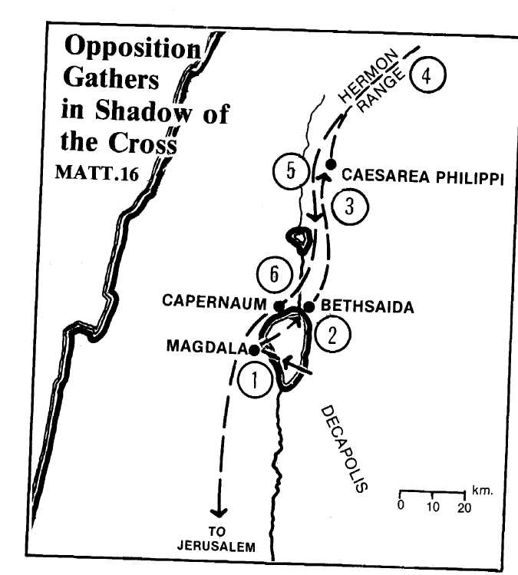
- After feeding the 4,000, Jesus and his disciples crossed the lake and landed at Magdala (Dalmanutha). There he was confronted by Pharisees and Sadduccees seeking a sign (Matt. 15:29; 16:1-5).
- They left by ship for Bethsaida where he healed a blind man (Mk. 8:22).
- At Caesarea Philippi, Peter confessed that Jesus was the Christ (Matt. 16:13).
- Jesus was transfigured on a high mountain near Hermon (Matt. 17:1; Mk. 9:2).
- Jesus healed an epileptic boy near Caesarea Philippi (Mk. 9:14-
29). He returned through Galilee to Capernaum (Mk. 9:30, 33).
- At Capernaum he provided tribute money, warned the disciples
who were arguing who was the greatest, and taught the impor
tance of forgiveness (Matt. 17:24-27; 18:1-35; See Lesson 15).

