348. THE LAST SUPPER AND GETHSEMANE
"Not my will but thine be done ..."

The first mission of Messiah was to die for the sins of the world. To do so he had to partake of the same nature as all mankind, that he might know and conquer its passions and weaknesses. Such a mission brought immense strain upon the Lord and it was in Gethsemane that this came to a climax. The thoughtful love which pervaded his manner in the preceding feast with his disciples is all the greater in that context.
The aim of this lesson is to understand the significance of the Memorial Feast which the Lord instituted before his death.

Matthew 26:1-56

A CONSPIRACY OF HATE (Matt. 26:1-5).
It was an anxious period for the elders of Jewry. Ever since Jesus had been in Jerusalem his popularity with the common people had increased. They had sung his praises on his entry to the city, and they had noted his decisive answers in the verbal battle with the Pharisees, Sadducees and scribes. Fired by envy, the chief priests, scribes and elders came together in the house of Caiaphas to map out a plan of murder (Prov. 27:4). The Passover Feast was only two days away and they feared that Jesus might be exalted even more in the eyes of the people (cp. Jn. 6:15). They must take Jesus therefore, before the Feast day in order to avoid a protest from the people.

AN AROMA OF LOVE (Matt. 26:6-13).
In contrast with these dark purposes, Matthew tells us of an act of grace that took place in the house of Simon the leper in the small village of Bethany some 3 kilometres east of Jerusalem. In this simple setting Jesus found a noble example of faith and love which was to be recorded as a memorial ever after (v.13). While he dined, a woman called Mary came and poured a very precious ointment on his head (Jn. 12:3). Her action was intended as an anointing of his body for burial and was therefore the more remarkable (Matt. 26:12). No other person, not even among the twelve whom he had instructed so often, had appreciated the necessity for his death to fulfil the role of Messiah.
It was an enlightened act of devotion and deeply touched the Master. Yet, unwittingly, it was a rebuke upon those who, with greater opportunities, lacked the same perception and generosity. Led by Judas, the disciples began to criticise her action as being wasteful and neglectful of the poor (vv.8-9: Jn. 12:4-6). The beautiful odour of the ointment, so like the spirit of Mary, had filled the room; but now it had become contaminated with strife and greed. Jesus sternly confronted the criticism, revealed the miserable hypocrisy behind it, and commended the faithful woman (vv.10-13).

FOR THIRTY PIECES OF SILVER (Matt. 26:14-16).
This open rebuke upon Judas Iscariot appears to have been a final catalyst. It drove him from the company of love and devotion to the councils of murderers. There he covenanted for thirty pieces of silver to betray Jesus, so that they might arrest him "in the absence of the multitude" (Lk. 22:6). Leaving the chief priests with hopeful expectations, Judas went back to the twelve and awaited an opportunity to betray the Son of God.

THE LAST SUPPER—WHERE IS THE GUEST CHAMBER? (Matt. 26:17-19).
How great is the love of Christ for his disciples! With Judas back in their ranks and knowing his evil intent, and bearing the stress of his approaching death, the Lord prepared his mind for the Passover. He desired to spend this time together and therefore directed only two disciples to prepare the guestchamber. He gave them vague instructions regarding its location (Lk. 22:15; Matt. 26:17-19; Mk. 14:13-15). Judas was thereby thwarted from planning an arrest at this time. Their Passover would be uninterrupted.

THE LORD'S SUPPER (Matt. 26:20-30).
The Passover having been prepared, Jesus came and sat down with the twelve. They were grief-stricken by the announcement that one of them would betray him. Incredulously they all began to doubt and ask, "Lord, is it I?" "He that dippeth his hand with me in the dish, the same shall betray me". Judas, "one of the twelve" (Mk. 14:10, 17, 43), who drank from the same cup, would perpetrate the heinous crime. It was written, "mine own familiar friend, in whom I trusted, which did eat of my bread, hath lifted up his heel against me" (Psa. 41:9; see also Psa. 55:12-14).

THE BROKEN BREAD.
In the midst of the Passover meal, Jesus introduced the New Covenant: "And as they were eating, Jesus took bread, blessed it, and break it, and gave it to the disciples, and said, 'Take, eat; this is my body' ". All were familiar with the details of the Passover, but here was a new approach! In place of the Passover Lamb, Jesus was now setting his "body" before them to eat. Later he took the cup of wine and said, "This is my blood of the new covenant". So in a man of flesh and blood—"a body prepared" (Heb. 10:5, 8-10)—would be seen the fulfilment of the unblemished Passover lamb, and indeed of all the sacrifices of the Old Covenant (Psa. 40:6-8). John the Baptist had declared this when he said, "Behold the Lamb of God which beareth away the sin of the world" (Jn. 1:29 margin).
Under the shadow of Mount Sinai, Moses had taken a bason and sprinkled the blood of the Old Covenant upon the people of Israel. They swore their allegiance to Yahweh and their determination to be obedient (Ex. 24:3-8). Yet the prophets had foretold a New Covenant, so indicating a termination of the Old (Jer. 31:31-33; Isa. 59:20-21). The New Covenant would be "new" because, coming later, it would provide for the forgiveness of sins (Jer. 31:34; Isa. 27:9; Zech. 9:11), and this feature is emphasised by the Lord "my blood which is shed for many for the remission of sins" (v.28). His words contained a further contrast to the terms of Moses' Old Covenant. The bread and the wine were not for the twelve only, nor for just Israel, but for an unspecified "many". In this phrase Jesus joins with the Spirit in Isaiah: "by his knowledge shall my righteous servant justify many for he shall bear their iniquities" (Isa. 53:11). He would be "the Saviour of the world", for "whosoever believeth" would find the remission of sins and the promise of everlasting life (Jn. 4:42; 3:15, 16; 12:32; Rom. 3:21-22; 10:11-13).

THE CUP OF WINE.
The cup of wine that followed was a symbol of his blood (Matt. 26:27-28). Blood signifies "life" and so in this simple but poignant way, Jesus portrayed that he would "pour out his soul (life) unto death" (Lev. 17:11; Gen. 9:4; Isa. 53:12, 10). In John 6:53 he enjoined all disciples to drink of his blood if they would live: "Except ye drink the blood of the Son of man ye have no life in you!" To a staunch Jew this must have seemed abhorrent as God had forbidden the partaking of blood (Lev. 17:10-11; Deut. 12:23; Acts 15:20-22). Here then was a deliberate and dramatic contrast: the blood of the sacrifices of the Law could not take away sin, but Christ's blood could do so and also bring life! To "drink" this "blood" is to "dwell in him and he in us" (Jn. 6:56). His words, his principles, his life, should dwell in us, so bringing about unity with him and each other.
These emblems were given on the eve of the Lord's suffering and death (Lk. 22:15). Paul comments, "For as often as ye eat this bread, and drink this cup, ye do shew the Lord's death till he come" (1 Cor. 11:23, 26). Why is such pre-eminence given to the Lord's death, when the principles of the bread and wine are seen throughout his life? It is because on the cross was seen the final victory over sin. As he expired Jesus said: "It is finished" (Jn. 19:30); so in his death, the principles seen throughout his life were dramatised.
The following paragraph is written in terms directly applicable to those who are "baptised into Christ". Students who have not yet reached that point in their lives can, nonetheless, consider the principles outlined and thus have their understanding enlightened.
When we meet to partake of the bread and wine our thoughts must focus on the death of the Lord. It was then that his body was "given" for the life of the world and his blood "shed" that others may drink (Jn. 6:51; Matt. 26:28). Paul exhorts that we should examine ourselves before partaking of the emblems. To do otherwise is to "drink unworthily" and to be "guilty of the body and blood of the Lord", or to join his murderers (1 Cor. 11:27-29). If on the other hand we dwell upon the principles of his death, we shall profit and ultimately receive life eternal (Jn. 6:54-57). Christ's people must walk in his steps; "they that are Christ's have crucified the flesh with the affections and lusts" (Gal. 5:24). The Memorial Feast is to be kept "till he come" (1 Cor. 11:26). It was Jesus himself who linked future glory with that eve of suffering, when he promised that he would not drink of the fruit of the vine until he drank it "new" with his disciples in the kingdom (Matt. 26:29).

GETHSEMANE (Matt. 26:36-46).
Having concluded this unique Passover Feast with a Psalm of praise (perhaps Psalm 118), the company left the upper room and in the darkness of the night, made their way down the slopes of the Kedron Valley to a garden called Gethsemane at the base of the Mount of Olives. Judas had gone out earlier and was already mapping out with the chief priests the plan for the arrest. He was familiar with Gethsemane for Jesus "ofttimes resorted thither with his disciples" (Jn. 18:1-2; Lk. 22:39). It was a terrible hour and Jesus felt the need for strength from his Heavenly Father. He knew what the prophets had written. He knew that Judas was plotting his death and he warned the others that they would forsake him—the scriptures must be fulfilled (v.31: Zech. 13:7).
Desiring companionship Jesus took three of his disciples, Peter, James and John, and entered the garden. He expressed to them the depth of his sorrows. He asked them to watch with him whilst he went off a little further to commune with his Father. His prayer was for deliverance from the dreadful cup of sufferings if it was compatible with his Father's will, which he would not refuse, saying, "not as I will, but as Thou wilt". There was no other way. God answered him by sending an angel, "strengthening him" (Lk. 22:43; Psa. 91:11, 14; 34:7-8). Returning to the three he found them asleep—Peter, too, who had so recently vaunted his loyalty (v.33, 35, 40). Jesus, despite his personal grief, could yet feel for them: "Watch and pray that ye enter not into temptation: the spirit indeed is willing but the flesh is weak" (v.41; cp. Rom. 7:17-23; Eph. 6:18). Three times he prayed in the same words, and returned each time to find the disciples sleeping (vv.42-44). It was the hour of his greatest grief and desolation (Psa. 69:1-4, 13-20). His sweat was abnormal, like great drops of blood falling to the ground (Lk. 22:44). Yet out of it he arose fortified by his communion with his Father, and resolute in his determination. "Behold, the Lord God will help me, who is he that will condemn me?" (Isa. 50:7-9). "Rise, let us be going" (v.46).

A GREAT MULTITUDE WITH SWORDS AND STAVES (Matt. 26:47-56).
Judas, "one of the twelve", arrived with the guards who did the bidding of the chief priests (cp. Jn. 7:32; Matt. 26:47). In the flickering light of torches and lanterns Judas betrayed his Master with a kiss. It was his sign to ensure that they arrested the right one (Jn. 18:3). Peter's love and anger surged to the surface. He took his sword and struck off an ear of one of the high priest's servants (v.51, Jn. 18:10). It was a loyal but uninformed action. Healing the ear, Jesus reminded Peter that twelve legions of angels were at his disposal should he so desire (Lk. 22:51; Matt. 26:53), but that it was not the hour for resistance. Moreover "all they who take the sword shall perish with the sword" (vv.52-53).
"But all this was done, that the scriptures of the prophets might be fulfilled. Then all the disciples forsook him and fled" (v.56).

LESSONS FOR US:
- It is easy to pass harsh judgments upon tender expressions of love which we fail to understand.
- The Memorial Meeting should be attended in a sober and thoughtful manner.
- Prayer is a great help against temptation, and we must be alert when approaching God.
- We are to "resist not evil"; vengeance is God's alone.
- "The angel of the LORD encampeth round about them that fear him, and delivereth them".

REFERENCE LIBRARY:
"Nazareth Revisited" (R. Roberts)—Chapters 52 and 56
"A Life of Jesus" (M. Purkis)—Book 7, Chapters 9, 10 and 11
"The Gospel of the Son of God" (L. G. Sargent)—Book VII, Chapters 1-2

PARAGRAPH QUESTIONS:
- How does the new covenant which Jesus instituted at the Last Supper differ from the old covenant given by Moses in Exodus 24?
- What did Jesus mean when he said: "This is my blood of the new covenant, which is shed for many for the remission of sins" (Matt. 26:2 8)?
- What did Jesus mean when he said, "He that . . . drinketh my blood dwelleth in me, and I in him" (Jn. 6:56)?
- Why did Jesus tell Peter, in the garden of Gethsemane, to put his sword back into its sheath?
- How is the love of Christ for us seen in the events which took place in the garden of Gethsemane?

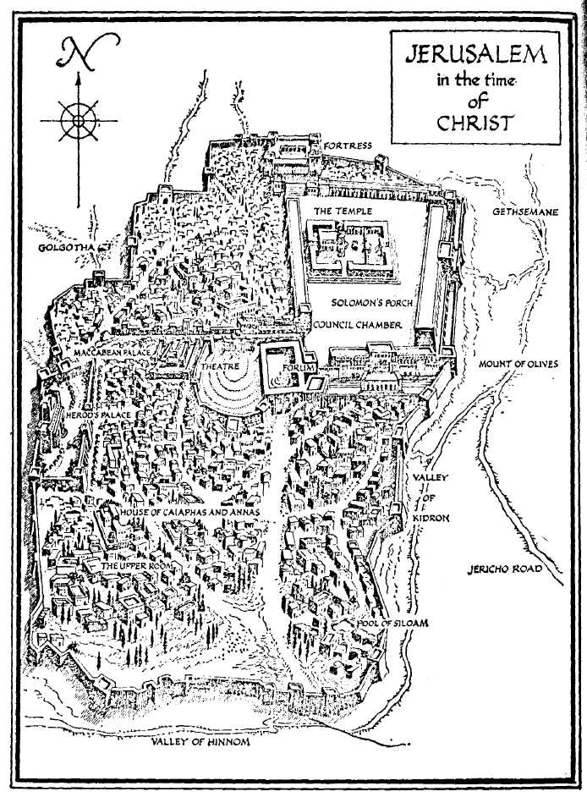
ESSAY QUESTIONS:
1. What instructions have been left for those in Christ to remember Jesus week by week?
2. What do the bread and wine taken by Jesus and his disciples at the last supper symbolise?
3. Describe the events which took place in the garden of Gethsemane, ' including the arrest of the Lord. Include in your answer as many of his words as you can remember.

