161. JACOB, THE BIRTHRIGHT AND THE BLESSING
This lesson shows us how God preferred Jacob to Esau; and how God guided the lives of all concerned in the carrying out of His purpose
.
Genesis 25

ESAU AND JACOB
Twin sons were born to Rebekah and Isaac after a remarkable prophecy had been given to them by God (Gen. 25:23). The prophecy revealed:—
- Two nations were to be developed from the two boys.
- They would be two manner of people—one fierce and warlike who would seek to dominate his younger brother: but eventually the elder would serve the younger.

In this prophecy, God revealed His knowledge of how these boys would develop. God realised that Esau would be a godless, fleshly man with no respect for Him, while Jacob would be the opposite. God therefore planned accordingly and chose Jacob as the one through whom the Abrahmic promises would be developed (Rom. 9:10-13).

Notice how Chapter 25:24-34 proves God's action to be correct. Esau was red (like the earth) and hairy (rough) when born (v.25). Jacob when born, had hold of Esau's heel as though he would have tripped him up and taken first place (v.26). This resulted in him being called Jacob meaning "supplanter" or "he who trips up by the heel" (for the purpose of getting in front). This desire to be first in sharing God's blessing remained with Jacob all his life. Esau developed in the skills of the world (v.27) but Jacob was a "plain" or "upright" man. This tells us that he preferred to spend much time in developing an understanding of the ways of God. But he was not a weak man. His life reveals him as a hard-working, determined man who drove himself toward his goal. He really wanted the inheritance of the promises! Verse 28 records the sad detail that Isaac allowed his natural affection for Esau to over-ride his knowledge of God's will. Rebekah was more thoughtful and saw in Jacob a godly seed. Isaac knew of God's purpose that Jacob was to have the promises. That can be seen when the meaning of Gen. 27:33 is noted (see section on "Jacob blessed").

ESAU SELLS HIS BIRTHRIGHT (Gen. 25:29-34).
Sod pottage is made from boiling red lentils (like beans) in water. Esau returned from hunting so faint that he thought he was about to die. He demanded food from Jacob who, quick to grasp the chance, offered to buy Esau's birthright with the vegetables. Because Esau agreed to this, it reveals several things about him:—
- He thought more of himself than of God.
- He did not care much about the honour of being firstborn, which gave him the "right" to a double share of the inheritance.
- He thought nothing of the responsibilities that elder sons had for training and caring for the younger members of the family.
Paul says he was a profane person (Heb. 12:16-17) which means unholy and ungodly. He was a man dominated by fleshly ways and who became known as "Edom" meaning "red", the colour of sin (also the colour of the pottage, v.30).

THE BIRTHRIGHT (Deut. 21:15-17).
In a family of Bible times other members of the family respected an eldest son. He was the firstborn, the head of his brethren. He would take over the respect due to the father, had a special claim to his father's blessing, and received a "double portion" of his father's goods by way of inheritance. This birthright could be given to another son by the father for a good reason. Esau gave up his priceless birthright for one simple meal.

JACOB BLESSED (Gen. 27).
Jacob's father, Isaac was 117 years old and his eyesight was failing. He thought that he was close to death and decided to give his blessing to his firstborn.

It is sad to note Isaac's refusal to accept the will of God in regard to Jacob and his resolve to give the blessing to Esau. Note the way in which the sons are described, "his son" (v.5) "her son" (v.6). This is a further criticism of Isaac's favouritism and his failure to rebuke Esau for his worldly ways.

Rebekah acted quickly so that the younger son would be blessed. She insisted that the hesitant Jacob obey her voice and deceive Isaac.

Jacob came before Isaac, acted out his part and deceived his father (w. 18-26). Isaac was confused over the speed in which the meal was prepared and the speech of the son who didn't speak like Esau at all. Still puzzled, he went ahead with the meal and blessed the son whom he believed was Esau. He pronounced the blessings of material prosperity, of authority over people and nations and blessings on friends and cursings upon enemies. This blessing is similar to the Abrahamic blessing by God. However in a remarkable statement Isaac said "Be lord over thy brethren and let thy mother's sons bow down to thee" (v.29). Here was the fulfilment of the words that God told Rebekah before the boys were born. The elder would serve the younger. But Isaac thought he was speaking to Esau! Then he realised that he had tried to oppose the purpose of God when the real Esau appeared and demanded the blessing (vv.30-33).

Stunned by such a reversal, Isaac "trembled with a great trembling greatly." His faith did not fail. In a moving demonstration of his submission to God's will he said "Yea and he shall be blessed". Hebrews tells us that "by faith Isaac blessed Jacob and Esau concerning things to come" (Heb. 11:20). Esau "lifted up his voice and wept" (v.38). These were tears of anger and frustration. Imagine the pressure brought to bear upon Isaac by the tearful pleas of his favourite son. Yet Isaac's faith, badly shaken, stood firm under that pressure. Failing to change Isaac's mind, Esau showed his real character by plotting the murder of his brother (see Heb. 12:16-17).

Isaac later blessed Jacob with the fulness of the Abrahamic covenant, (28:3-4) and at the same time confirmed Esau to a position of serving his brother (Gen. 27:38-40).

We should note that Isaac lived a further 63 years after these events, which in itself reveals his undue haste in wanting to bless Esau.

LESSONS FOR US.
• Before the two boys were born God chose Jacob because he foresaw the characters that would develop. But Isaac's favourite son was Esau who grew up to be a man of the world. We should resist any attraction of worldliness and prefer the quiet, godly attitudes as shown by Jacob.

•Esau demonstrated his unworthiness by selling his birthright for a "mess of pottage." Let us never treat the promises of God with the same lack of interest. We have been given the priceless hope of eternal life. Let us value this above all the temporary benefits of life today.

• Isaac's faith was developed to maturity as he submitted to the will of God. He had been humbled by the overriding hand of God. In our lives we should "prove what is that good and acceptable and perfect will of God" (Rom. 12:2) and be obedient to it. We can see from this lesson that we should not "lean to our own understanding" but rather "acknowledge God in all our ways" for then God will direct our steps (see Prov. 3:5-7). If we do that, God will guide us to the Kingdom and an inheritance of those great and precious promises made to Abraham, Isaac and Jacob.

REFERENCE LIBRARY:
"The Story Of The Bible" (H. P. Mansfield)—Pp. 141-150
"The Ways Of Providence" (R. Roberts)—Chapters 5, 6
"Elpis Israel" (J. Thomas)—Pp. 264-272 "Christadelphian Instructor" —Questions and Answers Nos. 87-89

PARAGRAPH QUESTIONS:
1. What message did God give Rebekah about her two sons?
- In what way did Esau despise the birthright?
- How did Isaac show faith in blessing his sons?
- Explain what is meant by the "birthright" (or "firstborn").
ESSAY QUESTIONS:
- Write a brief character study of Esau and Jacob.
- Show how Isaac's intentions to bless Esau were overridden by Jacob and Rebekah's actions.

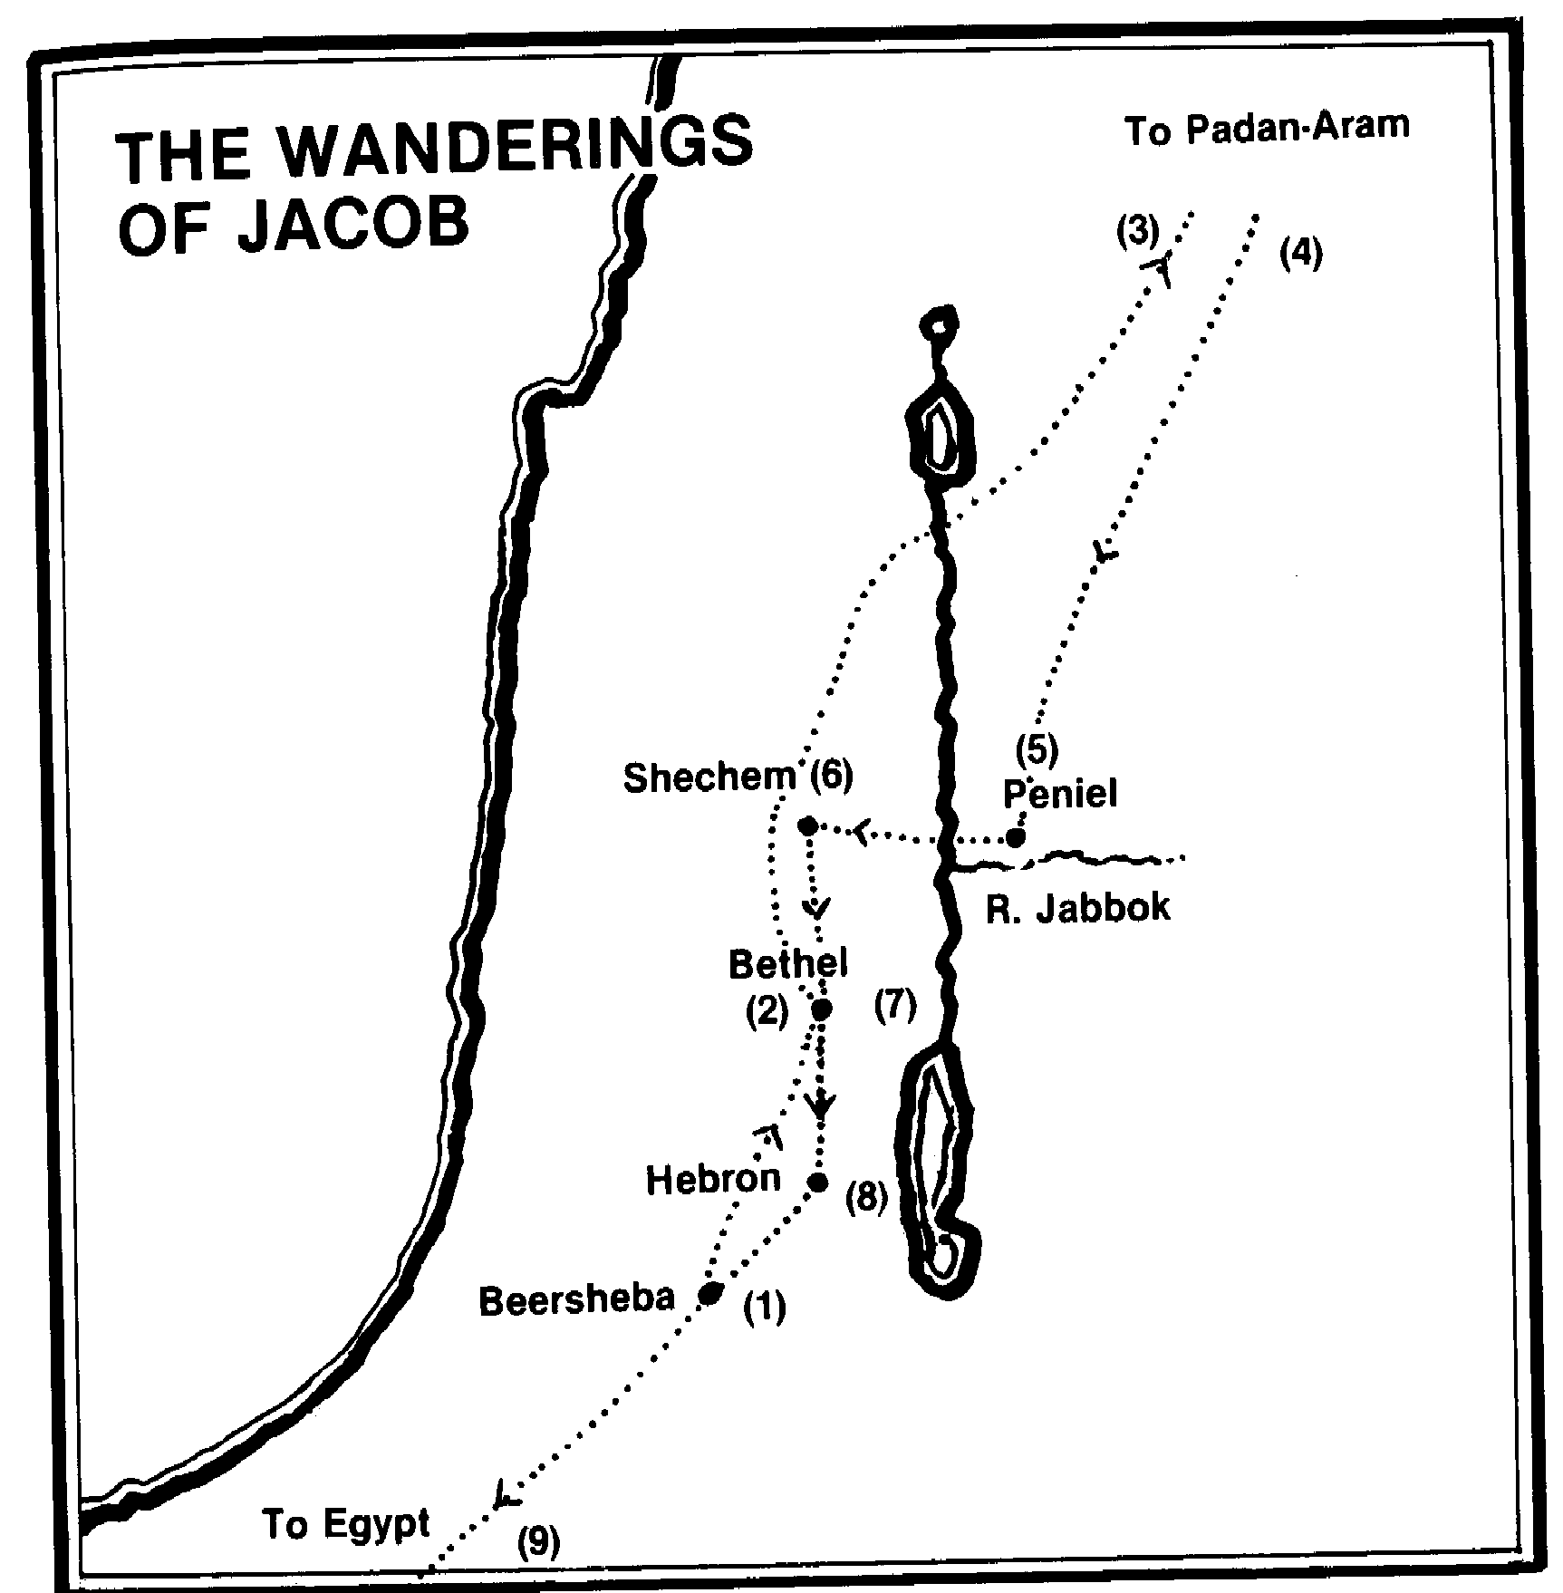

- Jacob flees from Esau after he obtained the blessing Isaac intended for Esau (27:41-46; 28:1-5).
- (2)Resting for the night at Bethel, Jacob is given the vision of angels ascending and descending on a staircase (28:10-22).
- At Padan-Aram Jacob serves Laban 14 years for Leah and Rachel (29:1-30).
- After working forty years for the deceitful Laban, Jacob leaves secretly with his wives, children and flocks (31:1-18).
- He wrestles with the angel at Peniel and the next day meets Esau who unexpectedly (by God's grace) proves friendly (32:22-32; 33:1-16).
- Jacob pitches his tent near Shechem, but leaves in haste when his sons Simeon and Levi kill the men of Shechem for the treatment of Dinah their sister (33:18-20; 34:1-31).
- Jacob returns to Bethel and builds an altar (35:1-15).
- He returns to his father Isaac, now dwelling at Hebron, the city where Abraham had dwelt (35:27).
- Later Jacob and his household move to Egypt at the invitation of Joseph (46:1-7).

