168. BAPTISED INTO MOSES
The nation of Israel was about to be born! Yahweh had made His name great in Egypt and now He instructed Moses to lead Israel out The crossing of the Red Sea is an event full of meaning, and we should try to understand its significance. We too, are called to leave behind a life of darkness, and to be baptised into a new life of "walking in light" i.e., according to the Word of God.

Exodus 14
LEAVING EGYPT BEHIND
The last plague had broken Pharaoh's resistance. In their sorrow for their firstborn sons, the Egyptians offered no resistance as the Israelites left.

600,000 men with their wives and children, together with some of the Egyptians who wanted to go with them, journeyed down to Succoth and camped there (Exod. 12:37, 38). Joyously they made booths to dwell in and celebrated their deliverance. Later when Israel was established in the land they celebrated this event by dwelling in booths each year during the Feast of Tabernacles (Lev. 23:39-43).

Leaving Succoth they journeyed down to Etham on the edge of the wilderness (Exod. 13:20). God was now leading the way with a pillar of cloud by day and fire by night (vv.21, 22). Why did God lead them south when He could have taken them by the main trade route to the northeast?

As well as leading the way to final deliverance from Egypt, God also knew that the people were not ready for war and occupation of the land (Exod. 13:17, 18; Deut. 8:2-6). They needed to be organised as a nation and given a Law. Sinai, with its quiet, remote and awe-inspiring mountains and wide plain, was well suited for this purpose. So in this direction they went.

PURSUED BY PHAROAH.
Moses led the people down the western side of the Red Sea. They camped at Pi-Hahiroth which was a desolate region with harsh, barren mountains and steep cuttings running down to the sea (Exod. 14:1-3). The area was grim and foreboding, and when Israel "lifted up their eyes," they saw the dust of Pharaoh's pursuing army! Hemmed in by mountains on each side, with the sea in front and the mighty Egyptian army in hot pursuit, Israel panicked. Terror and fear gripped the people. Pharaoh had regretted his decision to let them go and was "hard on their heels", determined to recapture and destroy the hated Hebrews.

It was such a habit to fear the Egyptians, that they turned upon Moses and accused him of bringing them into the wilderness to die! (Exod. 14:10-12).

Moses, however, was calm and faithful. He courageously calmed the panic stricken people with the words: "Fear ye not. Stand still, and see the salvation of Yahweh. . .He shall fight for you and ye shall hold your peace" (Exod. 14:13, 14).

DELIVERANCE THROUGH THE SEA
God gave Moses his instructions and then took the pillar of cloud and placed it between the Egyptians and the Israelites. While the Egyptians groped in darkness, the Israelites were given light to see, and to prepare to go on.

Moses led the children of Israel to the shore of the Red Sea. All night long a strong east wind blew, causing the waters of the sea to stand up as a wall and making a path through the sea (v.21; see frontispiece).

As the dawn broke—Moses gave the command to go forward. The children of Israel, accepting the miracle performed for them, hastened across. "By faith they passed through the Red Sea as by dry land" (Heb. 11:29).

The Egyptians, now able to see what was happening, plunged into the path in pursuit! But, alas for them, the chariot wheels came off, the horses floundered about, and all was confusion. Then they realised that they were fighting Israel's God, and panic broke out among them (Exod. 14:23-25).

Moses was instructed to stretch forth his rod again. When he did so the sea crashed in upon Pharaoh and his host. Not one escaped!

A NEW LIFE
Free now, from the bondage of slavery and death, Israel rejoiced in their deliverance. A wonderful song of deliverance was sung by Moses and the people, as recorded in Exodus 15:1-21. Truly, Yahweh had triumphed gloriously! (v.l).

God indeed is a Saviour and a Deliverer, able to do wonderfully in the cause of His people.

Paul says this crossing is like baptism (1 Cor. 10:1-5). It is a type intended to teach us the great things God will do for us if we will in faith "go forward" and obey God's command to be baptised (cp. Exod. 14:15).

While "buried" in the waters of baptism, we are like the Israelites of old: cut off from our past way of life. As we rise from the water to "a newness of life" (Rom. 6:3, 4) we are like Israelites standing on the East bank of the sea. We are then delivered from bondage, knowing that God is greater than the power of the world which held us captive before.

Ahead of us stands our "wilderness of life" with its narrow path leading to an eternal inheritance in the Kingdom of God. That deliverance should cause us to serve God each day of our lives, with joyfulness and thanksgiving. God, who has done great things for us, is surely worthy of our praise.

Behind us lies our former life, lived in service to sin. Faith in the God who has delivered us and a life dedicated in service to our Deliverer will in the end bring victory over the greatest enemy of all — death (1 Cor. 15:22, 23; Rom. 6:23).

SUMMARY:
•When God brought Israel out of Egypt, He led them south into the wilderness to cut off Egypt from them, to protect them from war and to develop them as a nation.

•We too are disciplined through hardship and trial for the development of our character and to fit us for the Kingdom.

• With mountains left and right, sea in front, and enemy behind, the great lesson God taught Israel (and us) is that there is no salvation apart from Him. We also experience the protective hand of God, who saves us from those who would destroy us.

•Threatened by death but believing in God, Israel went through the Red Sea and were thus "baptised into Moses" (1 Cor. 10:2).

•Once we come to a knowledge of the Truth, we can be delivered from the bondage of sin and death, by baptism into Christ.

REFERENCE LIBRARY:
"Elpis Israel" (J. Thomas)—Page 292-293
"The Visible Hand Of God" (R. Roberts)—Chapter 14
"Christadelphian Instructor" Questions and Answers Nos. 58 to 63
"The Story Of The Bible" (H. P. Mansfield)—Pp. 278
"The Wilderness of Life" (J. Martin)—C.S.S.S. Notes

PARAGRAPH QUESTIONS:
- Why did God lead the children of Israel south when He brought them out of Egypt?
- How did the people react when pursued by Pharaoh? What was wrong with their attitude?
- How did God deliver Israel from the pursuing army of Pharaoh?
- In what way is baptism like Israel's crossing of the Red Sea?

ESSAY QUESTIONS:
- Describe the crossing of the Red Sea and the fate of the Egyptians.
- On the basis of Israel's deliverance at the Red Sea explain the difference between the life we leave behind at baptism and the new life in Christ.
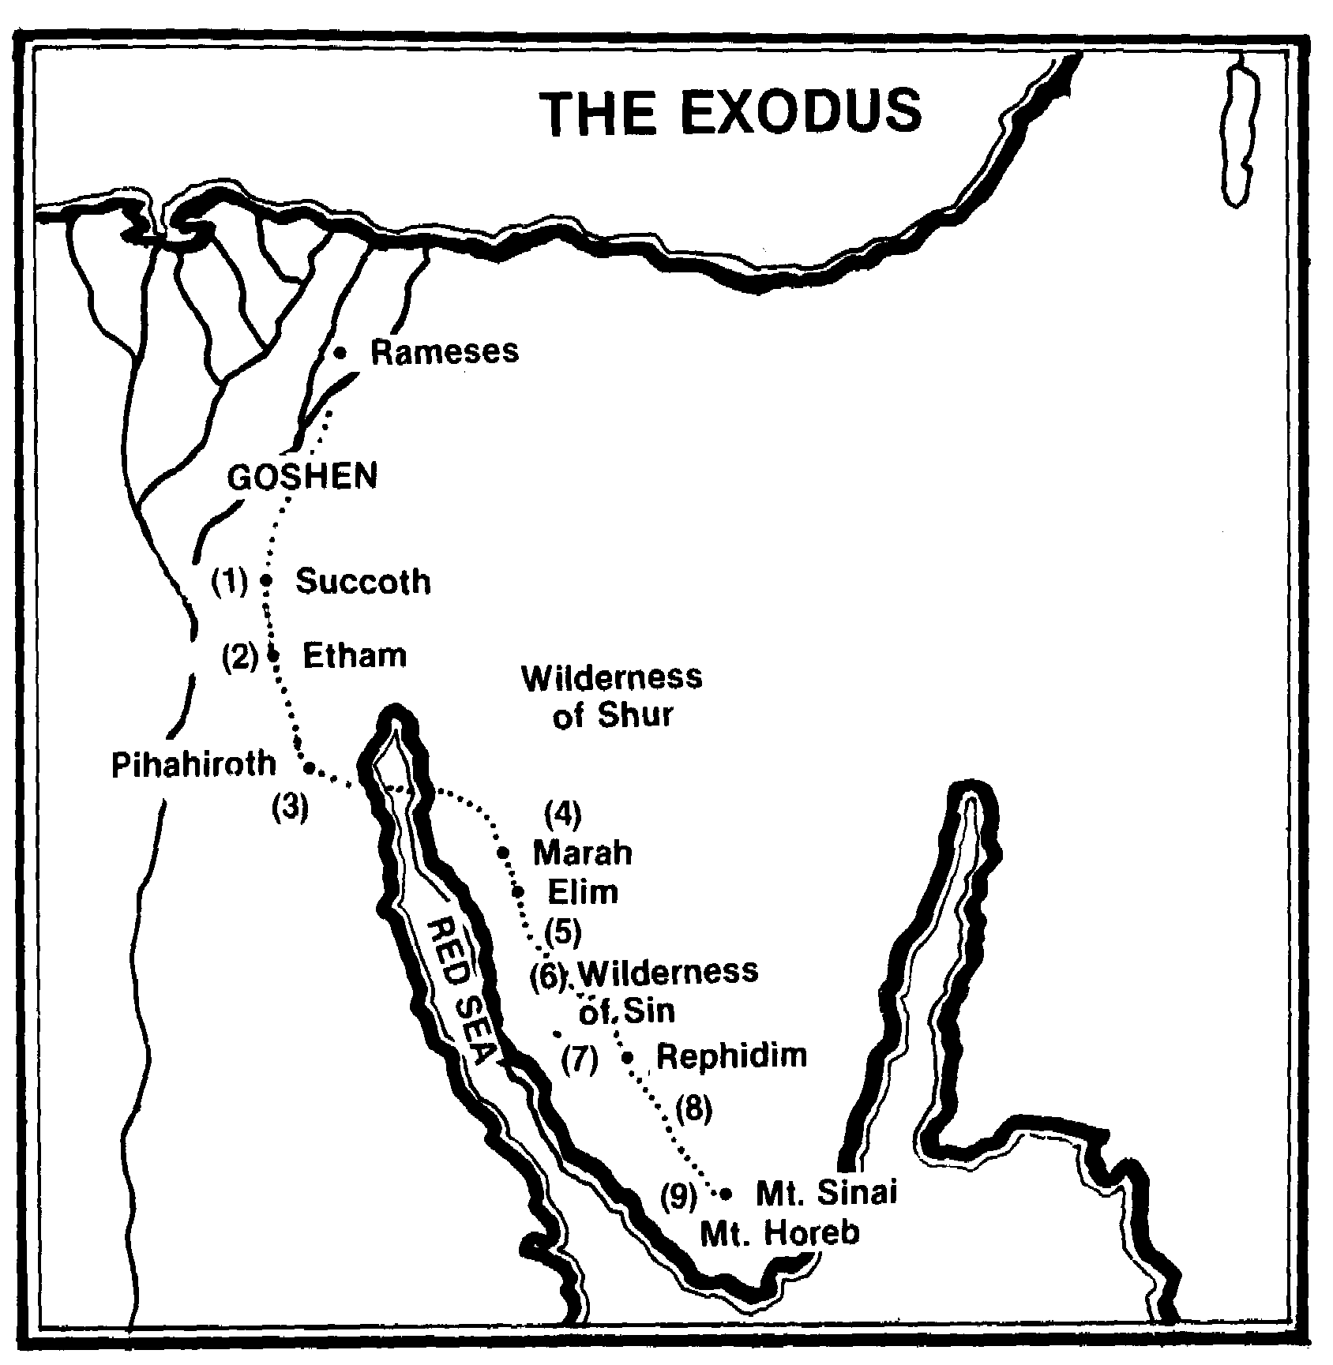

(l)On the night of the Passover, and after the firstborn of Egypt had been slain, Moses leads the children of Israel out from Rameses to
Succoth (12:31-39).
(2) From Succoth they are led by the pillar of cloud to Etham on the edge of the wilderness (13:20-22).
(3)The people are led along the western side of the Red Sea and, being pursued by Pharaoh, cross the Red Sea in a great display of God's mighty power to deliver His people (14:1-31).
- After three days they come to Marah where the bitter waters were miraculously made sweet (15:22-25).
- Israel encamp at Elim where there are 12 wells of water and 70 palm trees (15:27).
(6)The people complain and are fed by manna and quails (16:1-36). (7)Again complaining, the people are given water from the rock at Rephidim (17:1-7).
- Amalek is defeated when Moses' hands are held up by Aaron and Hur (17:8-16).
- Israel arrives at Mt. Sinai where the Law is given through Moses (19:1-6).

