175. FEASTS FOR YAHWEH
To consider the Memorial Feasts of Israel and their lessons for us.
Leviticus 23
THE FEASTS OF YAHWEH
The Children of Israel were to meet together at certain times of the year to keep these feasts. These were not feasts for eating and drinking. The people were to meet to praise God and remember what He had done for them. They were to be Memorial Feasts. They were to be regarded as times of rejoicing (Deut. 16:14). Sacrifices were to be offered to God.

In all there were seven feasts, including the Day of Atonement. Please refer to the calendar chart on.

The first three: The Passover, Feast of Unleavened Bread and Firstfruits, fell in the first month and were all included in the Feast of Unleavened Bread.

The fourth: The Feast of Pentecost or Weeks stood alone in the third month.

The last three: The Feast of Trumpets, Day of Atonement, and Feast of Tabernacles all occurred in the seventh month.

THE PASSOVER (Lev. 23)
This feast was to remind Israel of a great occasion in their history. Exod. 12:1-13 contains the details of the first Passover which occurred in the land of Egypt. We can remember how the Egyptians had made slaves of the Israelites, and would not let them go out of the land to a new home in Canaan although God had commanded it. The Israelites were ordered by Moses to select a lamb on the tenth day of the first month. Then on the 14th day they slew it and sprinkled its blood on the door posts. That night the Angel of Death went through the land. He passed over Israelitish homes protected by the blood, but entered into the houses of the Egyptians and slew the eldest child of each family. So grief-stricken were the Egyptians that they thrust out the children of Israel from their country. The Israelites were to keep this event in mind every year. On the 14th day of their first month Abib, they were to eat of an unblemished lamb. This feast would remind them that—

- They had been redeemed by the blood of the lamb;
- The lamb was without blemish. It was slain and its blood had been used to save Israel in the way that God had commanded.
- They had been saved by the power of God. God had saved them from the might of the Egyptian army, and had brought them into the land of Canaan (Exod. 12:37-51; 14).
- Yahweh was honoured and sanctified in the eyes of the Egyptians.

Christ is our Passover (1 Cor. 5:7)
Christ was as a "lamb" without blemish. We can be redeemed by his precious blood (1 Pet. 1:19). The risen Christ can deliver us from the bondage of sin and bring us unto God (1 Pet. 3:18).

THE FEAST OF UNLEAVENED BREAD (Lev. 23:6-8)
This feast was held during the seven days straight after the Passover, from the 15th to the 21st of the month of Abib. The people were to meet together, and offerings were to be made to God. During this time they were to eat unleavened bread. Unleavened bread is bread made without yeast. It does not ferment as does leavened bread. Paul tells us that leaven represents wickedness, so that unleavened bread represents a life free from malice and wickedness (1 Cor. 5:6-8; 2 Cor. 7:1). Therefore this festival week of unleavened bread was to remind the children of Israel that they were redeemed to be a separate people, and should live holy lives. First redemption, then a holy walk. The application of this feast in the life of followers of Christ is seen in their endeavour to walk as God would have them do.

THE FEAST OF THE FIRSTFRUITS (Lev. 23:10-14).
Included in the week of the feast of unleavened bread was the feast of the firstfruits. The first of the fruits to ripen was the barley. The first ripe ears of barley were to be gathered, made into a sheaf and brought to the priest as an offering to God. The people were not to eat of either bread or ears of corn until the first had been given to God.

This, too, was an act of thanksgiving to remind the people of God's goodness to them in providing them with the necessities of life. Being the first fruits it would suggest good things to come, the full harvest given by God.

Typically, this feast reminds us of the resurrection. Jesus was the first to rise from the dead, and is therefore known as the "firstfruits" of them that are dead. Later, when the resurrection occurs there will be a further "harvest" and many of the dead will be made alive again. Many will receive eternal life (1 Cor. 15:20-23).

THE FEAST OF PENTECOST (Lev. 23:15-22)
This feast was held 50 days after the first day of the Feast of Unleavened Bread. It was sometimes called the Feast of Weeks because 7 weeks were counted from the Feast of First Fruits. During these weeks the wheat had ripened for harvest, and at this Festival people thanked God for the grain harvest. Two loaves of bread made with fine flour and leaven were brought to the priests as an offering to God. Leaven was permitted in this offering. It was a reminder that in each one there is evil, and that we must continually strive to be more like Jesus. Even as Israel rejoiced before Yahweh, so should we rejoice because of His goodness to us (Deut. 16:11). On the first day of Pentecost after Christ's ascension the Holy Spirit was poured out on the disciples (Acts 2). The believers at this time were joined together and formed the first ecclesia. The loaves offered at the Feast of Pentecost remind us of the ecclesia formed on the Day of Pentecost. As the bread was made of many particles of flour formed into a complete unit or loaf, so the ecclesia was formed out of separate disciples into a unity in faith(l Cor. 12:12, 20; 1 Cor. 10:17).

Also as an act of gratitude no less pleasing to God, they were not to reap every part of their harvest but were to leave the corners of the fields and the gleanings for the poor. The gleanings were the ears of corn missed by the harvesters when they went over the crops the first time.

THE FEAST OF TRUMPETS (Lev. 23:23-25)
This feast and the following two were in the seventh month. This festival was held on the first day of the seventh month. It was a day of blowing of trumpets announcing the new month and the approach of the great Day of Atonement.

It pointed forward to the return of Christ and the gathering of scattered Israel to their land. Our hope is the Hope of Israel. We wait the time when "the trump of God" will sound to call His elect or faithful ones to Him (1 Thess. 4:16-17). Following this, all Israel will be restored to their own land and will accept Christ as their Messiah.

THE DAY OF ATONEMENT (Lev. 23:26-32)
This "feast", kept on the tenth day of the seventh month, was in the nature of a "fast", the only fast day Israel had to observe. On that day all Israel had to stop work and "afflict their souls", that is, be truly humble and sorry for the many sins that they had committed. It was to symbolise the coming time of Israel's full repentance, forgiveness and reconciliation to God. The day of Atonement was the only day in the year that the High Priest could go into the Most Holy Place of the Tabernacle (see previous lesson).

THE FEAST OF TABERNACLES (Lev. 23:34-44)
This festival is also called the Feast of Ingathering because it fell in the Autumn when the full harvest of corn, wine and oil had been gathered in. It was observed from the 15th to the 22nd day of the Seventh month. It was a time of rejoicing and thanksgiving when Israel showed their gratitude to God. They remembered that He had delivered them from Egyptian bondage and brought them into a land which produced so many good things. During the seven days Israel dwelt in booths or tents (hence the name tabernacles) made with boughs of trees. This feast pointed forward to the full harvest, the result of Christ's work during the Millennium. Looking forward to this all nations will rejoice together in this feast during his reign (Zech. 14:6-9).

CALENDAR IN ANCIENT ISRAEL

THOUGHTS FROM THE FEASTS
WEEKS/ .PENTE -COST
Let us briefly summarise the meaning of the feasts of Israel.

- The Passover: The partaking of the bread and wine is a reminder of the redemption provided by the blood of Christ (1 Pet. 1:19), and eternal life given by the power of the risen Christ (Phil. 3:10, 21).
- Unleavened Bread: We realise our responsibilities and should endeavour to lead holy lives to God (permit no "leaven" in our lives).
- Firstfruits: We are again reminded that Christ is the first fruits of them that sleep. He is the only one to have risen from the dead, never more to die.
- Pentecost: We desire to be in the resurrection, the harvest of those who are Christ's at his coming.
- Trumpets: We know that we are mortal, and that life is short. The time will come when the trumpet will sound and we will have to be judged by Christ. We need to prepare.
- Atonement: Repentance, and prayer to God for forgiveness is through the great High Priest.
- Tabernacles: We look forward to the time of rejoicing with Christ in His Kingdom.

REFERENCE LIBRARY:
"The Law of Moses" (R. Roberts)—Chapter 21
"Law and Grace" (W. F. Barling)—Pages 133-150

PARAGRAPH QUESTIONS:
1(a) Who is our Passover?
- What is unleavened bread and what did it bring to the mind of Children of Israel?
- Who was known as the "first fruits" of the dead?

2(a) The Feast of Pentecost reminded Israel of many things. What were they?
- Why did the children of Israel fast on the day of Atonement?
- What did the feast of Tabernacles bring to mind?
ESSAY QUESTIONS:
- Briefly outline the Memorial Feasts of Israel.
- Describe the Feast of Passover and its meaning to followers of Christ
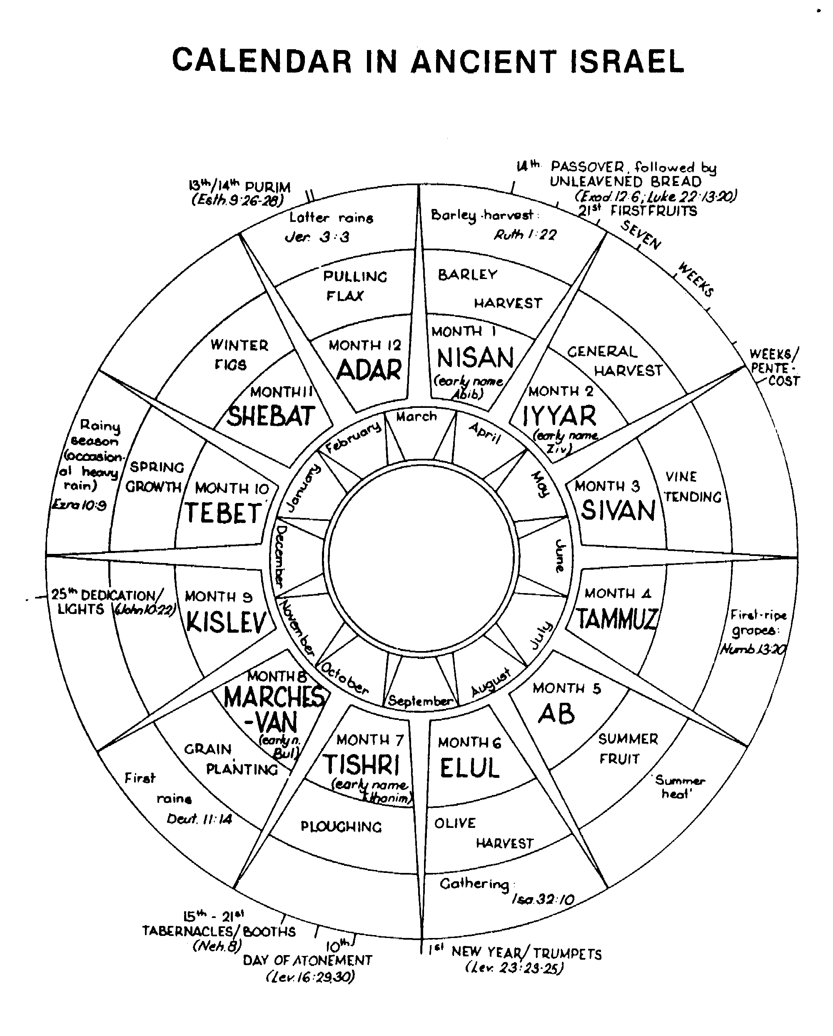

Scholars may wish to copy this calendar chart onto a Bible insert page and perhaps colour it in with sketches of the various activities such as harvesting and ploughing.

FACTS THAT SHOW THE THEORY OF EVOLUTION TO BE FALSE
1. THE GAPS BETWEEN THE SPECIES
Genesis Chapter 1 refers to the various "kinds" of creatures, e.g., "Every winged fowl after his kind" (v.21) and "beast of the earth after his kind" (v.24). Biology confirms the very distinct gaps between the different "kinds" or "species" of living things. Interbreeding between species never occurs in normal conditions. Where interbreeding does occur through man's control, the resulting hybrids are normally sterile — such is nature's barrier to the merging of the species.

This picture is not that which evolution would predict. If evolution is occurring, then there ought to be evidence in nature of transitional forms between one species and another. But all the gaps are bigger than evolutionists could wish. Even where deliberate human selection is involved, a new species has never been produced. Dog breeders can produce only dogs, rose breeders nothing but roses. Even fruit-fly breeders, who run through dozens of generations a year, have never bred anything but weird, mis-shapen fruit flies.

The vast gap between man and the apes is the most embarrassing gap of all to the evolutionist. If man is only a "naked ape", how did he acquire a brain that, although only a little bigger, can be a million times more powerful than that of the apes? What was it that caused man to be able to think abstractly, so that he can be a mathematician, a philosopher, a physicist, a poet? Why has he alone a voice which enables him to communicate abstract ideas and pass on his learning from one generation to another? How did he develop unique hands which enable him to put his brain to best effect? What process of "survival of the fittest" gave man his sense of humour, his artistic abilities, his appreciation of music, his sense of beauty, his ability to appreciate moral issues?

Evolution is left grasping for answers, but the Bible plainly reveals that: "God created man in his own image, in the image of God created he him" (Gen. 1:27).

2. THE FAILURE TO PRODUCE FOSSIL EVIDENCE
Darwin and his contemporaries had great hopes that geological research would eventually produce fossils showing gradual changes between species. After more than 100 years of such research and the discovery of millions of fossils, the gaps between species are still there. Furthermore the gaps in the fossil record correspond to the gaps in the living world today.

There is nothing to fill the gaps between:

fish and amphibia
amphibia and reptiles
reptiles and birds
reptiles and mammals.

Evolutionists have desperately searched for fossil evidence of man's evolution, but the earliest fossil men found are still Homo sapiens walking erect and with a brain as large as that of modern European man. Claims of supposedly prehuman fossils have been based on such scanty evidence as to bring the evolutionist into disrepute.

If man has descended from a lower form, there should be thousands upon thousands of intermediate hominoids (early "man") fully preserved and readily classified as such. Huxley, an eminent evolutionist, said that evolution would stand or fall on the fossil record. He was right. It falls!

3. THE COMPLEXITY OF NATURE
Evolutionary theory assumes that changes occurred on a "step-by-step" basis over countless ages. But numerous features found in nature can only be classed as "all or'nothing".
The eye with all its finely balanced components does not see unless it is fully developed. The ear does not hear unless all its intricacies are present and operational. How can evolution explain these organs in terms of gradual changes?
A bird flies because of: (1) its feathers (themselves very complex), (2) a lightweight body, (3) powerful wing muscles. Did blind chance cause all these to develop simultaneously, given that a complete development of all three was required before the bird could take off and fly and so gain an advantage over its fellows? Furthermore, did blind chance cause this to happen not once, but three times, for the ability to fly must have evolved separately for birds, bats and insects?

The poison apparatus of a snake requires: (1) a chemical plant for making the venom, (2) a safe storage vessel for it, (3) an
elaborate delivery system (fangs), (4) the instinctive skill to use the weapon effectively, (5) safeguards to ensure that the snake
does not poison itself. How could such apparatus evolve in stages?

Nature is filled with such complexities that evolutionary theory cannot explain. The honest response is: "O Lord, how manifold are thy works, in wisdom hast thou made them all" (Psa. 104:24).

4. THE PROBLEM OF LIFE'S ORIGIN
Life was thought to evolve starting from "simple cells". But even the simplest life is far from simple.

The simplest living things are viruses which typically consist of one large nucleic acid molecule surrounded by some protein molecules. Could a virus have evolved? Firstly nucleic acid is an extremely complex chemical with tens upon tens of thousands of atoms arranged in exactly the right order. Secondly proteins are also very large and complex molecules. Thirdly nucleic acid cannot thrive and multiply without its protein molecules. Fourthly, and most devastatingly, a virus is a parasite and can only grow and reproduce when living inside the body of some living host much larger than itself.

Evolution would require first the chance production of a far, far more complex one-celled creature, such as bacteria. The odds that this occurred are in the realm of fantasy.

5. THE MECHANICS OF EVOLUTION
At first evolution was thought to have occurred by changes acquired by habit, use, disuse or a change in environment being inherited by offspring. But after years of fruitless research, this theory has been largely abandoned.

Then came "neo-Darwinism" which explained change on the basis of random mutations coupled with the survival of the fittest. Mutations are basically changed offspring resulting from damaged genes in the parent caused by high level radiation. But mutations are most unlikely events and the vast majority of, if not all, mutations are harmful. Artificially induced mutations in fruit flies cause wilted wings, short wings, curled wings, stumpy wings — all useless to the fly. Mutations produce chaos, deformity and disability to already well-organised animals.

The lack of a mechanism for evolution has caused some evolutionists to suggest that evolution occurred in steps — e.g. a feather suddenly appeared on the offspring of a reptile. Men will do anything, but turn in reverence to the One who made them!

