257. FROM THE CALL OF ABRAHAM TO THE DESTRUCTION OF SODOM
"By faith. . . he went out, not knowing whither he went"

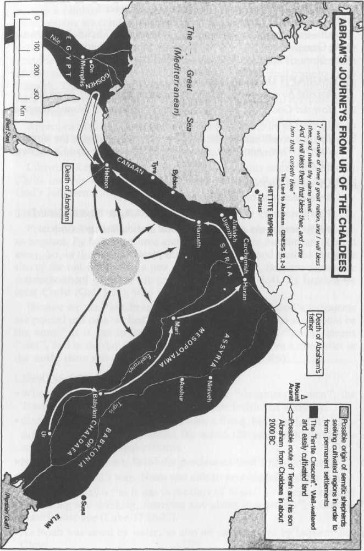
The call of Abram represented a new beginning. It was momentous in its importance for the whole world, for from him arose the nation of Israel as the centre of Divine Truth in the earth, and from which would come, in due course, the Divinely provided Saviour. The following two lessons will summarize the events in Abram's life as recorded in Genesis 12-22. They will concentrate on the narrative and show the ways of providence in the events and circumstances of Abram's pilgrimage. Lesson 259 will gather together from the same chapters the glorious hope of the promises given at various times to this great man of faith. The aim of this lesson is to show how great was Abram's faith when he responded to God's call and how righteous Lot was saved from Sodom.

Genesis 12-19

GOD'S CALL TO ABRAM—AND HIS RESPONSE (Gen. 11:26-32; 12:1-9).
(1) The First Call.
Abram lived in Ur of the Chaldees, an important city, but a centre of idolatry, on the bank of the Euphrates River. The noted archaeologist, Sir L. Woolley, in his book "Ur of the Chaldees," has shown that the city had great libraries and an advanced culture. It had a massive temple and it was the headquarters of the worship of the moon goddess.
When God called Abram thence, he had to leave a civilization sunken in idolatry. It is clear from Acts 7:2 that the first call to leave Babylon for the land of promise came to Abram in Ur, before he came to Haran. Similarly, Nehemiah 9:7 shows that the call came to Abram and not Terah his father, even though Terah's position as head of the family is preserved by his being mentioned first in Gen. 11:31. Terah himself, along with the rest of Abram's family, was an idolator (Josh. 24:2).
Again, whilst Gen. 11:32 states that "they went forth... to go into the land of Canaan", the land to which they were to go was not at first specified. At the outset, the ultimate destination was unknown, for it is recorded that Abraham "went out, not knowing whither he went" (Heb. 11:8).
Abram left Ur, with Terah his father, Nahor his brother, Lot his nephew, and Sarai his wife. He travelled in a north-westerly direction along the course of the Euphrates River, and eventually came to Haran. Here Abram received further instruction from God, and he sought to instruct and influence those there to join him in his entry into the land to which God was leading him (Gen. 12:1, 5).

(2) The Second Call.
To leave Haran and cross the River Euphrates into Canaan was to quit Babylon's civilization once and for all. There are those who will go so far in leaving behind the world of sin, but will not make the final break. So it was with Abram's family. It appears that they were reluctant to go any further. Then Terah died, and once more Abram heard the Voice of God commanding him, if need be, to go on alone. Gen. 12:1, which reads "Now the Lord had said unto Abram", should read: "Now the Lord said unto Abram" (R.V.), and the following words, "Get thee out" have the emphasis upon the word "THEE", as if God were saying "Abram — go for THYSELF".
Abram owed no patriotism to Babylon, the land of his birth. Further, family ties must not restrict his obedience to God, He had to leave his "kindred" and go into the land that God would show him (v.1). Thus Abram responded to God's call to enter the land. Of his immediate family, only his wife Sarai and his nephew Lot followed him. They took with them "their substance that they had gathered, and the souls that they had gotten in Haran", and came into the land of Canaan (v.5).

(3) Abram The Pilgrim
Having entered the Land of Promise, Abram was thereafter known as "Abram the Hebrew" (14:13). The word "Hebrew" means "A crosser over". He had crossed over from the ways of idolatry to the ways of God, from the Land of Babylon to the Land of Promise. The symbol of his changed state was his crossing over the River Euphrates, as we today pass through the waters of baptism into Christ.
Notice the process of Abram's spiritual development:

1st — Living in an idolatrous city;
2nd — He hears the call of God and sets out to leave the world behind him;
3rd — He comes to the Land of Promise, where he lives as a stranger and pilgrim, relying on God's care of him (Heb. 11:8-9).

Having entered the land, Abram travelled through it to Shechem (Gen. 12:6), where God renewed His promise (v.7), to Bethel (v.8), and then south again towards Beersheba (v.9). Famine then drove him into Egypt (v.10).

SEPARATION OF ABRAM AND LOT (Gen. 13:1-9).
Time spent in Egypt is not stated, but whilst there, God blessed Abram and Lot, so that their wealth increased greatly. The drought over, they journeyed north to Bethel, where Abram had built an altar (13:3, 12:8).
Specifically the altar had been built "between Bethel (the house of God) and Hai (Ruin)". On one side lay hope, and on the other disaster — all the difference between a wise choice and an unwise one. The place names are thus significant.
When Abram and Lot returned, their greatly increased flocks and herds had to compete for scarce grazing land made scarcer by the presence of "the Canaanite and the Perizite". Inevitably, strife and contention between their herdsmen resulted, and it became clear to Abram they would have to separate.
Abram found the disagreement unpleasant. As the elder and the leader of the party, he could have commanded Lot to obey his directions, but as a true pilgrim, he was not one to insist on his rights. The land had been promised to Abram, not Lot, who should have directed his herdmen to cease from strife as soon as it commenced. He should have deferred to his uncle's judgment in the matter, but he did not. So Abram deferred to Lot. He invited his nephew to take the land of his choice, so that he might take what remained. Eventually all the land would be his. But Abram's faith was that of the pilgrim who waited patiently for the Kingdom (cp. Heb. 11:13).

LOT'S CHOICE AND ITS EFFECTS (Gen. 13:10-18).
Lot chose the plain of Jordan toward the cities of Sodom and Gomorrah, and he suffered as a consequence. He left Abram for his new life towards the alluring cities of the plain. Spurred on by what appealed to the lust of his eyes, Lot's choice commenced a train of circumstances that led him to poverty and near ruin. Follow this train in your Bible. Remember that the same fate can be ours if we allow it. Here are six steps in Lot's decline following his strife with Abram:

- He LOOKED towards the well-watered plain (v 10).
- He CHOSE the luxury of the plain (v.11).
- He JOURNEYED east (v.11).
- He PITCHED towards Sodom (v.12).
- He DWELT IN Sodom (14:12).
- He WAS ALMOST OVERWHELMED in Sodom's disaster (Ch. 19).

Life might have had more problems for Abram, seeing his herds and flocks were denied the plentiful pasture of the plain; but in his honest labour and solitude he had communion with God which carried with it real peace of mind and happiness. It was not long before Lot's involvement in the life of the plain led to him being carried captive in one of its wars — from which Abram delivered him. At that time Abram made it very clear that he himself would have no part with the things of Sodom (14:14-24).

THE ANGEL'S VISIT TO ABRAHAM (Gen. 18).
Time passed. Lot and his family became more closely involved in the city life of Sodom. Meanwhile God had commanded Abram to be circumcised as the token of His covenant with him and his name was changed to Abraham. He was nearly 100 years of age and Sarai (now called Sarah) was 10 years younger.
The time had come for God to judge Sodom and the cities of the plain, and to extend His mercy to Abraham in providing the promised seed. So Yahweh appeared to Abraham, who was sitting in the door of his tent in the heat of the day. Suddenly, looking up, "three men stood by him". They were Yahweh's angels.
Abraham lost no time in offering them hospitality. At first, he did not know who his visitors were (cp. Heb. 13:1, 2), but it soon became clear that they spoke for Yahweh. Sarah found it difficult to accept their message, but they assured Abraham that "at the time appointed... according to the time of life... Sarah should have a son" (v.10).
Once their mission with Abraham was completed, the angels rose up and went towards Sodom. Abraham went with them. Because of his faithfulness (vv. 18-19), they told him of the impending judgment of Sodom and Gomorrah. Two of the angels set out to go there, while one remained with Abraham (v.22).
Although years had passed since their separation, Abraham retained a deep affection for Lot. He knew he was in Sodom, and he greatly feared that he would be overwhelmed in the city's judgment. He also knew Lot was a righteous person who would find no pleasure in Sodom's ways, and that his unwise choice in the beginning had led to him being entangled in its society (cp. 2 Pet. 2:8). So he pleaded for him: "Wilt thou also destroy the righteous with the wicked?" (v.23). God said that the city would be spared if there could be found 50, 45, 40, 30, 20 and finally as few as 10 righteous persons in its midst (vv.24-32).

LOT SAVED (Gen. 19:1-23).
It was evening when the two angels arrived at Sodom. Lot was sitting "in the gate of Sodom" — a place of prominence in the city (cp. v.9; Job 29:7-12). Like Abraham, he did not hesitate to offer them hospitality, pressing them to accept it when they would have refused. He knew how wicked the men of Sodom were, and protected his guests from evil. The men of Sodom regarded his action as an insult. They massed outside his home, and demanded that he deliver his guests to them. Lot went outside, and shut the door behind him. He tried to reason with them, but in vain. Such was their anger, that his life was threatened. The angels pulled him inside, struck blind his attackers and so he was saved.
Once inside, the angels informed him that the city would be destroyed. They had satisfied themselves that it was beyond help, but first they had to deliver the one righteous man it contained, and whoever else would listen to his call to separate. Urged on by the angels, Lot gathered together all his relatives, and pleaded with them all night to leave, but to no avail. With the coming of the dawn, the angels were urgent that he should leave with whoever would go with him. When he lingered, they led him, his wife and his two daughters out of the city, saying, "Escape for thy life: look not behind thee, neither stay thou in all the plain; escape to the mountain, lest thou be consumed" (v.17). Lot pleaded that he might find refuge in Zoar instead of the mountain and God granted his request. He withheld judgment upon the cities of the plain until Lot was clear of them. When Lot reached Zoar, the sun had risen in the sky. His entry there was the signal God awaited before pouring out His wrath.

SODOM DESTROYED (Gen. 19:24-30).
Suddenly, God's terrible judgment rained down. Fire and brimstone poured upon the land and cities. The earth erupted, and heaved to and fro. Volcanic ash settled all around, poisoning and sterilizing the land. It was reduced to a barren wilderness.
The attraction of Sodom proved too much for Lot's wife — she looked back with longing eyes and became a "pillar of salt". Jesus warned us when he said, "Remember Lot's wife" (Lk. 17:32).
Early in the morning, Abraham arose and stood in the place where he had pleaded with the angel for Lot. He looked toward Sodom and Gomorrah and "Lo; the smoke of country went up as the smoke of a furnace" (v.28). At the time he did not know it, but God had answered his prayer, delivering Lot for his sake (v. 29).

SIGNS OF THE TIMES (Luke 17:28-30).
The sin of Sodom is described by Ezekiel as "pride, fulness of bread, and abundance of idleness... neither did she strengthen the hand of the poor and needy" (16:48-49). Alongside extreme wealth could be found unrelieved poverty — and so it is today, as we are on the eve of the Lord's second coming. The days of Lot were said by the Lord to be characteristic of those of his second advent. Then, they "ate and drank, bought and sold, planted and builded". So preoccupied were they with the pursuit of material things, that all thought of God was pushed aside until destruction befell them. It is so today, for the world beckons men to indulge their fleshly appetites to the exclusion of God.
The destruction of Sodom took place primarily because of the prevalence of the sin to which Sodom has given its name, sodomy or homosexuality.
It is notable too, that this gross sin is widespread in modern Western society, and is even legalized in some countries. The awful end of Sodom has been set forth by God as a lesson to all those who might become involved in this perverted behaviour (Jude 7).
In both the old and new testaments this sin is utterly condemned by God, despite the attempts by some churchmen to justify it, and even ordain ministers who are homosexuals. (Lev. 18:22, 20:13; Rom. 1:27; 1 Cor. 6:9). These quotations serve to show how far many have strayed from the clear teaching of scripture.
The fact that homosexuality is so widespread and "acceptable" to our modern society is a sign in itself that we are living in the last days. History testifies that this sin becomes widespread when the morals of society sink to a low ebb, and that divine judgements swiftly follow.
Remember that Jesus said "as it was in the days of Lot, they did eat, they drank... But the same day that Lot went out of Sodom, it rained fire and brimstone from heaven, and destroyed them all. EVEN THUS shall it be in the day that the Son of Man is revealed". (Luke 17:28-30).

LESSONS FOR US:
- As Abraham was called upon to abandon the superstition of Babylon, so are we.
- Lot, Abraham's nephew, faithfully followed Abraham into the promised land, but allowed Sodom's attractions to lure him away from a life of total commitment.
- Lot became embroiled in Sodom and lost all, barely escaping with his life. Jesus has warned us that a similar fate awaits this world and has told us to "Remember Lot's wife".

REFERENCE LIBRARY:
"The Ways of Providence" (R. Roberts)—Chapter 3
"The Visible Hand of God" (R. Roberts)—Chapter 7
"Elpis Israel" (J. Thomas)—Part Second, Chapters 1 and 2
"Ur of the Chaldees" (Sir. L. Woolley)
"Story of the Bible" (H. P. Mansfield)—Vol.1, Pages 77-92, 105-110
"Christadelphian Instructor" (R. Roberts)—Nos. 82-89

PARAGRAPH QUESTIONS:
- Describe God's call to Abram and how he responded.
- What is the significance of the word "Hebrew"?
- What are the steps which led to Lot's decline?
- Why was Lot saved from destruction in Sodom?
- What did Jesus mean when he said, "As it was in the days of Lot..."?

ESSAY QUESTIONS:
- Write a short essay on Abraham the pilgrim.
- How did Lot become involved in Sodom? Describe his escape. How does Lot's situation correspond with our own?
- What lessons can we learn from the life of Lot?
- What does the Bible have to say about the sin of Sodomy? How are God's judgements against Sodom a warning to modern society?
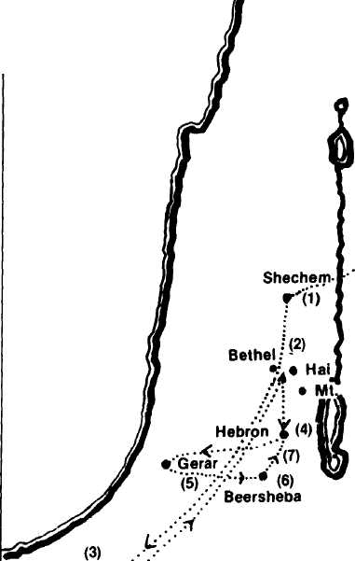
- Abram arrives with Lot and his family from Haran and builds an altar (12:6-7).
- Abram pitches his tent between Bethel and Hai and then builds an altar (12:8).
- To Egypt to escape a famine and return to Bethel/Hai (12:9-10; 13:1-4).
- After Lot has departed for the city of Sodom, Abram moves south to Hebron and builds another altar (13:18).
- Abraham sojourns in Gerar amongst the Philistines (20:1).
- Removes to Beersheba from where he travels to Mt. Moriah to offer Isaac (21:32-33; 22:2).
- Abraham buries Sarah in the cave of Machpelah near Hebron and later is buried there himself (23:19; 25:8-9).

