273. THE MOST SACRED PLACE IN ISRAEL
"The way into the holiest of all was not yet manifest"

The Most Holy Place was Israel's most sacred place, as its name indicates. Only the High Priest was permitted into it, and even then only once a year after special conditions had been fulfilled. In this way, all Israel was impressed with the holiness of Yahweh their God. He is separate from all flesh, and man must humble himself before Him if he would find approval in His sight. Our aim is to see the lessons embodied in the Most Holy Place of the Tabernacle.

Exodus 25:10-22; 37:1-9

THE MOST HOLY PLACE.
The Tabernacle was divided into two rooms by an embroidered curtain, known as the Veil (Ex. 26:31-37). The Most Holy Place was a perfect cube, 4.6 metres high, wide and long. It was at the far end of the Tabernacle. It was the dwelling-place of Yahweh in Israel: from here He would commune with Israel (read Ex. 25:22; Num. 7:89). There His glory shone forth and illuminated the otherwise dark interior of the Most Holy Place (Ps. 99:1; 80:1; Ex. 40:34).

THE ARK OF THE COVENANT (Ex. 25:10-22).
The only furniture in the Most Holy Place was a simple chest made of wood, which was covered with gold within and without. Its lid or covering was called the Mercy Seat. It was made of pure gold, and two Cherubim or figures with outstretched wings, one at each end, were beaten from the same piece of gold as the Mercy Seat. The faces of the Cherubim looked down towards the Mercy Seat (v.20). Inside the Ark there were placed three items — the two tables of stone on which the Law was inscribed (v.21), a golden pot containing manna, and later, Aaron's rod that budded (Heb. 9:4-5).
The Cherubim represented Israel in future glory (Rev. 4:7; 5:9-10). They were made entirely of gold, and the "precious sons of Zion" are "comparable to fine gold" (Lam. 4:2). They do not represent the complaining, disobedient Israel we read of in the Bible, but the true Israelites, those men and women of all ages who have embraced the Hope of Israel and so have become "Israelites indeed" (Gal. 3:26-29). Their faith has been tried in the fire of affliction and they have "come forth as gold"; they will be Yahweh's messengers in the Kingdom (Job. 23:10).
The Mercy Seat pointed forward to Jesus Christ. In Romans 3:25, he is called our Mercy Seat, for the word there translated "propitiation" can be rendered "mercy seat". Note well that the Cherubim and the Mercy seat were beaten out of the same piece of gold (Ex. 25:18-19). The Cherubim are "one" with the mercy seat as true believers should be "one" with Christ Jesus (Jn. 17:20-21). Notice, too, that the faces of the Cherubim are turned towards the Mercy Seat (Ex. 25:20), as the faces of the true believers should always be towards their Lord (Psa. 27:6-9).
From the mercy seat God spoke to Israel, even as He has spoken to us in His Son (cp. Num. 7:89; Heb. 1:1-2); there He "met" Israel, and Jesus Christ is alone the one through whom we can approach God (Jn. 14:6; 1 Tim. 2:5).

BLOOD IN THE MOST HOLY PLACE.
When the High Priest entered the Most Holy Place once every year, on the day of Atonement, he was commanded to sprinkle the Mercy Seat with blood (Lev. 16:14). If he presumed to go into the Most Holy Place without doing this, he would be killed by God (Lev. 16:2). The Cherubim looked down, their faces turned toward the Mercy Seat sprinkled with blood. Likewise our eyes turn to the Lord Jesus Christ, and we remember his sacrifice. We "see" his great offering for us, and we realize that without it, we could not be saved.
The holiness of God is emphasized by the limited access into the Most Holy Place. In fact, as the Most Holy Place was approached, fewer in Israel were involved: thus:
- Outside the Court were the thousands of Israel;
- Inside the Court only the Levites and Priests could come;
- In the Holy Place only the Priests could officiate;
- Into the Most Holy only the High Priest could enter, and then only once a year.

CONTENTS OF THE ARK.
Everything in the Most Holy Place emphasized ultimate perfection, that state of perfect fellowship and harmony with the Eternal God. Gold, the only metal used, symbolizes that which is precious and enduring or immortal. It also speaks of a tried faith which is required of those who shall attain to the ultimate state.

Consider also the contents:

- The Two Stones, on which the law of God was engraved, were of an enduring material.
- The Golden Pot contained the manna which kept forever and did not corrupt. See Rev. 2:17.
- Aaron's Rod which rod budded after being "dead" to show that God had chosen his family alone to be the priests (see Num. 17). So, too, Jesus has been brought from the dead and given eternal life, and this fact proves that he alone is the mediator between God and man (Heb. 7:23-25).

THE GLORY OF YAHWEH.
No outside light entered the Most Holy; even the light of the seven-branched lampstand was cut off by the dividing curtain. It was illuminated, however, by the glory of Yahweh, which shone from between the Cherubim and above the Mercy Seat (Ex. 29:43; 40:34; 25:22; Ps. 80:1).
When Jesus appeared 1900 years ago, he was likened to the LIGHT or GLORY of God SHINING IN A DARK PLACE (Jn. 1:5). He revealed the moral glory of the Father unto men. In all he said, and did, as well as in his wonderful character, there was to be seen a reflection of the Divine Glory. Now, however, following his resurrection and glorification, he reveals in all aspects the DIVINE GLORY. As the High Priest saw the glory of God above the Mercy Seat, we can visualize it displayed by the Lord Jesus. John says that the disciples beheld in him "the glory of the Father" (Jn. 1:14). All the world will see this at his second advent.
The glory of Yahweh that shone above the Mercy Seat symbolized moral perfection, the thing to be aimed at by God's people, as Jesus taught in Matt. 5:16. We reflect the moral glory of the Lord now when he dwells in our hearts by faith (Eph. 3:17). If we are faithful, we will attain to a glorious body like that which the Lord Jesus now has (Phil. 3:21; 1 Jn. 3:1-3). We live "in hope of the glory of God". When Jesus returns and changes our "vile" mortal bodies into glorious immortal bodies, men will behold in us the physical glory of God, in addition to the moral glory (Phil. 2:15).

THE PATH OF VICTORY.
Our walk towards ultimate perfection is depicted in a parable in the various stages of the Tabernacle—

1. Preparation
- The first requirement is knowledge. All must recognize in Jesus Christ the door through whom entrance is gained.
- Though the Brasen Altar was the first object seen in the Outer Court, the priests had to bypass it and first wash their hands and feet at the Laver. The water of the Word of God cleanses our minds and so purifies our walk (feet) and deeds (hands). In baptism our sins are washed away.
- Then we can partake of the altar of Christ, and our worship and offerings are acceptable to God because we are in him (Heb. 13:10). Only then we are able to minister in the Holy Place, the Ecclesia.

2. Dedication or Walking in the Light
A person does this when, having accepted Christ in the way appointed, he determines that he will walk with Christ in all his ways.
- He knows he must walk in the light of the Lampstand; he must be morally sound, living in conformity with Divine Truth.
- He must provide the shewbread for God with the frankincense, that is, he must offer to God the fruit of his labours, prayerfully and humbly.
- He must be a man of prayer (incense).

3. Exaltation or Sharing the Glory
The Veil symbolized "the flesh" (Heb. 10:20). Beyond the veil immorality and perfect fellowship with God is symbolized, when "the flesh" shall be put aside.

The ultimate glory of the perfected saints may be seen by considering Jesus when he was transfigured before his brethren (Matt. 17:2), or when he appeared to Saul on the Damascus road (Acts 9:3; 22:6; 26:13). As he is, so we may become (1 Jn. 3:1-3).

LESSONS FOR US:
• The three sections of the Tabernacle correspond to the steps by which God's glory might be attained:
- Outer court—Preparation—mental glory;
- Holy Place—Walking in the light—moral glory;
- Most Holy Place—Sharing the glory—physical glory.
•As the Most Holy Place was approached, fewer in Israel were permitted to officiate. God is holy and separate from flesh.
• Jesus has told us that many are called but few will be chosen. Only they will enter the immortal, divine state, represented by the Most Holy Place. Let us strive so that we might be accounted worthy of an entrance into the Kingdom of God.

REFERENCE LIBRARY:
"The Visible Hand of God" (R. Roberts)—Chapter 17
"The Law of Moses" (R. Roberts)—Chapter 13
"Law and Grace" (W. F. Barling)—Pages 63-66
"The Tabernacle" (C.S.S.S.)

PARAGRAPH QUESTIONS:
- Explain briefly the lessons contained in the contents of the Ark of the Covenant.
- What is the significance of the Veil separating the Most Holy Place from the Holy Place?
- What were the Cherubim, Mercy Seat and the Ark? What were they made of and how were they connected?
- How does the Tabernacle illustrate the three steps in our calling?

ESSAY QUESTIONS:
- Explain the connection between the Cherubim, the Mercy Seat and the sprinkled blood in the Most Holy Place and give their significance?
- Describe how the glory of Yahweh is progressively revealed in the Tabernacle.
- How does the Most Holy Place and its contents teach us about the future?

THE FURNITURE OF THE TABERNACLE
THE BRAZEN ALTAR
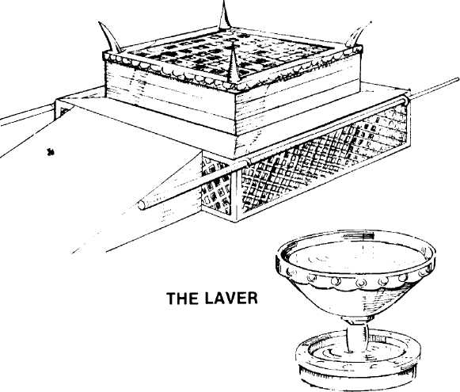

THE SEVEN BRANCHED LAMPSTAND
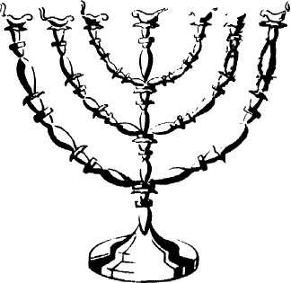

TABLE OF SHEWBREAD
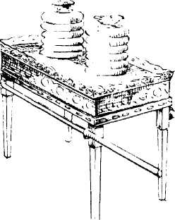

ALTAR OF INCENSE

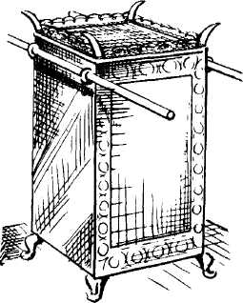
THE ARK OF THE COVENANT

