276. WHY ISRAEL FAILED
"Who shall give us flesh to eat"

It was a scene of glory when Israel left Mt. Sinai after a stay of about twelve months (cp. Ex. 19:1; Num. 10:11). Here was "the ecclesia in the wilderness" (Acts 7:38) to whom "the gospel was preached" (Heb. 4:2). A journey of only eleven days separated them from the Promised Land, but within a few days the people had become dispirited by the hard, tiring walk through the barren and desolate wilderness. Israel soon forgot that the Land of Promise was just ahead of them and that they had the power to overcome their present problems to possess it. They allowed their problems to get the better of them and so lost their zeal for the purpose that God had with them. Instead of taking them eleven days, faithlessness brought condemnation and over 38 years passed by before they crossed over Jordan.

Our aim in this lesson is to see the disasters and disappointments that can come if we lose sight of the hope of the promised land before us.

Numbers 10:11 -12:16

DEPARTURE FROM SINAI (Num. 10).
Summoned by the blast of the trumpets, Israel departed from Sinai as an army, with the standards of the tribes waving proudly to the sound of marching feet. The cloud of glory, the symbol of Yahweh's presence, went on before them (vv. 11-13), and the nation marched in four divisions, under the leadership of Judah (v.14), Reuben (v. 18), Ephraim (v. 22) and Dan. (v. 25).

In the centre of the marching tribes came the Tabernacle carried by the Levites. A prefabricated structure, it could be quickly dismantled or erected during the journeying of the children of Israel.

The entire scene was one of orderliness and confidence. The day's march began and ended with a prayer (vv. 35-36). Israel had the power to conquer and they had the invitation of God to enter the Land. A journey of only eleven days lay before them (Deut. 1:2, 8).

THE PEOPLE MURMUR AT TABERAH (Num. 11:1-3).

Between Sinai and Kadesh, the Israelites had to pass through "that great and terrible wilderness" (Deut. 1:19). In these appalling conditions the people soon began to complain (Num. 11:1). This was the start of a general apostasy from God's way. We should always remember that 'grumbling' can set a bad example to others. To work in the Truth is a great privilege and all such opportunities to serve our Master should be accepted cheerfully and gratefully (cp. Phil. 2:14; 4:11).

Fire from God consumed many of the complainers at this spot, which afterwards became known as Taberah, i.e. "burning". Our God is "a consuming fire" to those who refuse to obey Him (Heb. 12:29).

DISCONTENTMENT AFTER TABERAH (Num. 11:4-15).
As they journeyed on in this wilderness, it was the "mixed multitude" who could no longer endure the hardships. These were the Gentiles who had come out of Egypt with Israel (Ex. 12:38). They looked back instead of forward. They longed for the spicy diet of Egypt and loathed the manna of God's providing which they considered monotonous and tasteless (Num. 11:5-6). Their cry at this time was "Give us flesh" (v.13), and they led the people of Israel into the same attitude.

We too can exemplify the cry, "Give us flesh", if we consider the Word of God dull and uninteresting, and seek the things that are palatable to our fleshly instincts. It is far better to stay with the wholesome words of Truth as our staple diet (cp. Ps. 119:97-103). We can see, too, that complaining produced a chain reaction and affected many others. But zeal also is contagious: if we are enthusiastic for the things of God we will encourage and build up our fellow pilgrims.

PROVISION OF QUAILS (Num. 11:16-35).
The Israelites desired flesh and God said that He would provide the same, but in a way that would teach them a grim lesson (vv. 18-20). God caused a wind to blow and with it came vast flocks of quails which settled round the camp. The people thought that this was the answer to their prayers. With greedy expectation they rushed out of doors to gather the quails so abundantly supplied. For a full day and a night, plus all the next day, they stood up and gathered the quails (v. 32).

They had no desire for the food of God's providing, but found no difficulty in staying up all night to gather that for which "flesh" craved. In their greed and haste to gather as much as possible, there was not a single thought for the Giver of it.

Retribution was swift and decisive. While the flesh was in their mouths, they were smitten down with a deadly plague. The name of the burial plot, Kibroth-hattaavah, memorialized the sin and the lesson, for it means "the graves of the greedy" (vv. 33-34). The Psalmist, commenting upon this incident, says, "God smote the fattest of them" (Ps. 78:29-31).

What a grim lesson is this. Do we ever think that instruction drawn from the Bible is dry and boring? Do we sometimes wish for the spicy things of life? Do we find it difficult to sit through a spiritual exercise, but easy to listen to or look at that which panders to our lusts and emotions? The only cure to an answer of "yes" is to contemplate the utter vanity of all the ways of men and flesh and to turn to God. The Bible alone supplies the answer for our greatest need — salvation and eternal happiness. When this is understood, study of the Word becomes vital and interesting. "Blessed are they that do hunger and thirst after righteousness: for they shall be filled" (Matt. 5:6; cp. Psa. 119:20).

ENVY IN THE HOUSEHOLD OF MOSES (Num. 12).
After leaving Kibroth, the Israelites had not gone far when they were further delayed. Miriam, the sister of Moses, a prophetess (Ex. 15:20), and one of the three leaders, deprecated Moses and demanded a greater share of the authority and power (Num. 12:1-2). Aaron too became involved.

God had selected Moses as the leader because he had the essential qualifications for leadership: he was meek above all men, a quality which was especially noticeable when God at first called him (v.3; Ex. 3:11; 4:10-17; cp. 1 Pet. 5:1-3).

God moved swiftly to vindicate Moses. He, Miriam and Aaron were commanded to appear before the Tabernacle. The angel of God came down in the pillar of cloud and stood in the door of the Tabernacle. Miriam and Aaron were singled out and called forth. They were solemnly reminded of Moses' unique and close relationship with God. Whereas God would reveal Himself to a prophet in a vision or dream, Moses would enjoy a more intimate relationship: "with him will I speak mouth to mouth, even apparently, and not in dark speeches". Finally they were challenged, "Wherefore then were ye not afraid to speak against my servant Moses?" (vv. 4-9).

Furthermore God smote Miriam, and the dreadful plague of leprosy covered her flesh, humiliating her before the people (v. 10). Both Moses and Aaron pleaded for her, but for seven days God made a public example of her. Her sin was repugnant to God. Woman's position before man is one of submission — so God had ordained in the beginning (Gen. 3:16; 1 Cor. 11:7-12). In this the modern women's liberation movement defies the will of God and is likewise odious before Him. Therefore for seven days Miriam remained outside the camp, in which time the children of Israel "journeyed not".

KADESH REACHED.
The Israelites passed through the wilderness of Paran and at last they came to Kadesh (Num. 12:16; 13:26), south of the land of promise. The word Kadesh means "sanctuary". Sometimes called Kadesh Barnea (Deut. 1:19), it was an oasis in the harsh wilderness, a place of beauty at the edge of a region of complete and utter desert. For the first time the Israelites had a glimpse of the glorious land that God had promised them.

THE CAUSE OF FAILURE.
The writings of the apostles show that the basic cause of Israel's failure was faithlessness: they did not believe the Word which was preached unto them. Thus they lacked the vision of the promised land and instead turned back in their hearts to Egypt (Acts 7:37-39; Heb. 3:19; 4:1-2, 6).

Worldly attractions are likewise a temptation today. The pressures and influences of the world can produce in us an "unwillingness to hear". This in turn can cause us to put our trust in our own ability to provide for ourselves, rather than turning to our God for strength (cp. James 1:17). In our hearts there can be a "mixture" of pride and fleshly desire instead of a mixture of the Word of God and faith in that Word. We can fail for the same basic reasons as Israel did.

LESSONS FOR US:
Like "the ecclesia in the wilderness", we are being taken by God out of "Egypt" and are preparing for an entrance into the Kingdom of God.
We should therefore "forget" the things behind us and "reach forth" to the great vision before us (Phil. 3:13-14).
Rather than complain, we should be thankful for all we have (1 Thess. 5:18).
A longing for the passing excitement of the flesh will bring disaster to us, as it did to Israel (1 Cor. 10:6-11).
Envy and jealousy must be put aside by the disciple of Christ (Gal. 5:20-22).

REFERENCE LIBRARY:
"The Story of the Bible" (H. P. Mansfield) —Vol. 2, No. 4, 5
"Where It Happened" (I. Collyer)—Chapter 6
"Moses My Servant" (H. Tennant)—Pp. 105-114
"The Wilderness of Life" (J. Martin)—C.S.S.S. Study Notes
PARAGRAPH QUESTIONS:
- What was the basic cause of Israel's failure in the wilderness?
- Only an 11 day journey stood between Israel and the Promised Land. Mention three events which delayed them.
- Describe the incident involving quails at Kibroth Hattaavah.
- How did Miriam delay Israel's journey? What lessons do we learn from this?

ESSAY QUESTIONS:
- Describe how Israel failed after they left Mt. Sinai.
- In what ways can we fail on our journey towards God's Kingdom — the Promised Land? Compare our experiences with those of the children of Israel.
- Compare our journey to the Kingdom of God with the wilderness journey of Israel after they left Mt. Sinai.
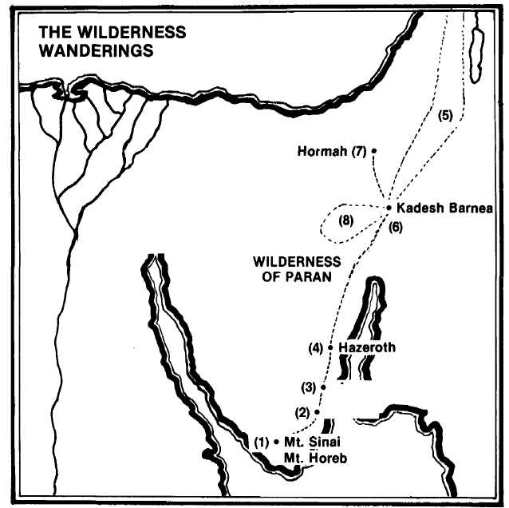

After a stay of about twelve months, Israel leaves Mt. Sinai, led by the pillar of cloud (Num. 10:11-13).
Complaining at Taberah brings destruction by burning (11:1-3).
The people cry for flesh and quails are provided, quickly followed by a plague (11:4-35).
Miriam and Aaron speak against Moses. Miriam is smitten with leprosy and Israel is delayed seven days (12:1-16).
Twelve men are sent from Kadesh Barnea to spy out the land (13:1-26).
The report of ten faithless spies causes Israel to rebel and seek to return to Egypt under a new leader (14:1-10).
Following the declaration of God's punishment, the people seek to enter the land, but are driven back by the Amalekites and Canaanites at Hormah (14:40-45).
During the 38 years further wanderings, Korah, Dathan and Abiram rebel against Moses and Aaron, and are swallowed up by the earth (16:1-35).

