279. THE DEATH OF MOSES
"His eye was not dim nor his natural force abated"

At Kadesh, God commanded Moses to speak unto the Rock that it might bring forth water. Moses disobeyed God in smiting the Rock and so was not allowed to enter the land.

"For unto whomsoever much is given of him shall be much required" (Luke 12:48). The importance of our careful attention to God's Word is emphasized in this incident in the life of the great man Moses.

This incident, together with the death of Aaron and Miriam, also highlights (in type) the fact that the Law cannot give life; it is through Jesus (Joshua) that entrance into the Land of Promise will be gained.

The aim of this lesson is to see how God's care of His people in the wilderness pointed forward in many ways to the work of Yahweh Jesus Christ.

Numbers 20 & 21:4-9; Deuteronomy 34

MOSES PUNISHED (Num. 20:1-13).
For 38 years Israel wandered in the wilderness between Kadesh and Elath. As the time of wandering came to an end, they again moved north to Kadesh. There Miriam died (Num. 20:1). The people complained to Moses because of the lack of water. He was told to take Aaron's rod and SPEAK to the rock. Instead he SMOTE the rock and said, "Must WE bring water out from thence" (Ps. 106:32-33). Thus he not only disobeyed, but spoke inadvisably with his lips.

Paul says that the rock represented Christ (1 Cor. 10:4). Earlier, at Rephidim, Moses had been told to smite the rock in order to provide life-giving water (Ex. 17:5-6; refer Stage 1, Lesson 19). A second smiting of a rock at Kadesh was inappropriate as far as the type was concerned, for Christ was only once crucified, when the serpent power bruised him, and now all that was necessary was to "speak to the rock".

God punished Moses for his action. He told him that he would not enter the Land of Promise. In doing this, God emphasized to the people the importance of obedience. If a man like Moses, so faithful and earnest, was thus punished, how circumspect they must be.

The lesson is no less important for us. The Word of God demands that we obey its commands implicitly if we desire to enter the Kingdom. And as the Israelites then had to look to a new leader (Joshua) to bring them into the Promised Land, so likewise we look to Jesus (the Greek equivalent of 'Joshua') to bring us, through obedience to the Gospel, into the Kingdom of God.

DEATH OF AARON (Num. 20:14-29).
Following this incident at Kadesh, the children of Israel were refused passage through Edom (vv. 14-21). Therefore they journeyed southward toward the Gulf of Elath.

This took them past Mt. Hor (v.22), a barren rugged mountain from which a remarkable view of the harsh wilderness can be seen. Here Aaron died. His priestly garments were given to Eleazar his son and, ascending Mt. Hor, from which he could have one last look at the wild region in which the Israelites had wandered to and fro for so long, he passed to his rest.

FIERY SERPENTS IN THE WILDERNESS (Num. 21:4-9).
The journey was very dismal. Perhaps the people thought, when the King of Edom refused to give them passage, that they would perish in the wilderness like their fathers. In any case, they became "much discouraged because of the way" (v. 4). They felt that they were at the point of death, and were tired of the monotonous diet of manna. Were they to be as faithless as the previous generation?

God punished them by sending serpents among the people, which bit them so that many died (v. 6). The people saw this as the punishment of God — that death came because of sin. ("The sting of death is sin", 1 Cor. 15:56). "We have sinned", they declared and they asked Moses to help them by interceding with God (v.7).

Moses did so. He was told by God to make a serpent of brass and put it on a pole. All who looked at the serpent of brass would live. But they had to look upon it in faith — they had to believe it would save them. If they did not look upon the serpent of brass in faith, then it would be of no use to them — they would die.

Many years later, Yahweh Jesus referred to this incident as a type of his death (John 3:14-15). And what a wonderful lesson it teaches when seen as that. It takes us back to the promise of Eden (Gen. 3:15), and it takes us forward to the offering of Yahweh Jesus.

How does it apply to Jesus? We can liken human nature to the serpent. Jesus called the Scribes and Pharisees "serpents" (Matt. 23:33). They were like serpents with poison in their fangs, poisoning the minds of those who listened to them. Jesus was of the same nature as they were, of the same nature as we are (Heb. 2:14), but he did no sin. He was therefore represented by a serpent — not by a real serpent which stung and brought forth death, but rather by the brazen serpent which was "lifted up", just as he was lifted up for all to see in his crucifixion.

As the Israelites looked at the serpent of brass in faith and lived, in spite of having been bitten by the real serpents, so we who have been "bitten" by human nature must look at the crucified Jesus if we would
live. We must "crucify the flesh" with its affections and lusts and so overcome (Gal. 5:24).

Hence, in this journey towards the Promised Land, Israel was taught to look to the means God would provide to conquer sin and death.

TOWARDS THE PROMISED LAND.
At the top of the Gulf of Elath, Israel turned east and, after skirting the border of Edom, marched north to the range of forest and pasture lands on the east of Jordan. As they neared the Land of Promise the excitement of the people grew, and their joy found expression in poems of triumph and happiness. The desert was left far behind, and on the eastern side of the Jordan they could see the real beauty of the land they were to inherit.

Two kings opposed them — Sihon, the Amorite and Og, king of Bashan (Num. 21:23, 33) — but these were destroyed in pitched battles. The king of Moab employed the Babylonian prophet, Balaam, to curse Israel, but his curse was turned into a blessing and Moab, together with Balaam, was punished.

At last Israel stood on the borders of the Promised Land and made ready to enter into their inheritance.

DEATH OF MOSES (Deut. 34).
The book of Deuteronomy contains the last message of Moses, delivered during the last month of his life. He recapitulated to Israel all that had happened to the nation. He called upon them to "be strong and of good courage" (Deut. 31:6), telling them to put their trust and faith in God who would not fail them. He warned them of apostasy (Deut. 31:29), telling them that the time would come when they would depart from the ways of God, and this would be a challenge to those in their midst who desired to continue in the ways of righteousness.

The new leader, Joshua, was appointed (Deut. 31:7-8), and he was commanded to put his trust in God, to be "strong and of good courage", for he "must go with this people unto the land." Moses assured Joshua that God would not fail him.

At last the time came for the great leader to die. His physical strength was unaffected (Deut. 34:7), but his work was finished. Leaving the camp of Israel, he ascended Mt. Nebo, probably a mountain in the range of Pisgah. There before him was the Promised Land. Beneath him was the camp of Israel stretching out in its four divisions, awaiting the order to march. On the other side of Jordan could be seen the fortress of Jericho (key to the land of Palestine), the valley of Esdraelon, the twin hills of Ebal and Gerizim, the fertile valley of Shechem. There were the hills of Judea with the powerful fortress of Jebus standing out upon what was later called Mt. Zion. As Moses gazed over this scene he knew that, although he was not to lead the people into the land, one day he would stand within its borders. With Abraham and the other worthies, under the leadership of Yahweh Jesus, he will enter his inheritance. Like so many others, Moses "died in faith, not having received the promises, but having seen them afar off. . ." (Heb. 11:13). He died in confidence of his future inheritance and glory.

So passed to his death a very noble man. In leading Israel, in caring for the people, in interceding on their behalf, in bearing with their sins, in supporting them, in guiding them through the desert towards the Promised Land, in teaching them God's laws, in baptising them in the Red Sea — in all the many, many ways, we see him as a type of Yahweh Jesus (see Deut. 18:18-19). But the type was not complete in Moses, and thus another man was selected to lead Israel over Jordan — Joshua, the man of faith.

And as God buried one of His workmen, so another took up the task. For though the workmen die and lay down their tools, the work must go on.

LESSONS FOR US:
- As Moses experienced to his great sorrow, God requires that we follow His Word faithfully. Salvation and entry into "the Promised Land" will not come to those who distort His commands.
- Like the children of Israel, we must look to a new leader (Jesus/Joshua) to bring us into the Kingdom. This is something which the Law of Moses could never do.
- Salvation from the sting of sin requires faith or belief in "Christ crucified" and the work of atonement wrought through him. God gave His only beloved son "that whosoever believeth in him should not
perish, but have eternal life" (John 3:14-17).
- "Be strong and of good courage" is advice which Moses gave to Joshua, which David later gave to young Solomon, and which is applicable to any young person today facing the issues of truth and the world.
- Israel's experiences constituted a parable of our walk to the Kingdom of God (1 Cor. 10:1-11). We must come out of the world, be baptised into Christ, hearken to His word, be tested under trial, and submit to the Judgment at which some will be rejected and others accepted.

REFERENCE LIBRARY:
"The Visible Hand of God" (R. Roberts)—Chapter 19
"The Story of the Bible" (H. P. Mansfield)—Vol. 2, Nos. 8 & 9
"Moses My Servant" (H. Tennant)—Pages 148-165

PARAGRAPH QUESTIONS:
1 What lesson do we learn from the punishment God inflicted upon Moses?
2. In what ways was the brazen serpent a type of Jesus?
3 "These all died in faith, not having received the promises, but having seen them afar off and were persuaded of them and embraced them". How does Moses fit this description?

ESSAY QUESTIONS:
- Why was Moses not allowed to enter the Promised Land? What lesson do we learn from this?
- Describe the incident of the fiery serpents and show how this points forward to Christ's work in overcoming sin and death.
- How were Israel's wanderings and final entrance into the Promised Land a parable of our walk to the Kingdom?
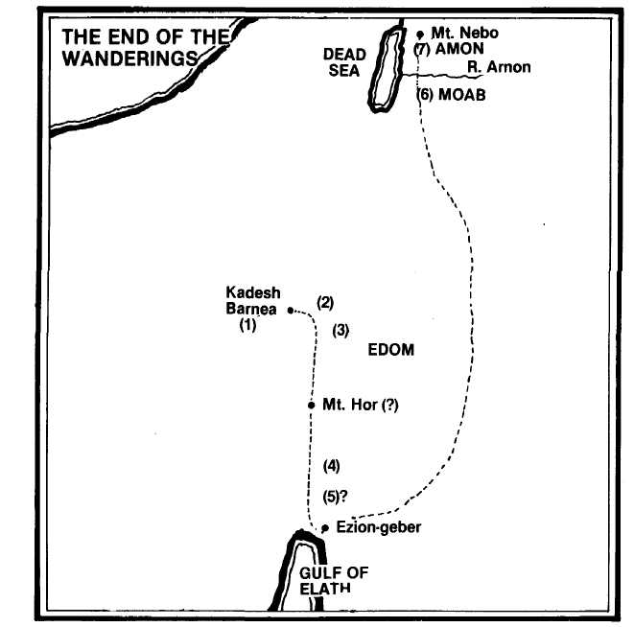

- At the end of the wilderness wanderings, Israel returned to Kadesh where Miriam died (Num. 20:1; 33:16-36).
- Moses sins in striking the rock to provide water (20:2-13).
- The king of Edom refuses Israel passage through his land, so Israel must detour south to skirt the land of Edom (20:14-22; 21:4; Deut. 2:8).
- Aaron ascends Mt. Hor on the border of Edom and dies (Num. 20:23-29).
- The people complain again and God sends fiery serpents, from whose bite those who look to the brazen serpent on a pole can be healed (21:4-9).
- Israel, climbing the rugged canyon of Arnon, obtained a great victory over Sihon king of the Amorites and then Og king of Bashan (21:13).
- Moses ascends Mt. Nebo, from whence he views the whole promised land, and then dies (Deut. 34:1-8).

Section 2 CONQUEST OF THE LAND

In Lessons 5 to 10 the Book of Joshua is under consideration. We shall learn about the triumphant entry into the Promised Land and the fall of the gateway city, Jericho.

Following a central campaign, two further campaigns were conducted by Joshua against the confederated forces of the Canaanites in the south and also in the north. The strong nations were subdued and it .remained for the individual tribes to move to their allocated territories and to wipe out the remaining pockets of resistance. God had thus honored His promise to take Israel out of Egypt and bring them into Canaan.

But the conquest was not without salutary lessons — at Ai and later in connection with the Gibeonites. Though successful, the Israelites still needed to defer to Yahweh in all their decisions. Failure to do that was fraught with peril. On the positive side we find that greater, faithful men were rewarded — Joshua and Caleb received their promised inheritance.

The Section closes with Joshua's last words to the nation he had served so faithfully. He reminded them of the indisputable blessings showered on them as a nation from the call of Abraham onwards. God had guided the course of their national life, saving and delivering them in times of peril. This realization is made the basis of his final plea to his people to serve Yahweh in spirit and in Truth. So there is much in this section to learn and be admonished by.

