280. ENTERING THE LAND
"Be strong and of a good courage"

The crossing of the Jordan was important to the development of Israel as a nation. It ended the wilderness wanderings and commenced a new beginning as the nation entered its inheritance.

Prior to the death of Moses, Joshua had been selected as leader. "Be strong and of good courage; for thou shalt bring the children of Israel into the land," he was told (Deut. 31:6). He had the qualifications of courage, faith, wisdom and experience. The meaning of his name (Yahweh is salvation) indicated his mission. The Greek "Jesus" in the New Testament is the equivalent of the Hebrew "Joshua". Joshua was a type of Yahweh Jesus Christ who is our "Saviour" and the "Captain of our salvation ".

Our aim in this lesson is to see the triumph of faith and obedience in Israel's crossing of the river Jordan and to see the types shown in this incident.

Joshua 1, 3 & 4

JOSHUA'S COMMISSION (Josh. 1:1-9).
"Arise, go over this Jordan, thou, and all this people", was God's instruction to the new leader Joshua (v.2). Before them lay the challenge of a land which would be theirs, if only they had the courage to go in and possess it. Joshua was assured of God's help (v. 5), and given his guide for success: "This book of the law shall not depart out of thy mouth; but thou shalt meditate therein day and night, that thou mayest observe to do according to all that is written therein; for then thou shalt make thy way prosperous and then thou shalt have good success" (v. 8).

THE PEOPLE INSTRUCTED (Josh. 3:1-13).
For three days Israel camped near the banks of the river Jordan. There they were commanded to sanctify themselves — to prepare themselves and set their minds on the great wonder that God was about to do. Officers were sent through the whole camp to instruct the people on what was required of them (vv. 1-5). How careful each one would be to carry out Joshua's command on the joyous day when their wilderness wanderings would be over — remembering that their parents had perished in the wilderness because they had disobeyed Moses' commands.

Then the nation was given the assurance of victory in the land. So great would be the display of God's mighty power when He took them across Jordan, they could rest confident in His ability to drive out the nations before them (vv. 7, 10).

CROSSING THE JORDAN (Josh. 3:14-17).
Since the people had now been carefully instructed as to what should be done, the crossing could now commence.

First the Ark, carried by the priests, took the lead (instead of being in the centre of the tribes as before — Num. 10:21), and went ahead of Israel by "about two thousand cubits" (v. 4).

The tribes followed the Ark. They saw the priests come to the swiftly flowing waters of the Jordan. As the priests stepped in, the waters began to boil and foam, being drawn back by God's great invisible power. The people looked with amazement at the wonderful sight as the waters of the river banked up, and then slowly began to flow backwards (Ps. 114:3-5). A great valley of dry land appeared where once there was a river in flood.

North of where the Israelites were, there was a town called Adam. Usually the waters descended swiftly from Adam to the Dead Sea further south. But now the waters "rose up upon an heap" and began to flow as far back as Adam towards the "Living Sea", the Sea of Galilee (v. 16; Ps. 114:3). The natural law was reversed. The waters south of the point of crossing emptied into the Dead Sea (v. 16).

While the priests, holding aloft the Ark, remained in the midst of the dry river bed, the people of Israel hurried across (v. 17; 4:10). They were led by the tribes of Reuben, Gad and Manasseh, who had been given an inheritance on the east of Jordan, but who now were showing their willingness to fulfill their vow to help the other tribes obtain their inheritance, before entering into their own (4:12; 1:12-18).

A MEMORIAL ESTABLISHED (Josh. 4:1-18).
Once the people had crossed, Joshua again instructed them. As a memorial of the wonderful miracle, Israel was told to appoint twelve men of Israel to take twelve stones out of the midst of Jordan and set them up on the western bank of the river as a lasting memorial of the wonderful miracle. They would teach future generations the great things God had done by arousing the curiosity of the children (vv. 6-7).

In addition, twelve stones were taken from the land and placed in the river where the priests stood. When the priests left the river-bed, the river flowed once more.

As Yahweh had promised him, Joshua was "magnified in the sight of all Israel" as the result of the miracle (v. 14, cp. 3:7). It was even more amazing than the crossing of the Red Sea. The crossing had taken place when the river was in flood, and at a place where the water is both deep and rapid. On this occasion, unlike the crossing of the Red Sea, there was no mighty wind to drive the water back; no reflux of the tide upon which doubters might fix to deprecate the miracle. Nobody could doubt the divine power manifested in it. Certainly there was no doubt among the surrounding nations who witnessed in broad daylight this incredible event. No wonder their hearts "melted" (5:1).

CIRCUMCISION AND PASSOVER (Josh. 5:2-12).
The crossing took place on the 10th day of the first month, the day when the Passover Lamb was selected, thus speaking of deliverance (4:19; Ex. 12:3). And the place of the crossing was called Gilgal, meaning "rolling". There Yahweh "rolled away the reproach of Egypt from off Israel" (v. 9), for the children of Israel were circumcised — the rite had been discontinued since leaving Egypt (v. 5)—and thus they entered into complete covenant with Yahweh.

There on the plains of Jericho, across Jordan, Israel celebrated the Passover on the 14th day of the month — 40 years after being delivered from Egypt. The corn of the land was eaten and the manna ceased. Gone were the days of wandering; ahead was a new life (w. 10-12).

THE AMAZING TYPE.
The whole incident is wonderful in itself but made even more so when the hidden message conveyed by it is revealed.

The Ark points forward to Yahweh Jesus Christ (Heb. 9:11). Previously hidden in the midst of Israel (Num. 10:21), it was now brought to the very head, entering the river about 2000 cubits before the rest of the tribes.

In the type, the passing over the river points forward to the passing over of believers from a state of mortality to one of immortality — from the "wilderness of life" to the "promised land". Jesus did that "about 2000 years ago" and has taken the head of affairs (see Matt. 28:18).

The word "Jordan" means "Descender", and its waters descended from out of the Sea of Life (Galilee), through the town "Adam" to the Sea of Death (the Dead Sea). But when the Ark, held aloft by the priests entered the river, the same waters flowed back as far as Adam towards the Sea of Life. The tide of mortality which flowed from the first man Adam has been driven back through our Ark, Yahweh Jesus Christ (Rom. 5:12,17). It is also the case in prospect with ourselves when we embrace the things of Christ. We enter upon a way of life, in place of the way of death in which most people walk.

Moreover, Israel as a nation was subjected to two "baptisms". When they crossed the Red Sea they were "baptised into Moses" (1 Cor. 10:1-2) and became the nation of the "old covenant" (2 Cor. 3:14); and now they had passed through water again. Why? To typify the change which all true believers must experience. When we pass through the waters of baptism, we experience a change of relationship to God, for we enter into covenant relationship with Him. But when we are approved at the judgment seat, and enter our inheritance, we shall experience a change of nature, from that of mortality to that of immortality.

The water of the Red Sea was salt water, but the water of the Jordan was fresh, or "living water". The latter is used as a symbol for the Spirit of God (John 4:10, 14; 7:37-39), so that in crossing the Jordan, the people foreshadowed the change to spirit-nature or immortality (see 1 Pet. 1:4; 1 Cor. 15:44).

As soon as Israel crossed the River Jordan they were circumcised in obedience to the word of Yahweh (5:2). Circumcision was the token of the Abrahamic covenant. It involves the cutting-off of the flesh and speaks eloquently of the repudiation of confidence in the flesh, just as baptism does (cp. Col. 2:11-12; Phil. 3:3). It was to be performed on the eighth day after the birth of male children. Eight is the number of a new beginning. Thus in this command, too, the repudiation of the flesh and the change from mortality to divine nature is prefigured.

In the transition too from the manna to the corn of the land, there was the giving up in symbol of the things of the Law for the true bread from heaven, "Christ our Passover" (John 6:30-35; 1 Cor. 5:7).

How much more interesting the Bible becomes when the lesson behind the event is considered. When the wonderful miracle is matched with the amazing type, the whole account becomes vital and interesting.

LESSONS FOR US:
- Joshua 3 shows that great difficulties were overcome by the power of Yahweh: "Is anything too hard for Yahweh?"
- Joshua 4 reveals that we should keep in memory the wonderful works of God, teaching them to our children.
- The world mocks at such stories as the miraculous crossing of the Jordan, but events just as miraculous are happening in the world today: Israel is back in the land again — God predicted it; the world thought it impossible; powerful rulers tried to defeat it; but it has come to pass.
- By entering into covenant relationship with God through the one appointed—our Joshua, Yahweh Jesus — we have the hope of a change from mortality to immortality.

REFERENCE LIBRARY:
"The Ways of Providence" (R. Roberts)—Chapters 12-13
"The Visible Hand of God" (R.Roberts)—Chapter 21
"The Story of the Bible" (H. P. Mansfield)—Vol. 2, No. 9
"Joshua" (J. Ullman)—Chapters 1, 3-5

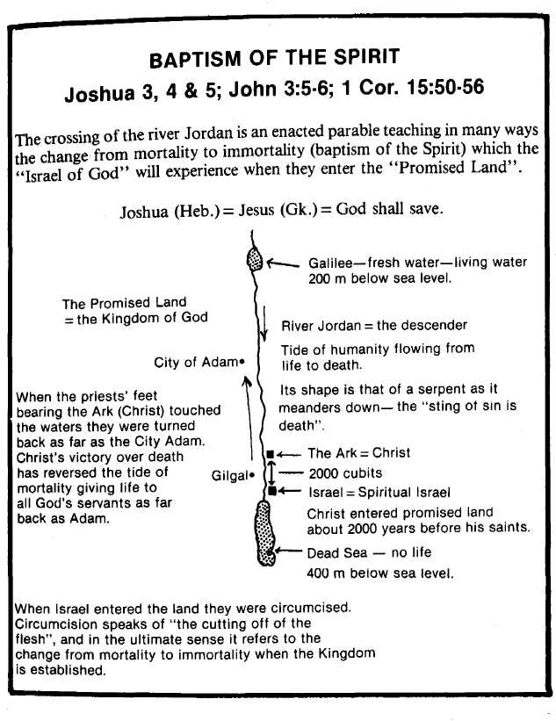
PARAGRAPH QUESTIONS:
- What instruction was Joshua given when he was appointed as Israel's new leader?
- When Israel crossed Jordan, the waters were driven back as far as the town Adam towards the Sea of Galilee. What lesson does this teach us?
- At the time when the children of Israel crossed Jordan, the Ark went ahead of the people by about 2,000 cubits. Who does the Ark represent and what is the significance of "about 2000 cubits"?
- Why were 12 stones taken from Jordan when Israel crossed the river?

ESSAY QUESTIONS:
- Briefly outline the manner in which Israel crossed the Jordan and comment upon the types which were shown in this event.
- How does the crossing of the Jordan prefigure the change from mortality to immortality?
- In what way was Joshua a type of Yahweh Jesus Christ?

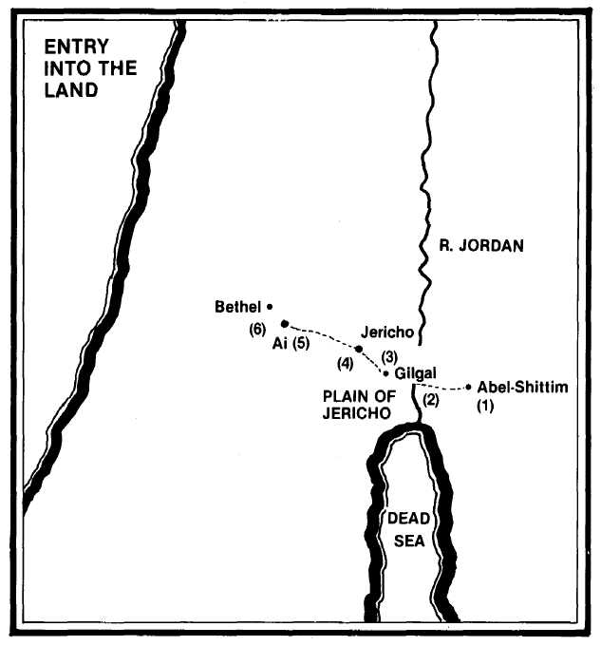
- Two spies are sent by Joshua from Shittim to reconnoitre Jericho (Josh. 2:1).
- Led by Joshua, the Israelites leave Shittim and cross the Jordan, the flow of which miraculously ceases (3:1).
- Israel encamps at Gilgal where they are circumcised and where the manna ceases and they eat of the corn of the land (4:19; 5:9-12).
- Jericho is beseiged and taken after its walls miraculously collapse (6:1).
- A force of 3,000 men is sent to Ai, but they are repulsed because of Achan's sin (7:1-4).
- By setting an ambush of 5,000 men between Bethel and Ai, and drawing out the men of Ai from the city by his other men, Joshua overcomes Ai and destroys it (8:12-21).

