284. THE NORTHERN CAMPAIGN— THE LAND AT REST
"He left nothing undone of all that Yahweh commanded Moses"

Before the tribes could settle in their inheritance the power of the Canaanites had to be broken in the north. This was accomplished after a decisive victory over a confederacy of six nations at the Waters of Merom. Through such campaigns Joshua made it possible for Israel to enter into their inheritance in the land promised to Abraham. He did his part faithfully and the people had only themselves to blame for not capitalising on this initial work. They failed to secure their own lot and compromised with the nations round about which they did not utterly destroy (Josh. 17:13).

Yahweh Jesus Christ has similarly made it possible for us to gain an eternal inheritance, but we must be obedient to God's commandments if we are to ultimately gain that reward (Heb. 2:9-10, 14-15; Col. 3:24).

Our aim in this lesson is to see the need to continue daily in our warfare against sin.

Joshua 11 & 14:6-15

THE NORTHERN CAMPAIGN:
JABIN AND HIS CONFEDERACY DESTROYED (Josh. 11).
The destruction wrought by Israel on the southern section of Canaan had its effect in the north. Jabin ("the Wise"), king of Hazor, moved to confederate the kings of the nations in the north from the Mediterranean seaboard across to Mt. Hermon (vv. 1-3). A massive host assembled at the Waters of Merom near Lake Huleh equipped with formidable weapons of war including horses and chariots (vv. 4-5). In the south, at Gibeon, Joshua's forces had fought a predominantly Amorite force who were mountain dwellers and chariots were of no use in this type of terrain. At Merom where the country was flatter the Canaanite chariots made their appearance. The celebrated plain of Esdraelon nearby was the site of numerous chariot battles in the years that followed (e.g. Judges 4).

Here then, was Israel's greatest challenge since entering the land. Yahweh spoke to Joshua, assuring him of victory and prophesying that, by the same time on the morrow, the enemy would be slain and his chariots and horses destroyed (v. 6). This signal destruction of the implements of war, including the horses, was to be an object lesson to Israel who were continually taught by God not to be impressed with the war-horse and chariot, nor to trust in them for their own deliverance (Psa. 20:7; 33:16-17; Deut. 17:16; 20:1-4).
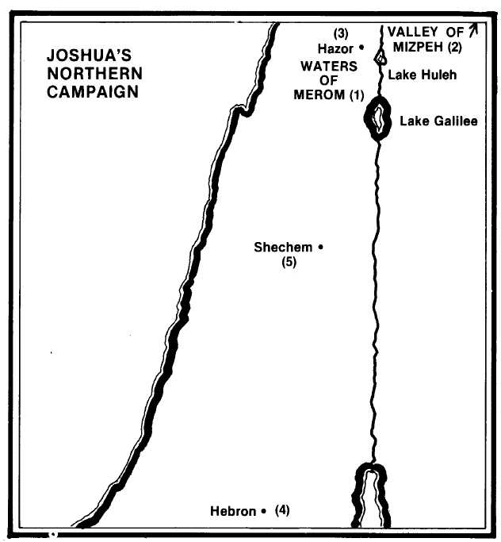
- Jabin king of Hazor assembles at the Waters of Merom the kings of the nations in the north of the land to fight against Israel (Josh. 11:1-5).
- Joshua suddenly marches his army to the Waters of Merom and routs the kings, chasing them as far as the valley of Mizpeh (11:7-9).
- Hazor is burnt and its king is slain (11:10-11). All the northern section of the land as far as Mt. Hermon is now under the control of Joshua (11:16-17).
- Joshua divides the land and Caleb seeks for an inheritance in Hebron (14:12-13).
- At the end of his life Joshua gathers the tribes to Shechem for his final words of instruction and exhortation (24:1).

Joshua once again employed a forced march and the resultant element of surprise to come upon the Canaanite camp at the Waters of Merom (v. 7) (see map).

The Canaanite forces were scattered by the fury and suddenness of the Israelites' attack. They had no time to mobilize their chariots or mount their cavalry and Israel pursued them to utter annihilation across the entire north of the land, from the sea-coast to the Valley of Mizpeh in the East completely destroying them (vv. 8-9).

Jabin the king of Hazor was put to death, the inhabitants of Hazor were slain, and the city was utterly destroyed by fire.

In verses 12-15 we are told of how faithfully Joshua carried out Moses' earlier instructions to completely destroy the Canaanites. The fortified cities were left intact but the inhabitants destroyed (vv. 13-14). After a protracted campaign across the northern region, Joshua subdued the remaining pockets of resistance (vv. 16-17), so preparing the entire land for settling by the tribes of Israel (v. 23).

THE LAND AT REST.
The military campaigns had been triumphant and God's promise to Moses to drive out the organised resistance had been fulfilled (Ex. 23:23). The record emphasises the sweeping effect of Joshua's work by the frequent use of the phrase "utterly destroyed" (10:28, 35, 37, 39,40; 11:11, 12, 20, 21). The responsibility now lay squarely with each tribe, family and individual to secure their inheritance. The remaining Canaanites, while not a military or organised threat, still needed to be dispossessed and this required faith and courage on the part of each member of the nation. Unfortunately Israel's failure to meticulously obey Yahweh's instructions to destroy the Canaanites, and their inability to overcome some of the last pockets of resistance, caused the seeds of later tragedy to be sown. Such examples are seen in Joshua 13:13; 15:63; 16:10; 17:12; 13; 18:3.

In Hebrews 4:8-11 Paul shows that the promised rest was not secured by Joshua for that generation ("Jesus" in v.8 should instead be "Joshua"—refer margin). Like their fathers in the wilderness, they failed through lack of faith (Heb. 4:1-2). We have now the opportunity for an inheritance in the promised land under Jesus, the antitypical Joshua.

CALEB'S INHERITANCE: THE REWARD OF FAITH (Josh. 14:6-15).
A notable exception, however, was the case of the faithful Caleb. Though an old man of 85, he came to Joshua and spoke to him concerning the promise made to him 45 years previously when he was one of the 12 spies. This promise was that he would inherit the land because of his faith in bringing back a good report, disregarding the obstacles to Israeli taking the land (Deut. 1:36). Now, demonstrating the same disregard foil difficulties and the same faith in Yahweh, he asked Joshua for the very tract of territory where he had seen the giant sons of Anak when they had entered the land to spy it out (v. 12).

The contrast between Caleb's attitude and that of others in Israel is emphasised by the fact that later Joshua had to remonstrate with seven tribes who had failed to secure an inheritance (18:3). Furthermore, the part of the land requested by Caleb was not an easy part to conquer or hold. Joshua appointed him the hill country of Judah, including the city of Hebron, and Caleb had to drive out three giant sons of Anak in order to possess it (15:13, 14).

WHY GOD WAS JUST IN DESTROYING THE CANAANITES
In the destruction of the Canaanites and the systematic conquest of the land we have a section of God's Word much criticised and misunderstood by those not understanding the Truth. Such people cannot understand a God Who directs the slaughter and destruction such as that upon Hazor and other cities of Canaan. Nor can they understand statements such as that in Josh. 11:20: "For it was of Yahweh to harden their hearts. . ." We need to see things from God's point of view. In Gen. 15:16 we learn that the nations of Canaan were already in iniquity and yet God did not judge them for another 400 years. The iniquity which came to fulness in Joshua's time included idolatry, immorality and perversions of the grossest type, which formed the basis of their religious worship such as human sacrifice, cruelty and animalism of the type found only where flesh is allowed to gratify its own desires without any restraint (see Rom. 1).

The children of the Canaanites were also slain because they were the seed of a generation of "serpents" (cp. Ex. 20:5). Modern research has taught us of the importance of the first 4 or 5 years of a child's life in determining attitudes and behavioural patterns. God with his infinite wisdom knew that the products of such a generation could not be changed. In another sense this too was merciful, as it was not God's purpose to make of Canaan a nation of orphans who would ultimately be Israel's responsibility (read Deut. 20:10-18).

Yahweh was just in destroying them, but most importantly, He was showing great care, love and mercy to His people of Israel. How could Israel be expected to live as a holy nation amidst such temptation and distraction? They were warned that to preserve the Canaanites would be to their disadvantage and ultimate ruin (Deut. 7:1-6; 18:9; Num. 33:55). God has commanded us to be separate from the world around us for the same reason: "the whole world lieth in wickedness" (1 John 5:19) and Yahweh Jesus Christ prayed that we might be kept from its evil (John 17:15, 16).

Though the servants of God do not now physically resist evil in the same sense, the time will come to cleanse the land of Israel of its enemies and to establish the kingdom of God. Then, like Joshua of old, Yahweh Jesus Christ and his saints will destroy the wicked (Psa. 149:5-9; Zech. 14:3, 5, 21; Rev. 2:26, 27; John 18:36).

The hardening of the hearts of the Canaanites was a similar case to that of Pharaoh (Josh. 11:20; Ex. 9:34-35), where the manipulation of circumstances and events by God produced a response which was quite predictable knowing the pride and stubbornness of the people concerned.

LESSONS FOR US:
- Joshua is a type of Yahweh Jesus Christ in his work of conquest and the gaining of the inheritance of the Land of Promise.
- Our entry into the "promised land" requires diligent obedience on our part and the sort of faith and courage which was displayed by Caleb.
- This faith disregards present difficulties and adversity and keeps the ultimate goal and objective in sight —principles followed by Caleb.
- We need similar clarity of vision and purpose that we too might secure the promise of a place in God's Kingdom: "Work out your own salvation with fear and trembling" (Phil. 2:12).

REFERENCE LIBRARY:
"Elpis Israel" (J. Thomas)—Pages 300-301
"The Visible Hand of God" (R. Roberts)—Chapter 21
"The Story of the Bible" (H. P. Mansfield)—Volume 2, No. 11
"Joshua" (J. Ullman)—Chapters 11, 14

PARAGRAPH QUESTIONS:
- How did Joshua deal with the kings in the north?
- In what ways did the life of Joshua point forward to Christ?
- What parallels are there between our walk in the Truth and Israel's destruction of the Canaanites under Joshua?
- God was just in commanding the total destruction of the Canaanites. Discuss this statement.

ESSAY QUESTIONS:
- Joshua succeeded in his campaigns, but Israel failed to consolidate their position. What was the consequence of their failure and what do we learn from this?
- Describe Caleb's faithful action in requesting his inheritance. What do we learn from such action?
- What is the "rest which remains to the people of God" and how can we attain to it?

