285. THE LAST WORDS OF JOSHUA
"Ye are witnesses against yourselves that ye have chosen you Yahweh, to serve Him"

As the end of a long and fruitful life in God's service approached Joshua saw the need to leave the people of Israel a final exhortation and warning. This he did in an address to the nation assembled at historic Shechem as recorded in Joshua 23 and 24.

At the beginning of his work, upon the death of Moses, God had exhorted Joshua in certain terms (Josh. 1:7). Now the same advice, to which was added the experience and example of Joshua himself, was to be passed on before he died. Yahweh Jesus Christ similarly left his final messages for his disciples before his death (John 13 to 17), after his resurrection (Acts 1:1-11) and in the Book of Revelation (Rev. 1:1).

It is a solemn warning to us that the effects of these warnings were short-lived in each case and the advice and direction was not heeded.

Our aim is to see the need to serve God in both sincerity and truth.

Joshua 23 & 24 JOSHUA ASSEMBLES ISRAEL (Josh. 23:1-2).
In Joshua's call of Israel and the leaders together, we are immediately impressed with his true greatness. Here, at the culmination of a life in which he had performed all that Yahweh had asked him (11:15), Joshua avoided any self-praise and instead directed the people's attention back to serve God in faithfulness and truth. In reviewing the experiences of life from his old age (v. 2), he could clearly see the issues confronting them and he warned them accordingly.
His address can be summarized in these main sections:—

- Praise and thanksgiving for the things God had done for Israel (vv. 3-5).
- Exhortation and encouragement (vv. 6-10).
- A final warning (vv. 11-16).

THANKSGIVING, ENCOURAGEMENT AND WARNING (Josh. 23:3-16).
On the basis of Yahweh's past goodness toward them, His faithfulness in performing all that He had promised and the great benefits which He had bestowed upon them, Joshua assured them that God's promises could be confidently trusted (v. 5). Joshua reiterated the words addressed to him by God when he took over the work from Moses: "Be ye therefore very courageous" (v. 6, cp. 1:7). To heed the commandments given in the book of the Law would require courage, because the influence of the nations round about would be an ever-present distraction. Hence Joshua exhorted them to single-mindedness — "that they might not turn aside there from to the right or the left".

He encouraged them to cleave unto Yahweh and so avoid the pitfalls of association with the Gentile nations around them. The word "cleave" in v. 8 has the idea of a very close association and is used in Gen. 2:24 (a man should "cleave unto his wife"), and in Ruth 1:14 (describing the association between Ruth and Naomi). Such an association must be motivated by a deep love and Joshua exhorted them in verse 11 to reveal this love towards God. This is the key to all success and is the first and greatest commandment (Deut. 6:4-5; Psa. 18:1).

The alternative was to "cleave" to the nations round about. (Joshua used the same expression in v. 12). This association would result in their love being directed toward these peoples and intermarriage which would bring disaster for them as an holy nation (vv. 12-13).

Separateness is the first requirement for us too, as it was for Israel. We are told not to love the world or the things in the world (1 John 2:15), and to be a separate people (2 Cor. 6:14-18). Perhaps the shortest route to disaster in the Truth is the cultivation and fostering of friendships with the opposite sex outside of the Truth. This leads to deeper relationships and even marriage as Joshua warned Israel.

Joshua further encouraged the children of Israel by reminding them that because God had been with them to that point, they had been invincible (vv. 9-10). Moses had foretold that one man of Israel would chase a thousand (Deut. 32:30). However disobedience would reverse this situation (Isa. 30:17).

God had warned Israel through Moses that to leave the Canaanites among them would be like leaving thorns and briers to constantly pick and irritate (Num. 33:55). Joshua reiterated this in verse 13. Jesus taught us that the "thorns and briers" with which we contend will, like the Canaanites in Israel's case, eventually choke the growth of the seed of the Word of God. Our "thorns" are the "cares and riches and pleasures of this life" (Luke 8:14). Moses had been told that all the evil which God sought to bring upon the Canaanites would be visited upon Israel if they disobeyed, and Joshua repeated this warning (v. 15; Num. 33:56; Lev. 26:14-16; Deut. 28:15, 16, 63).

Joshua concluded with a solemn warning which had a note of inevitability about it: "when ye have transgressed the covenant. . ." (v. 16).

JOSHUA GATHERS THE TRIBES TO SHECHEM (Josh. 24:1-13).
It was to Shechem that Abraham first came to receive the promise concerning the land. God said to him there, "Unto thy seed will I give this land" (Gen. 12:7). We are told the Canaanite was then in the land, but Abraham remained separate and looked to the future fulfilment of the promise (Heb. 11:8-10).

It was to Shechem also that Joshua first led Israel after the fall of Ai in obedience to the command of Moses (8:30-35; Deut. 27:4-26). There the blessings of the Law were read from Mount Gerizim and the curses from Mount Ebal. The whole Law was read to Israel and written upon stones, and sacrifices were offered on an altar of unhewn stone.

So at the end of his life, Joshua again assembled the tribes at Shechem to renew the covenant they had made with God (Ex. 24:7-8). He fittingly began by taking them back in thought to Abraham's call out of an idolatrous civilization (vv. 2-3). He reminded Israel of the great deliverance from Egypt and the wilderness wanderings, and how God had been with them in defeating the Amorites on the east of Jordan and how Baalam's intention to curse Israel had been frustrated (vv. 5-10).

The more recent history of the conquest of the land was brought before Israel to impress them with the faithfulness and power of Yahweh their God (vv. 11-13). Notice how many times "I" is found in verses 1 to 13, so emphasising God's loving care and deliverance of Israel.
THE CALL TO SERVICE (Josh. 24:14-31).
Having laid his foundation, Joshua came to the purpose of the assembly, namely to exhort and warn Israel: "Now therefore fear Yahweh and serve him in sincerity and in truth" (v. 14). (The Hebrew word translated "sincerity" has the sense of giving oneself completely). At this very spot Yahweh Jesus Christ later told a Samaritan woman, whose religion was a mixture of truth and error, that the Father should be worshipped in "spirit and truth" and that "salvation was of the Jews" (John 4:22-23; cp. 2 Kgs. 17:32-33, 41).

It comes as something of a shock to realise that already the contact with the nations of Canaan had begun to erode the truth in the "ecclesia" of Israel, for Joshua urged them to put away idols from among them (v. 14). Sincerity and truth demanded a decision and Joshua delivered an ultimatum to the people to make their choice that day. . . Yahweh or the gods which their fathers had forsaken and rejected. Joshua had made his choice: "as for me and my house we will serve Yahweh" (v. 15). Joshua practised what he taught and he had the courage to stand alone if necessary.

The people protested their innocence (vv. 16-18), but Joshua refused to be distracted and firmly stated that they could not serve Yahweh unless absolutely committed and prepared to do so in singleness of mind (vv. 19-20). He reminded them of the jealousy and holiness of God's character which had been revealed to Moses when, on an earlier occasion, idolatry had been present in their midst (Ex. 32:1; 34:6-17).

Israel again protested their fidelity and desire to serve Yahweh (v. 21). So Joshua called them to witness against themselves. To test their sincerity, he challenged them to put away the strange gods which were among them and to serve Yahweh with their whole heart (v. 23).

The people agreed and thus Joshua made a covenant with Israel. To impress the occasion upon them, he wrote the words in the book of the Law and placed a great stone under the oak at Shechem where Abraham had received the promise and made an altar (Gen. 12:7), and where the idols of those who came with Jacob when he returned from Padan-aram were hidden (Gen. 35:1-5). Thus Shechem came to symbolise resolution and rededication to Yahweh: their idols were cast away and God was served in spirit and in truth.

Our idols can be anything at all which competes for our love for God. In today's world, pleasure, entertainments, social and community interests, sport, ambition and many other aspects of the carefree, casual life which is characteristic of our age, can be very detrimental to our spiritual development. They blur our vision and perception of the coming kingdom, and rob us of valuable time which should be used in God's service. Let us not be like the Israelites who protested their allegiance to the Truth whilst secretly serving idols. Paul tells us that covetousness, for example, is idolatry (Col. 3:5). In today's world we need the courage of Joshua. Yahweh's standards remain the same. It is only ours that are liable to change. Joshua exhorted a singleness of mind and we are reminded of the need for this characteristic by Yahweh Jesus Christ: "No man can serve two masters" (Matt. 6:24); and by James: "a double minded man is unstable in all his ways" (Jas. 1:8).

The final public act of Joshua was a fitting close to his life. The greatest testimony to him is in verse 31: "Israel served Yahweh all the days of Joshua and all the days of the elders who over lived Joshua".

LESSONS FOR US:
- To stand apart from worldly ways and fight the warfare against sin requires courage and determination — "be ye very courageous", was Joshua's exhortation.
- Close associations with and cultivation of friends in the world easily lead us from the Truth. Marriage outside the Truth was wrong in the days of Joshua and remains so.
- God requires that we worship Him "in spirit (sincerity) and in truth".
- We need to join with Joshua in declaring emphatically, to all who would hear, "as for me and my house we will serve Yahweh''

REFERENCE LIBRARY:
"The Story of the Bible" (H. P. Mansfield)—Vol. 2, No. 11
"Joshua" (J. Ullman)—Chapters 23-24

PARAGRAPH QUESTIONS:
- Name three things that happened at Shechem in the early history of the nation of Israel and its patriarchs.
- Joshua told the people to serve God "in sincerity and in truth". What did he mean by this and who said later that God must be worshipped "in spirit and in truth"?
- What was the main warning contained in Joshua's last address to the nation? How does this affect us?

ESSAY QUESTIONS:
Why was it necessary for Joshua to address his last words to the people of Israel? What did he impress upon them?
Joshua said, "As for me and my house we will serve Yahweh". When did he say this, who did he say it to, and what lesson was he trying to teach?
Joshua impressed Israel with the need for separateness. How were they to keep separate? What are the things in the world that we should remain separate from?

Section 3 THE PERIOD OF THE JUDGES
This section covers a period of some 450 years of Israel's history. In this time Israel was not an organised and united nation as in the period of the Kings which followed. For this reason chaos often prevailed as all went their several ways. The fear of Yahweh declined and this led to invasion by the surrounding nations and the subduing of Israel. In His mercy God raised up men of faith who delivered the nation from their oppressors. Some of these great characters and their circumstances we shall consider: Deborah, Gideon and Samson. In each case of deliverance we shall find that God's strength was made perfect in weakness; He used insignificant means to bring about the deliverance lest Israel should claim victory for themselves. Thus He was impressing the lesson upon them that He alone can overcome their enemies and provide salvation.

The period of the Judges gives way to the reign of kings and this change was bridged by the last of the Judges and first of the prophets, even Samuel.

The last lessons in this section deal with Samuel's birth and mission and the eclipse of the house of Eli.

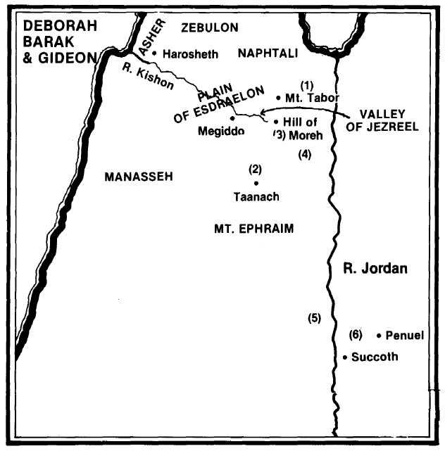
- Deborah calls Barak to assemble on Mt. Tabor with 10,000 men from he tribes of Naphtali and Zebulon (Judges 4:6).
- They fight Sisera's army at Taanach by the waters of Megiddo. The hariots of the Canaanites are bogged as the river Kishon suddenly floods and they flee before Barak unto Harosheth (4:15-16; 5:19-21).
- The Midianites and the Amalekites gather at the valley of Jezreel by the hill of Moreh (6:33; 7:1).
- Gideon summons the tribes of Asher, Naphtali and Zebulon together with his tribe of Manasseh (6:34-35). He chooses a small force of 300 men which routs the Midianites (7:22).
- Gideon appeals for help from the tribe of Ephraim to cut off the retreat of the Midianites at Jordan (7:24).
- Gideon pursues the Midianites across Jordan and on his return punishes the towns of Succoth and Penuel for not assisting his work (8:1-17).

