288. SAMSON: EXAMPLE OF FAITH & FOLLY
"Strengthen me, I pray thee, only this once, O God"

Samson's life is one of profound tragedy. Given great blessings by God, we see him ascend to glorious heights of spiritual and physical strength as the single-handed conqueror of the Philistines — no one in Israel being prepared to align themselves with him. And then he is found in the depths of human weakness, beguiled by a temptress, and blinded and mocked by the uncircumcised. Moreover his strength and his weaknesses symbolise Israel in this period.

The great lesson of Samson's life is so aptly summarised by the proverb: "Better is he who rules his spirit than he that takes a city" (Prov. 16:32).

Samson made Philistine cities tremble at his presence, but it was only in the final act of his life that he properly learnt the lesson of subduing human passion. His faith wrought great things and for this cause he is enrolled among the heroes of faith, who "out of weakness were made strong, waxed valiant in fight, turned to flight the armies of the aliens" (Heb. 11:32, 34).

The aim of this lesson is to show that separation from the world is essential for salvation.

Judges 13

DIVINE VISITATION—A SON IS PROMISED (Judges 13:3-23).
Manoah and his wife were of the tribe of Dan. They lived in the town of Zorah which was really a city of Judah (Josh. 15:33), but inhabited by Dan because this tribe had failed to take its own inheritance (Jud. 13:2, 25; 1:34). Dan migrated to the north of Israel, abandoning the portion God had assigned them (18:1-2; Josh. 19:40-48), but a faithful remnant had stayed behind despite their nearness to the dreaded enemy, the Philistines. Manoah and his wife were of these — but their great sorrow in life was that they had no children (13:2).

Barrenness was an intense source of shame to a woman in those times. Like Rachel before and Hannah after, Manoah's wife would have offered many prayers to God for children (Gen. 30:22; 1 Sam. 1:8, 10-11). At last she was answered by angelic visitation and promised a son.

This happy news was reported to Manoah who, apparently unable to comprehend the greatness of the promise, prayed for a second visitation (v. 8). God hearkened to him and the angel again appeared to his wife who then ran to fetch Manoah. The angel confirmed the promise and the commands (w. 13-14). But Manoah knew not that it was an angel (v. 16).

He wished to show honour unto "the man of God" (v. 8), and offered to prepare a meal for him (cp. Gen. 18:5-8). The angel refused to eat and said that if he was to offer a burnt offering, it must be made to Yahweh. Manoah prepared his offering and, as the flame arose from the altar of rock, the angel mingled with it and ascended (Heb. olah). In the term "burnt offering", the word "burnt" signifies "ascending", to indicate the attitude of dedication towards Yahweh (Lev. 1:9). Thus when the angel ascended in the flame of the burnt offering, God's acceptance of their dedication was plainly demonstrated.

With this Manoah perceived that an angel had been in their presence. He was greatly perturbed and feared death. But his wife, apparently the more spiritually perceptive, comforted him with the observation that the offering had been accepted, wonders had been seen and great blessings promised — God would not have so dealt with them if He intended to slay them.

In course of time a son was born, called by his mother "Samson", meaning "brilliant sunlight".

A NAZARTTE FROM THE WOMB (Judges 13:4-5; Num. 6).
When the angel first spoke to Manoah's wife (her name is not given) he had declared "the child shall be a Nazarite unto God from the womb."

The Nazarite vow is recorded in Num. 6. The word means "separation" and this concept is stressed throughout this chapter. Israel at Sinai were told they could be a "kingdom of priests" (Ex. 19:6). Yet their Law forbad them, on pain of death, from entering into the priesthood, as this was reserved for the sons of Aaron (Num. 18:6-7; see also Lesson 3). How then could other Israelites, who desired in their heart to separate themselves totally to the service of God, realise the offer made at Horeb? The Nazarite vow provided this opportunity. By it an Israelite could imitate the High Priest, for as in the case of the High Priest "all the days of his separation he is holy unto Yahweh" (Num. 6:8; cp. Ex. 28:36).
There were three specific injunctions for the person who vowed to be a Nazarite:—

He was to eat nothing associated with the vine or its products (Num. 6:3-4; cp. the priests, Lev. 10:9-10).
He was forbidden to trim the hair of his head (Num. 6:5; cp. The priests, Lev. 21:5).
He must avoid the defilement of death, even if the dead was of his family — a condition that only applied to one other man in Israel, the High Priest (Num. 6:6-8, cp. Lev. 21:10-11).

Thus the holiness of the Nazarite vow was impressed upon Israel and yet, by it, any Israelite, male or female, could imitate the separation of the High Priest.

Normally the vow was taken voluntarily by adults for a specific term. In Samson's case God had determined it before he was born.

Why was it that Samson should be a Nazarite, a separated one? Note that his mission is stated immediately after the injunction that he should be a Nazarite (Jud. 13:5) — "he shall begin to deliver Israel out of the hand of the Philistines". Deliverance would come by separation to God. Failure to realise this principle had been at the root of all Israel's troubles from the beginning of the time of the Judges (2:2-3). They had associated with the nations of Canaan and learned their ways. They were still doing this in Samson's time. So God raised up a young man wholly dedicated to Him and totally separate from the nations. Then we read that "The child grew and Yahweh blessed him. And the Spirit of Yahweh began to move him at times in the camp of Dan" (13:24-25). Though the word of Yahweh was precious in those days (1 Sam. 3:1), His Spirit began to move Samson, the separated one.

THE WOMAN OF TIMNATH (Judges 14 and 15).
Timnath means "assigned portion". It was a city of the Philistines though God had assigned it to Dan (Josh. 19:43). Samson went down to this city, no doubt at the prompting of the Spirit of Yahweh, but while there his eye was caught by a daughter of the Philistines. He determined to marry her despite the protests of his parents.

The family went down to visit the woman in Timnath (Jud. 14:5). While Samson was passing the famous vineyards (surely no place for the Nazarite), a lion roared against him. Samson felt the power of Yahweh surge into his body and without a weapon of any kind he tore the ferocious beast asunder. He passed straight on to visit the woman, undeflected by his experience.

Later he went back to take her to himself and turned aside to see the ruin of the lion. To his amazement a hive of bees had established their industry within its carcass (vv. 8-9). Samson returned to his parents and gave them some of the honey. But he did not tell them from where he obtained it.

In due time, his father (but not his more spiritually inclined mother — cp. v. 10 with v. 5) accompanied him to Timnath to the wedding feast called by Samson. Thirty Philistines were appointed to be his companions and his best man was also a Philistine (w. 11, 20). Samson could never have betrayed his vow more completely. Here was the one separated to holiness uniting himself in marriage to the uncircumcised. The commandment forbidding marriage outside the Truth was put aside (Deut. 7:1-4).

In the midst of the revelry, Samson's mind returned to the slaying of the lion and he put forth a riddle about it to the guests. They had to explain: "Out of the eater came forth meat, and out of the strong came forth sweetness" (v. 14). If they failed within seven days to explain the riddle then they had to give him 30 sheets and 30 changes of raiment, and vice versa if they succeeded.

The Philistines were in a desperate plight. They threatened to burn Samson's wife and her father's house if she failed to furnish them with the answer. Therefore she used all her feminine wiles to entice him and at length on the seventh day, he yielded. Thus the riddle was made known to the Philistines.

Rising in great anger Samson slew 30 Philistines and so answered the terms of the agreement (v. 19). He left behind his new wife and returned to Zorah to his father's house. This provided him with a further opportunity to humiliate the Philistines, for sometime later Samson sought his wife again, only to find that she had been given to the Philistine who was best man at his wedding (v. 20). This outraged him and provoked retaliation; viz.:—

- He burnt down their cornfields with 300 foxes bearing firebrands in their tails (15:4-5).
- He smote the Philistines with a "great slaughter" (15:8).
- He slew 1,000 of them with the jawbone of an ass (15:14-17).

STRENGTH LOST THROUGH A WOMAN (Judges 16:1-21).
Great faith amidst profound weakness was the rule of Samson' life. Despite the lesson of Timnath, he sinned with another Philistine woman in Gaza (16:1-3). He then fell prey to yet another, the seductress Delilah, in the valley of Sorek. Through his weakness Yahwehs of the Philistines discovered the secret of his superhuman strength.

Such an association with a partner outside the Truth must in the end, result in anguish of mind, though it may seem attractive at the beginning. How can we share our lives with someone who does not share our most precious hopes and desires?

In his Nazarite vow of separation to Yahweh lay the key to his great strength, his unshaven head. By subtle enticement, Delilah elicited his secret just as the woman of Timnath had done previously (14:17). The Philistines were soon informed and, while he "slept upon her knees", a Philistine "shaved off the seven locks of his head." "Yahweh was departed from him" (v. 20). Down into the prison house in Gaza he was led to grind corn for the enemies of Israel amid the clank of fetters of brass. His eyes, which had been the source of his temptation, were now bored out of their sockets (1 Jn. 2:15-16).

In this tragic spectacle we see that suffering follows sin (v. 21). Samson learnt this lesson while suffering in the prison of the Philistines. The words of Christ surely must summarise his thoughts: "If thine eye offend thee, pluck it out; it is better for thee to enter into the kingdom of God. . ." (Mk. 9:47).

VICTORY IN DEATH (Judges 16:22-31).
The Philistines gathered for a great feast in Gaza, in thanksgiving to their god, Dagon, for the victory over Samson. Samson was brought before the crowds so they could mock him. The strong man of Israel was led in by the hand of a young boy.

But Samson knew his hair had grown again during the months in prison. He believed in the mercy of God. He knew that his greatest enemy was himself when moved by the lust of the eyes and the lust of the flesh. He was no longer proud or lustful. In faith he sought and was led to the great pillars upon which the house was supported. He prayed to God and strength flowed into his body. He grasped the pillars and said, "Let me die with the Philistines". By divine strength he caused the house to collapse. Samson and 3,000 Philistines died at once—more perished in his death than he had slain in his life. By faith he triumphed over his enemies (Heb. 11:32-33).

His brethren and the house of his father gathered his remains and he was buried in between Zorah and Eshtaol, the place where the Spirit had moved him at the first (16:21).

LESSONS FOR US:
- The life of a Nazarite is set forward in God's word as an example to us of voluntary dedication to God and a corresponding separation from the practices of the world.
- While separation requires the cutting off of sinful lusts, it alone can bring true happiness in the end.
- Samson's life of separation was marred by his attractions to worldly women. It has ever been true that marriage with the alien is a breach of God's command.
- Young people should be careful to limit their contact with the world so that they will not be drawn aside like Samson by "the lust of the eyes."
- In a world which encourages free expression and liberality, it is important for saints to remember the proverb which epitomises Samson's life: "Better is he who rules his spirit than he that takes a city" (Prov. 16:32).

REFERENCE LIBRARY:
"The Story of the Bible" (H. P. Mansfield)—Vol. 3, No. 3
"Samson" (R. Abel)—C.S.S.S. Study Notes

PARAGRAPH QUESTIONS:
- The angel that spoke to Manoah 's wife said that Samson would be "a Nazaritefrom the womb". What three things was the Nazarite in Israel to do?
- What weakness brought about Samson's downfall? What lessons do you learn from this?
- Samson showed great weaknesses in his life, but he is mentioned in Hebrews 11 as a man of faith who will be in the Kingdom. Comment on this by referring to the last act of his life.

ESSAY QUESTIONS:
- What was a Nazarite and why was Samson to be a Nazaritefrom the womb?
- "Better is he who rules his spirit than he that takes a city". Illustrate this proverb from the life of Samson.
- Separation from the world is essential for salvation. How is this lesson illustrated in Samson's life?

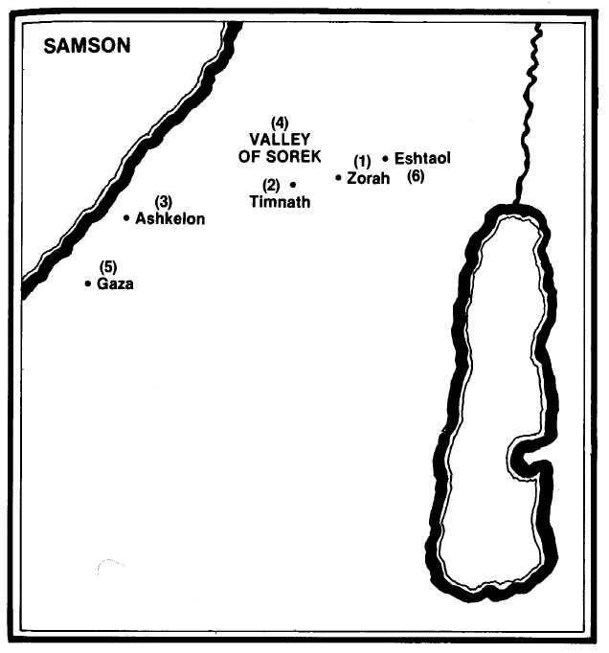
- The spirit of Yahweh begins to move Samson at times in the camp of Dan between Zorah and Eshtaol (Judges 13:25).
- Samson marries a woman of Timnath (14:1-4).
- Because of her, his riddle is solved and he supplies the wages by killing 30 men of Ashkelon (14:19).
- Samson falls prey to the wicked Delilah from the valley of Sorek and is deprived of his strength (16:4).
- He is blinded and taken to grind in the prison house at Gaza (16:21).
- In his death he brings down the house of Dagon and is then buried between Zorah and Eshtaol (16:31).

