294. DAVID—CHOSEN BY GOD
"Man looketh on the outward appearance, but Yahweh looketh on the heart"

God's command to utterly destroy the Amalekites was not heeded by Saul. Instead he asserted his own will. He had not perceived that God desires a willing heart to serve Him. The character that had developed in Saul throughout his rule erupted into presumption (1 Sam. 13:8, 9, 14), and disobedience (15:16-23). For this reason he was rejected as King of Israel.

Yet God was determined to rule His people through a man of His own choice (1 Sam. 13:14; Acts 13:22). This king would be "a man after God's own heart." His choice was David the shepherd whose early life fitted him for the time when he became King of Israel and conqueror of God's enemies.

Our aim in this lesson is to see that God desires obedience to His precepts from a willing heart and that His choice is made on the basis of a knowledge of internal motives rather than external appearance.

1 Samuel 16 SAMUEL SENT TO BETHLEHEM (1 Sam. 16:1-5).
Samuel's prolonged mourning for the lost king was interrupted by a word from God: "How long wilt thou mourn for Saul, seeing I have rejected him from reigning over Israel? Fill thy horn with oil and go, I will send thee to Jesse the Bethlehemite: for I have provided me a king among his sons." Later it was recorded in the Psalms: "I have found David my servant; with my holy oil have I anointed him" (Psa. 89:20).

Samuel was afraid to go openly to anoint the new king while the old king was still on the throne, particularly since Saul had become violent and possessed of a jealous, angry, fitful fear. Samuel therefore went up to Bethlehem at the command of God seemingly to offer sacrifice, but secretly to select the man born to be king. At first sight the subterfuge seems almost unworthy of the great mission. We must view it according to the circumstances of the time. An open proclamation of David as Saul's successor would have brought the sword of Saul to Bethlehem, upon the family of Jesse, as in later years Herod massacred the young children in the same place in the hope of killing the newly born Jesus.

Samuel's arrival in Bethlehem caused consternation, for Bethlehem was not normally one of the towns of his circuit (1 Sam. 7:16). The elders of Bethlehem imagined that Samuel's stern finger would probe out some hidden evil: "Comest thou peaceably?" They breathed a sigh of relief when the prophet declared: "Peaceably: I am come to sacrifice unto Yahweh"

THE DIVINE SELECTION (1 Sam. 16:6-11).
Jesse and his sons were specially invited to the sacrificial meal. Samuel took stock of the man and his sons. The firstborn, Eliab, seemed to have the makings of a king. The prophet looked favourably upon the man who by face and stature might have borne himself royally.

Samuel took counsel of God. The nature of the conversation is most revealing. God's clear, unmistakable voice was like a second conscience in Samuel. This was no mere refined spiritual thinking on Samuel's part, no "self inspiration," as it were. God spoke to Samuel and Samuel knew it. Moreover what Samuel heard was unexpected: "Look not on his countenance, or on the height of his stature: because I have refused him; for Yahweh seeth not as man seeth; for man looketh on the outward appearance, but Yahweh looketh on the heart" (v.7). This was the enunciation of a divine principle, applicable not only to the selection of David as king but also to every man who will be in the Kingdom of God (Rev. 2:23). "I have refused him", meant that his heart was not right in the sight of God.

In turn all seven sons at home with Jesse were rejected. "Yahweh hath not chosen these," said Samuel to Jesse. Samuel refused to sit down to eat until the eighth son, whom the family had not considered necessary to invite to the sacrifice, was brought in from the field.

THE ANOINTING (1 Samuel 16:12-13).
Although David was "youngest" and quite out of mind so far as suitability for the throne was concerned, he was a "man after God's own heart" (13:14). David cared for his father's "few sheep" and this was to be his life's commission in a fuller sense (Psa. 78:70-72). Great men before him had been prepared by this occupation for greater changes —Abel, Abraham, Isaac, Jacob and Moses. David knew his sheep by name, led them in and out, found pasture and water for them, anointed them, bound up their wounds, protected them with his own life against the onslaught of wild beasts and shared their life night and day. This age-old occupation worked upon his character and developed in his mind a sense of responsibility and compassion for others, a love and devotion which remained with him to the end of his days (cp. 2 Sam. 24:17). He keenly felt what it meant for God to be the great Shepherd of Israel.

His life as a shepherd also gave him a great appreciation of the majesty of God as Creator. As he lay out on the wild hillside of Judea at night, he would ponder the wonder of God's handiwork and be drawn to study His Law (Psa. 19; 119:9).

Keen of eye, lithe of body, auburn-haired and of fair countenance (so the record suggests), David stood before Samuel. The command of God in Samuel's ear was urgent and incisive: "Arise, anoint him; for this is he" (16:12). The horn of oil was poured upon his head while he stood among his brethren. What they thought is not recorded. Their later words and deeds speak of envy, like Joseph's brethren (17:28; cp. Psa. 23:5). What David specifically thought of this mark of favour does not appear in the Scripture, although the 23rd Psalm may well have been written against this background. No doubt he turned over in his lively mind the meaning of this meeting with Samuel as he sat at the table with him. This was the first of four anointings for David: three by men, in Bethlehem, Hebron and Jerusalem, and one by God's Spirit at the hand of Samuel here at home at the threshold of an almost unbelievably full life.

DAVID AND HIS GREATER SON
The following chart sets out a brief parallel between David and Jesus Christ, up to this early stage of David's life.
DAVID | JESUS CHRIST
Revealed in the house of Jesse in Bethlehem by Samuel whose work parallels John the Baptist's (see Lesson 15). | David's greater son born in Bethlehem (Luke 2:4) and revealed as Messiah by John the Baptist (John 1:29, 31, 36).
Literally a shepherd, and thereby prepared to lead Israel (Psa. 78:70-72). | A shepherd of men (Mark 6:34; Isa. 40:11), the Good Shepherd who would lay down his life for his sheep (John 10:11).
Least esteemed among his brethren | His brethren did not believe on him (Psa. 69:7-9; Isa. 53:2-4; John 7:5).
Anointed with the Spirit-symbolised by anointing oil | Anointed with the Spirit at his baptism (Matt. 3:16-17) and, when resurrected, made "Christ" —"the anointed'* (Acts 2:36).

THE SPIRITUAL SIGNIFICANCE OF DAVID'S ANOINTING.
Anointing with oil was God's way of formally inducting kings and priests to their office (cp. Lev. 8:12). The oil speaks of the Spirit of God (2 Cor. 1:21-22), and so its descent upon the head symbolises God's approval and sanctification (i.e. that God had set the person apart for His special purpose). Notice how the giving of the Spirit to David followed his anointing (1 Sam. 16:13). This anointing of David points forward to the Messiah (English "Anointed One"; Greek "Christ"). Jesus was anointed with the Spirit at his baptism when God showed His approval of Him in the words, "This is my beloved son, in whom I am well pleased" (Matt. 3:17; see also Isa. 61:1; Heb. 1:9; Jn. 3:34). He was finally approved of God after his obedience to death when God raised Him from the dead. He was then glorified and given divine immortal nature. Peter said that by the resurrection God had made him "both Lord and Christ" (Acts 2:36; 3:13).

LESSONS FOR US:
- The true son or daughter of God, like Samuel, will mourn when others such as Saul stray from the narrow way. They lament a society with no interest in Zion.
- Outward show does not impress God. He looks on the heart and desires those who willingly conform to His ways and not act in an independent manner.
- We can fit ourselves to partake in full measure of the sacrifice of Christ in company with all his brethren if we allow the power of the Word of God to influence our lives.
- Men in this world may consider us the least in their sight, just as David's brethren did, but it is God's opinion of us, not man's opinion, which will determine our destiny.
- Those who realise that Yahweh "looketh on the heart" will endeavour to pattern their lives on the examples of both David, "the man after God's own heart" and his greater Son, Jesus the Anointed.

REFERENCE LIBRARY:
"The Ways of Providence" (R. Roberts)—Chapter 15
"The Visible Hand of God" (R. Roberts)—Chapter 23
“The Story of the Bible” (H. P. Mansfield)—Vol. 3, No. 8
"The Man David" (H. Tennant)—Pages 19-23

PARAGRAPH QUESTIONS:
- Why was Samuel reluctant to go to Bethlehem, to anoint David? What became his offical reason for going?
- What lesson is there for us in the choice of David to be king instead of his brothers?
- How did David's early life as a shepherd help prepare him to be king?

ESSAY QUESTIONS:
- Compare the characters of Saul and David.
- What qualities of character fitted David to be King?
- Compare the selection and anointing of David with that of Jesus.
- "Man looketh on the outward appearance but Yahweh looketh on the heart" (1 Sam. 16:7); "Out of the abundance of the heart the mouth speaketh" (Matt. 12:34). What is the principle underlying these two quotations? How does this apply in the selection of David and rejection of Saul?
- Describe the anointing of David by Samuel.

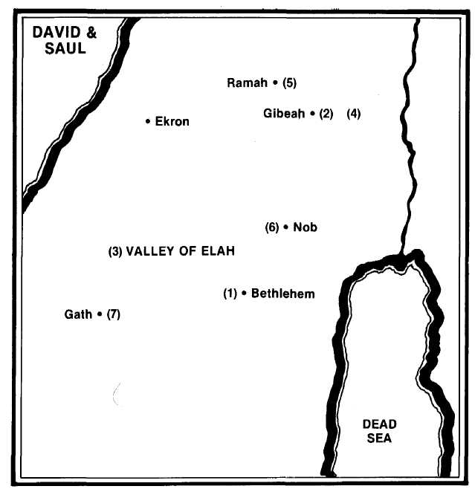

- Samuel anoints David before his family at Bethlehem, then returns to his home at Ramah (1 Sam. 16:1, 13).
- David plays his harp before King Saul at Gibeah (16:21; 15:34).
- David fights Goliath in the Valley of Elan (17:1-2, 20). The Philistines are pursued to Ekron (17:52).
- David returns to the palace of Saul (18:2) where he receives Jonathan's friendship but is the product of Saul's envy, especially in view of his successful forays against the Philistines (18:3-8).
- With the help of Michal, David flees to Samuel at Naioth in Ramah (19:18).
- On receiving a signal from Jonathan that he is in great danger from Saul (20:1, 33-37), David flees to Nob, the place of the priests (21:1).
- Taking the shewbread and the sword of Goliath, he flees to King Achish of Gath from whom he escapes by feigning himself mad (21:10-13).

