357. THE GOSPEL NET WIDENS: TO SAMARIA AND ETHIOPIA
"They that were scattered abroad went everywhere preaching the word"

The death of Stephen was the signal for the development of the next dramatic sequence of events in the spread of the gospel. The Truth's opponents, the Jewish authorities and Saul of Tarsus in particular, no doubt strengthened by their apparent triumph in securing Stephen's death, unleashed fierce persecution against the ecclesia. This had the effect of scattering the several thousand strong ecclesia at Jerusalem far and wide, which was Yahweh's purpose; to further spread the glad tidings of the kingdom and the things concerning the name of Jesus Christ. The aim of this lesson is to see this spread of the gospel and to measure the response of men and women to it.

Acts 8

SAUL MAKES HAVOC IN THE ECCLESIA (Acts 8:1-4).
One of the most remarkable evidences of the truth of the Gospel is the fact that a man like Saul of Tarsus could be converted and become the great apostle to the Gentiles that he did. The merciless persecution of the ecclesia following Stephen's death, found Saul as its most deadly and ruthless instrument. His own words uttered later in his life best summarize his fanatically misplaced zeal. To the Galatians he wrote "... beyond measure I persecuted the ecclesia of God and wasted it" (Gal. 1:13. See also Acts 22:4, 19-20; 26:9-11). Both men and women suffered as they were dragged from their homes to prison; the synagogues were invaded to search them out and they were often put to death through Saul's instrumentality. The Jerusalem ecclesia was scattered abroad throughout Judea and even Samaria (v.l), as a result of this persecution, although the apostles remained in Jerusalem showing their courage and faith. The Lord Jesus Christ had told the apostles in his last words to them (Acts 1:8), that they would witness to him "in Jerusalem, and in all Judea, and in Samaria, and unto the uttermost part of the earth". The preparatory events had taken place as the word of the gospel began to be carried forth through Judea and Samaria. "They that were scattered abroad went everywhere preaching (Gk. 'announcing the good news of) the word" (v.4). What faith these early brethren and sisters had, to announce "good news" in the face of such cruel and fierce persecution. Saul's purpose was thus frustrated, for in attempting to suppress and destroy "that way", he in fact contributed to its spreading beyond Jerusalem. Some travelled further to "Phenice (Phoenicia), Cyprus and Antioch (in Syria), preaching the word to none but unto the Jews only" (11:19). Some of these were proselytes themselves from Cyprus and Cyrene in Africa, and they spoke the Gospel to the Grecians (Gentiles) at Antioch. Thus the gospel net began to widen and Jewish prejudice was being gradually conquered. How fitting that Stephen's speech had provided the initial impetus for this. There was no more striking illustration of this breaking down of prejudices than the proclamation of the truth in Samaria. Jews and Samaritans normally had no dealings with each other (Jn. 4:9). The Lord Jesus had initiated the work of preaching the gospel in Samaria when he spoke to the woman at Jacob's well and subsequently many Samaritans believed on him and his word (Jn. 4:41).

PHILIP PREACHES IN SAMARIA (Acts 8:5-13).
Philip (called the Evangelist, Acts 21:8), was one of the seven chosen along with Stephen (6:5). He went to Samaria to preach Christ. Though the Samaritans' religion was a mixture of truth and error they did believe in the coming of Messiah (Jn. 4:25). The people "with one accord" attended to Philip's preaching and observed the miracles which he performed (v.6). They believed the "things concerning the kingdom of God, and the name of Jesus Christ" and were baptised. Note that the things concerning the name of Jesus Christ were now included as essential elements of the gospel (v.12; cf. Lk. 8:1; 9:2). In his prophecy to Israel, Isaiah had said, "Who hath believed our report and to whom is the arm of Yahweh revealed?" (53:1). The Samaritans had believed and had seen the evidence of Yahweh's power demonstrated by Philip in healing many of them. The Samaritans had shown this readiness to believe the spoken word and accept it, even without confirmation of the miracles, when Jesus had been among them (Jn. 4:41-42); "Many more believed because of his own word, and said unto the woman, now we believe, not because of thy saying: for we have heard him ourselves and know that this is indeed the Messiah, the Saviour of the world".

SIMON THE SORCERER.
There was, however, one among the Samaritans who was more motivated by sight than faith. He was Simon, a sorcerer who had been "giving out that himself was some great one" (v.9). He had a great following and all the people of the city attributed his power to God, and he was consulted on all matters (vv. 10, 11). No doubt he had a knowledge of the sciences such as chemistry, and the arts of the conjurer, and was able to uphold his reputation and power over the people. He accepted the Truth, was baptised, and associated with Philip in the work, but it was the miracles which Philip did which impressed Simon most. We are told "he wondered" at the miracles and signs. The word is the same as "bewitched" in verses 9 and 11, showing that he was mesmerized by the power. His conversion was not a true one, not being based on the word and faith without qualification.

PETER AND JOHN SENT TO SAMARIA (Acts 8:14-24).
The success of Philip's work in Samaria was gladly received in Jerusalem, and the apostles, Peter and John, were sent north to Samaria. Peter had shown at Pentecost that the seal of belief and faith in the one gospel was the bestowal of the Holy Spirit (2:38). This power to bestow the Spirit though rested solely with the apostles, and Philip could not communicate it to others, although he possessed it himself, having had it bestowed by the apostles (6:6). When Peter and John arrived they prayed that the Spirit might come upon those who believed (vv.15,16 and note v. 18 —references which emphasise the fact that the presence of the apostles was required for the gifts of the Spirit to be passed on). Simon observed that the Spirit was conferred by the apostles laying their hands upon those who were to receive it (vv.17, 18; also 19:6). He stooped to offering the apostles money for the power to pass on the gift of the Holy Spirit to others. His intention was obviously to make merchandise of the Holy Spirit and he was willing to invest his money to obtain it (v.19). He was concerned with his power and influence which had nourished his pride before Philip came upon the scene and ended his preeminence in the city. Peter condemned him outright and warned him that he was in danger of perishing with his money (vv.20, 21). Peter's words cast doubt on the likelihood of Simon repenting of his wickedness, for he was in the "gall of bitterness" (cp. Heb. 12:15; Deut. 29:18). Such a man was Esau who traded the things of the Spirit for material gain (Heb. 12:16). He was said to be in "the bond of iniquity". Jesus came to open the prison of those that are "bound" by sin and iniquity (Isa. 61:1), but Simon had not come out of the prison of sin entirely. With God, forgiveness is offered, but this is conditional on our attitude and willingness to change our ways (2 Tim. 2:24-26). Simon implored Peter to pray that the things Peter had threatened come not upon him (v.24), but there is no evidence of a desire to inwardly reform.

THE TRUTH PREACHED TO AN ETHIOPIAN (Acts 8:25-40).
The apostles, as they returned to Jerusalem, preached in other villages of Samaria, complementing Philip's work. Philip meanwhile received a commission from an angel to go southward to a deserted section of the road to Gaza. In this desolate place he was directed to join an Ethiopian in a chariot (v.29). He was a man of great importance, being in charge of the treasury of Queen Candace of Ethiopia, and was a eunuch, unmarried and unable to produce children. This man had come in contact with the things of Israel and the covenants of promise, and though a Gentile he travelled to Jerusalem to worship at the feasts as a proselyte convert to the Law of Moses (v.27). As Philip joined him he was reading Isaiah 53, a passage of scripture which has puzzled natural Jews over the centuries, and was also causing him some consternation. In reply to Philip's question, "Understandest thou what thou readest?" he said, "How can I except some man should guide me" (vv.30, 31). He asked Philip to come up into the chariot and sit beside him. He was reading from Isaiah 53 verses 7 and 8: "He was led as a sheep to the slaughter; and like a lamb dumb before his shearer, so opened he not his mouth: In his humiliation his judgment was taken away: and who shall declare his generation? for his life is taken from the earth". The eunuch desperately wanted to know of whom the prophet was speaking, himself or someone else. The eunuch felt a kindred spirit with the person in the passage; because this man, although unable to "declare his generation", would ultimately have a multitudinous seed, as Isaiah went on to say (Isa. 53:10, 11). Beginning at the passage from which the Ethiopian was reading, Philip began to preach Jesus (v.35). How the Ethiopian's heart must have burned as Philip outlined the sufferings of Christ, the reasons for them, and how his sacrificial work would bring great benefits and salvation to many. As the prophecy of Isaiah unfolds from chapter 53, it speaks of a great seed being developed from Zion, once barren (54:1-3); and of the sons of strangers, and eunuchs being blessed in the spiritual house which Yahweh is building through the work of Messiah (56:3-5). As they travelled along and Philip unfolded the scripture from Isaiah 53:7 onwards, the eunuch became convinced of the Truth, having already an understanding of the fundamentals of Israel's Hope. Seeing an oasis of water in the desert, he eagerly asked Philip to baptize him (v.36). Having confessed his faith in the things of Jesus Christ, the eunuch alighted from his chariot, and with Philip went down into the water to be totally immersed into the name of the Lord Jesus Christ (vv.37, 38) (Total immersion is evident from the record for it says: "they went down both into the water" and came "up out of the water"). The Spirit then caught Philip away to Azotus (i.e. Ashdod) and the eunuch went on his way rejoicing, southward to his homeland: there to spread the gospel further abroad.

LESSONS FOR US:
- Philip's preaching in Samaria is an example of the effect of the gospel on men and women who obey from the heart and believe the Word.
- Simon the sorcerer is an example of one more impressed with the miraculous and things external to the Word itself—he was prepared to trade in spiritual things to his own advantage. Peter's rebuke shows that such an attitude places a person in jeopardy of eternal destruction.
- Philip's encounter with the Ethiopian eunuch shows how we can also be aided by others who may instruct us in the Word to greater understanding.
- Like the Ethiopian eunuch, we should not only know the facts of Christ's sufferings and glory, but find a personal and joyful involvement with Christ.
- Complete immersion in water is necessary for baptism unto salvation.

REFERENCE LIBRARY:
"The Story of the Bible" (H. P. Mansfield)—Vol. 13, Pages 56-64
"Elpis Israel" (J. Thomas)—Part First, Ch. 4,
"The Constitution of Righteousness"

PARAGRAPH QUESTIONS:
1. What effect did Saul's persecution of the ecclesias have on the spread of the gospel?
- How was the Holy Spirit conferred upon believers?
- Why was Simon the sorcerer rebuked by Peter?
- What things does the incident of the Ethiopian eunuch teach us are necessary for salvation?

ESSAY QUESTIONS:
1. Describe Philip's role in the spreading of the gospel after Stephen's death.
- What lessons do we learn from the attitudes of the Samaritans and Simon the sorcerer when Philip visited them?
- What scripture was the Ethiopian eunuch reading when Philip met him and why did it become so meaningful to him?

(1.) As a result of the persecution of the ecclesia at Jerusalem, disciples are "scattered abroad throughout the regions of Judea and Samaria" (8:1).
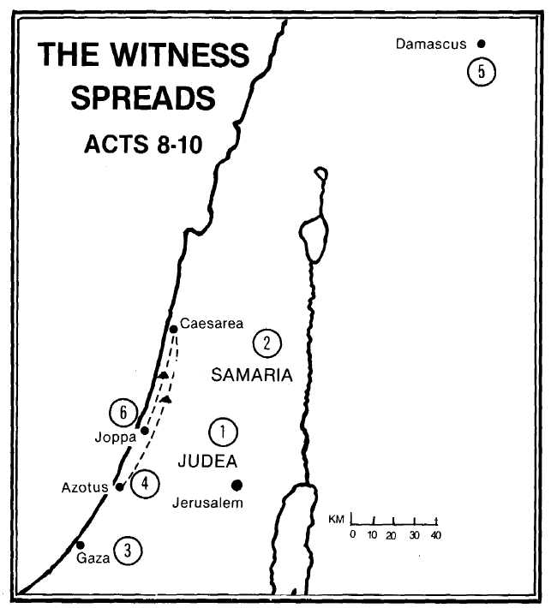
(2.) Philip the evangelist goes to Samaria preaching the gospel of the kingdom, followed by Peter and John (8:5, 13).
(3.) Philip teaches and baptises the Ethiopian eunuch on the desert road from Jerusalem to Gaza (8:26).
(4.) Philip is caught away from the Ethiopian eunuch and travels up the coast from Azotus to Caesarea, preaching everywhere the gospel (8:40; 21:8).
(5.) Saul of Tarsus is stopped by the Lord Jesus 'Christ near Damascus on his journey of persecution (9:3).
(6.) Peter is summoned from Joppa to Caesarea where he opens tne door of faith to Cornelius and his household (10:1-6).
3erfb

